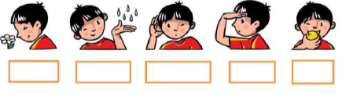
2. Write the name of the sense

3. Complete the table with the following words
Touch – Hearing- Taste- Olfactory epithelium- Ear – Eyes –Skin- Light- Chemicals in air- Chemicals in food

Stimuli detected | Sense | Sense organs
 | Sight
Pressure
 | Smell
 |  | Taste buds
Vibrations in the air

3. What are the main parts of the nervous system? Write
