- Look and find the past simple form of these verbs. Then write them in the table.
say watch play wear climb write buy walk eat drink find go
a | t | w | e | r | w | g | w | h | i | p
w | a | t | c | h | e | d | o | j | y | p
b | r | d | l | g | n | o | r | e | t | l
o | e | e | i | h | t | l | e | d | r | a
u | d | y | m | j | f | o | u | n | d | y
g | a | g | b | e | q | w | e | a | t | e
h | w | f | e | a | w | r | o | t | e | d
t | s | e | d | k | l | h | j | e | v | v
s | a | i | d | d | f | g | e | d | c | b
e | d | d | w | a | l | k | e | d | x | n
b | c | s | a | z | d | r | a | n | k | m

Regular | Irregular
 | said

- Look and write the questions. Then look again and put the pictures in the order they happened.
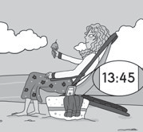
b

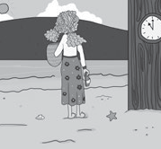
Where did she go?
a
She went to the beach.

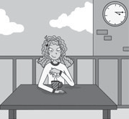
c
She drank a hot chocolate.

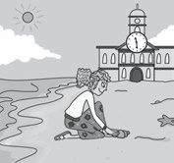
e

She found a shell.

3 Answer the questions.
  - What did you eat for lunch yesterday?

  - Where did you go on holiday last year?

  - Who did you see this morning?

What did she ? She ate an ice cream

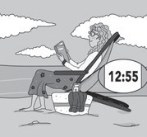
d

She wore sunglasses.

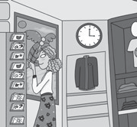
f

She bought a postcard.

