Social Science Quiz - 4th Grade

The Neolithic Age. Look at Students’ book, pages: 83 and 84.

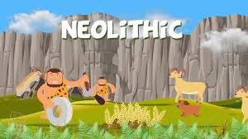

**Fill in the gap with one word or a number:**

1. The Neolithic Age started ……………….. years ago.

2. Human beings started to look after ………………..

3. We can see people dancing in ……………. paintings.

4. People used ……………. to make weapons and tools.

5. People made ………………. objects from clay or mud.

6. People made settlements in Almeria in about …………... BCE.

7. People constructed ……………………… from large stones.

Answers:

1. 12,000

2. animals

3. cave

4. stone

5. ceramic

6. 5,000

7. megaliths