Tim loves to go with his mother when she goes grocery shopping. His favorite store is right next door to the grocery store. It is Billows Book Store. Tim goes straight to the bookstore when they get to the grocery store. Mom buys groceries. Tim’s favorite section is the sports section for children. They have all kinds of books about sports. There are magazines that tell everything about sports.
Tim likes sports and he spends a lot of time looking at the books and magazines in this section. He likes the area with children’s books, too. Tim always waits in the bookstore for Mom to come and get him. He chooses one book or a magazine and Mom buys it for him. It is a nice way to spend a Saturday afternoon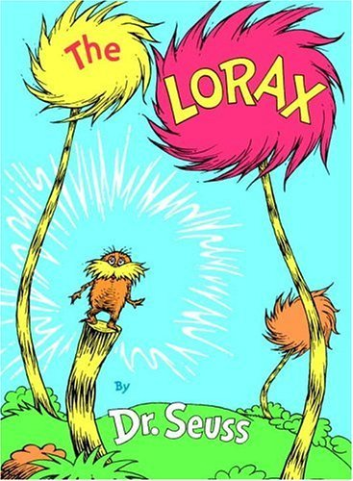.

- Why does Tim like to go grocery shopping with his Mom?
a.He goes to the ice cream shop.
b.He goes to the bookstore.
c.He can see all of his friends.
d.He likes to buy clothes.

- When does Tim go to the bookstore?
a.on Friday morning
b.on Saturday morning
c.on Sunday afternoon
d.on Saturday afternoon

- What does Tim like to read about ?
a.animals b. sports
c. cars d. bikes

- What does Tim's mother do when she comes to get Tim?
a.gives him food
b.takes him to school
c.buys a book or magazine for him
d.takes him to see his friends

- Tim looks for sports books and _____ in the bookstore
a.newspapers b. videos
c. posters d. magazines

- What sports does Tim like?
a. basketball b. football
c. golf d. all of these

