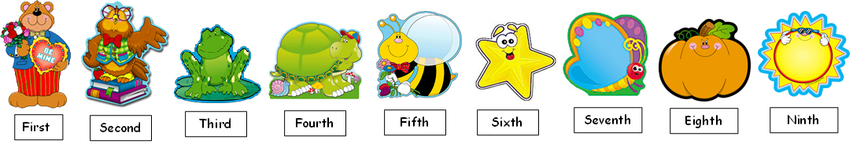

**Look at the pictures and circle the correct order of each of them.**

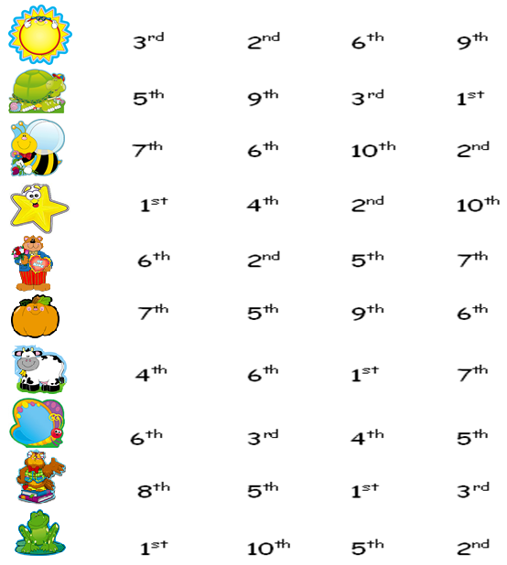

**Order the letters to find ordinal numbers.**

a)ehevnelt ______________

b)eeshxtint: ______________

c)nhnti: _______________

d)tfhfi: _______________

e)ethithter: _____________

f)hsnetve: _______________

g)ennhitten: _______________

h)eethwttni: _____________

i)dtihr: _________________

j)htnet: ________________

**Find the following ordinal numbers in the soup letter.**

1. 83rd
2. 15th
3. 20th
4. 38th
5. 12th
6. 50th
7. 91st
8. 49th
9. 306th
10. 40th
11. 80th
12. 645th
13. 14th
14. 18th
15. 73rd
16. 2nd
17. 19th
18. 8th
19. 90th
20. 1st

