**Wednesday 25th March, 2020**

**Hello everybody!**

ACT1: Copy and complete.

Copiar diálogo en la libreta y completarlo con las frases que nos dan en la derecha. (Act. 3 P. 45)

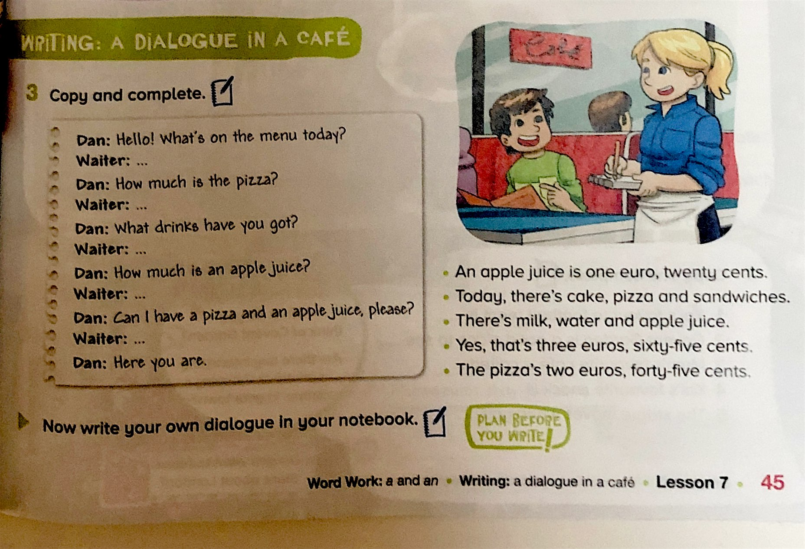

ACT2: Revise the dialogue p. 45.

Ensayar diálogo en casa con ese vocabulario o puedo añadir otros alimentos. ¡Venga, ahora tú eres el profe o la seño y explicárselo a tu familia! ¡Practícalo en casa todos los días!

ACT3: How much/is activity.

Check How much is/are grammar in your book. P. 40. And write sentences in the worksheet. You can print it or copy the sentences in your notebook.

How much is…. – Singular. Ex: How much is the book?

How much are…? – Plural. Ex: How much are the books?

Ex: How much is this ruler? It is two punds thirty.

How much are the shoes? They are fifty euros.

