vocabulary

1 Circle the opposites of the words below in the puzzle. Then write the pairs of opposites.

young • intelligent • strong • fast • heavy • huge
s | t | u | p | i | d
l | i | g | h | t | w
o | l | d | a | i | e
w | r | a | e | n | a
p | n | o | z | y | k
1. …………………… / ……………………
2. …………………… / ……………………
3. …………………… / ……………………
4. …………………… / ……………………
5. …………………… / ……………………
6. …………………… / ……………………

2 Circle the TWO adjectives to describe the animal in each picture.
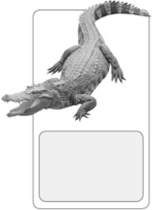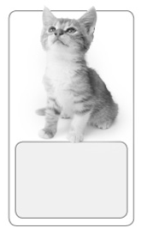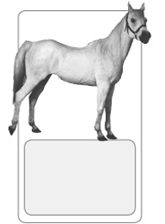
dangerous
pretty
frightening
1
young
tiny
old
2
fast
tiny
strong
3
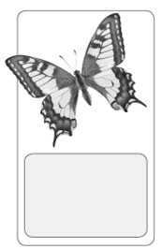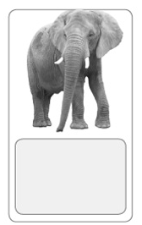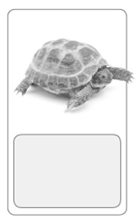
heavy
pretty
light
4
weak
huge
intelligent
5
slow
dangerous
endangered
6

3 Complete the sentences with the adjectives below.
weak • endangered • frightening • dangerous • light • intelligent
1. Dolphins can do many tricks. They are very …………………… animals.
2. Feathers are …………………… .
3. A baby giraffe can stand, but its legs are very …………………… .
4. Pandas are an …………………… species.
5. Don’t go near that tiger. It is very …………………… .
6. Lions can make a …………………… noise.
grammar

4 Write comparative sentences with the words below.
1. the giant panda / is / endangered / the African elephant

2. whales / are / big / sharks

3. lions / are / frightening / cats

4. horse riding / is / dangerous / walking

5. a butterfly / is / colourful / a mouse

6. cheetahs / are / fast / pumas

5 Look at the pictures. Then write comparative sentences with the words below.
cold • heavy • adventurous • cheap • young


1
TOM
JAMES
Tom is …………………………………… James.

2
£2.00
£3.00
The apples are …………………………………… the oranges.

3
CATHY (12)
JANET (10)
Janet is …………………………………… her sister Cathy.

4
KEVIN
PETE
Pete is …………………………………… Kevin.
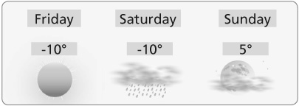
5
On Friday it was ……………………………… on Sunday.

