VOCABULARY
1 Write the correct adjectives under each picture.
1
thin  fat  tall  short
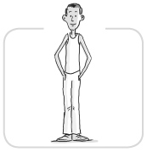
a ............................. ............................. b ............................. .............................
2
straight  light  curly  dark  long  short
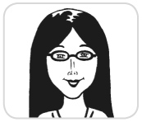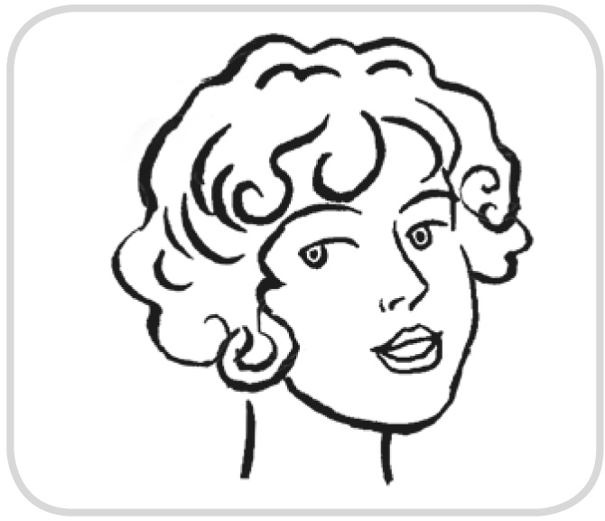
a ............................. ............................. b ............................. .............................
............................. .............................
2 Choose the correct answers.
1 Nabi Tajima from Japan is 117. She’s very straight / old / dark.
2 You can’t see an atom because it’s very small / big / ugly.
3 Penélope Cruz is a beautiful / curly / light woman. She is also a talented actress.
4 My dog is thin / tall / ugly, but I love him.
5 My brother is very long / old / young. He’s just a baby.
6 LeBron James is a small / good-looking / big man, but he isn’t fat.
7 Many girls like Enrique Iglesias because he’s a good singer and because he is very
long / straight / good-looking.
grammar
3 Look at the picture. Then complete the sentences with the correct form of to be.
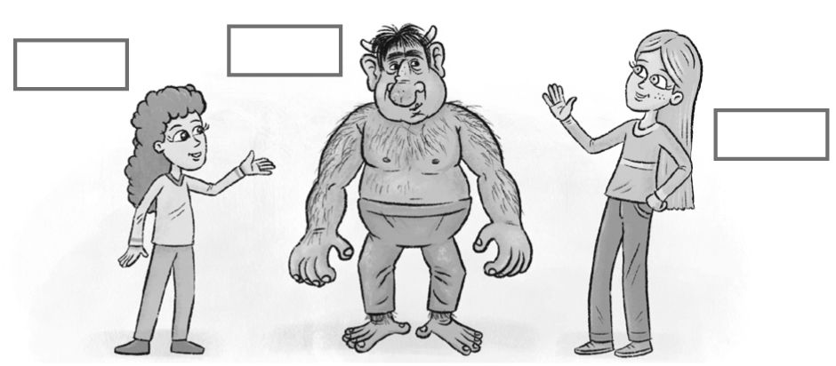
Lizzy
Igor
Suzy
1 Suzy and Lizzy ............................................... girls. They ............................................... old.
2 Igor ............................................... a person. He ............................................... a monster.
3 Lizzy ............................................... tall. She ............................................... short.
4 Suzy and Lizzy ............................................... beautiful. They ............................................... ugly.
4 Write questions with the words below and the correct form of to be. Then answer
the questions according to the picture.
1 Igor / good-looking

2 Suzy and Lizzy / lookalikes

5 Look again at the picture in Exercise 3 and complete the sentences with the
correct form of have got.
1 Lizzy ............................................... straight hair. She ............................................... curly hair.
2 Suzy and Lizzy ............................................... big eyes. They ............................................... big ears.
3 Igor ............................................... a big nose. He ............................................... a big mouth.
4 Igor and Lizzy ............................................... light hair. They ............................................... dark hair.
6 Write questions with the words below and the correct form of have got. Then answer
the questions according to the picture.
1 Igor / big ears

2 Suzy and Lizzy / long hair

VOCABULARY
1 Match A to B.
A B
1 mother ..... a uncle
2 sister ..... b grandfather
3 aunt ..... c father
4 grandmother ..... d brother
2 Look at the family tree and complete the sentences with the family words below.
cousin  grandmother  sister  brother  uncle  children
mother  grandfather  father
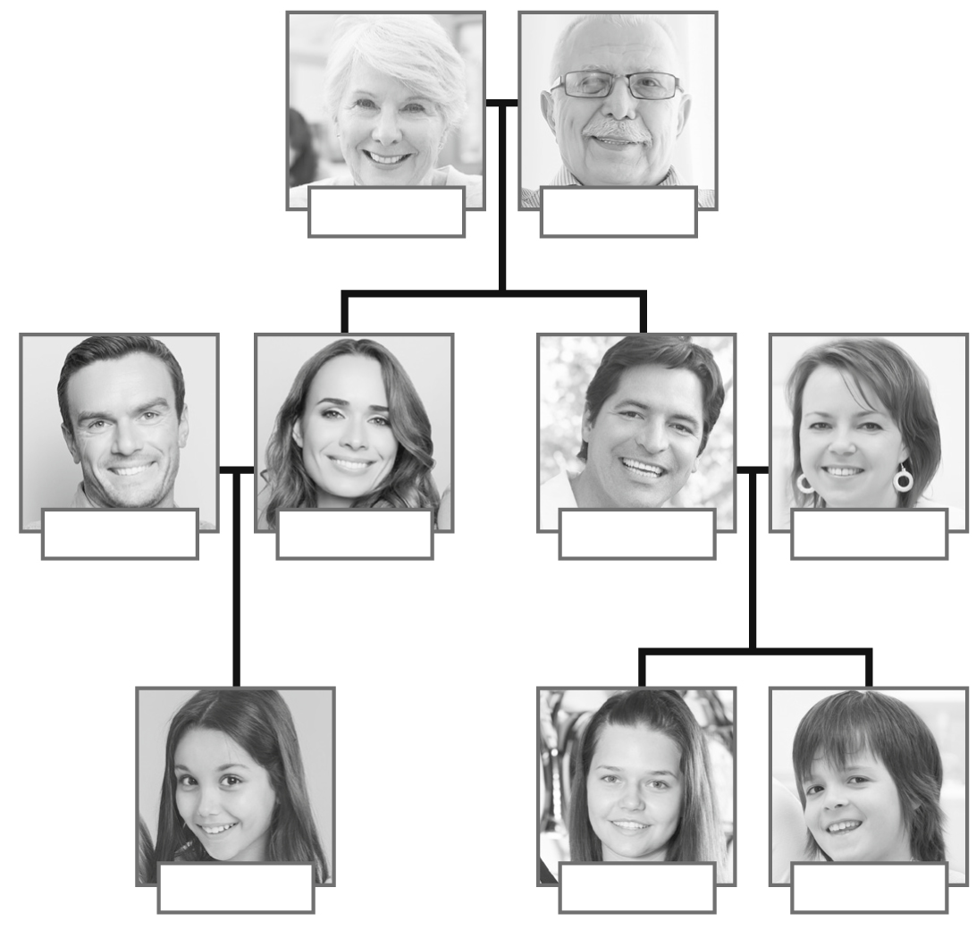
Linda
George
Paul
Evie
Blake
Tina
Katie
Amy
Max
1 Blake and Tina have got two ............................................... . Their names are Amy and Max.
2 Linda is Amy’s ............................................... and George is Amy’s ............................................... .
3 Blake is Amy’s ............................................... and he is Katie’s ............................................... .
4 Evie is Blake’s ............................................... and she is Katie’s ............................................... .
Linda
Linda
Linda
5 Max is Katie’s ............................................... and he is Amy’s ............................................... .
grammar
3 Complete the chart with the possessive adjectives.
Subject pronouns | Possessive adjectives
I | 1
you | 2
he | 3
she | 4
it | 5
we | 6
you | 7
they | 8
4 Complete the sentences with the correct possessive adjectives.
1 Please give this book to Anne. It’s ............................................... book.
2 We haven’t got blue pens. ............................................... pens are black.
3 I have got a cat. ............................................... cat is black.
4 I have got two sisters. ............................................... names are Mia and Lucy.
5 Harry has got a black schoolbag. The blue schoolbag isn’t ............................................... .
6 You have got two cousins. ............................................... cousins are young.
5 Complete the sentences with the Saxon genitive form of the words in brackets.
1 My ............................................... (father) name is Liam.
2 The ............................................... (teachers) meeting is at seven o’clock.
3 Susan is ............................................... (Leo) sister.
4 Our ............................................... (cousin) house is on Oak Street.
5 Their ............................................... (children) names are Amelia and Oliver.

