VOCABULARY
1 Complete the sentences with the words below.
outfit  smart  comfortable  watch  match  tight
1 That top doesn’t ............................................... those trousers.
2 These shoes aren’t ............................................... . They hurt my feet.
3 I can’t wear these jeans. They’re too ............................................... .
4 I don’t wear a ............................................... because I can see the time on my phone.
5 The skirt and top make a nice ............................................... .
6 Is this dress ............................................... enough for a wedding?
2 The words in bold are in the wrong sentences. Write them next to the correct sentences.
1 I need high heels for the beach. ...............................................
2 I usually wear large clothes to school – jeans and a T-shirt. ...............................................
3 I keep my money in my jeans’ flip flops. ...............................................
4 This coat is too casual for me. I need a smaller size. ...............................................
5 I can’t dance in pockets. I’ll fall! ...............................................
3 Complete the e-mail with the words below.
top  belt  tried on  wallet  size  loose  fit
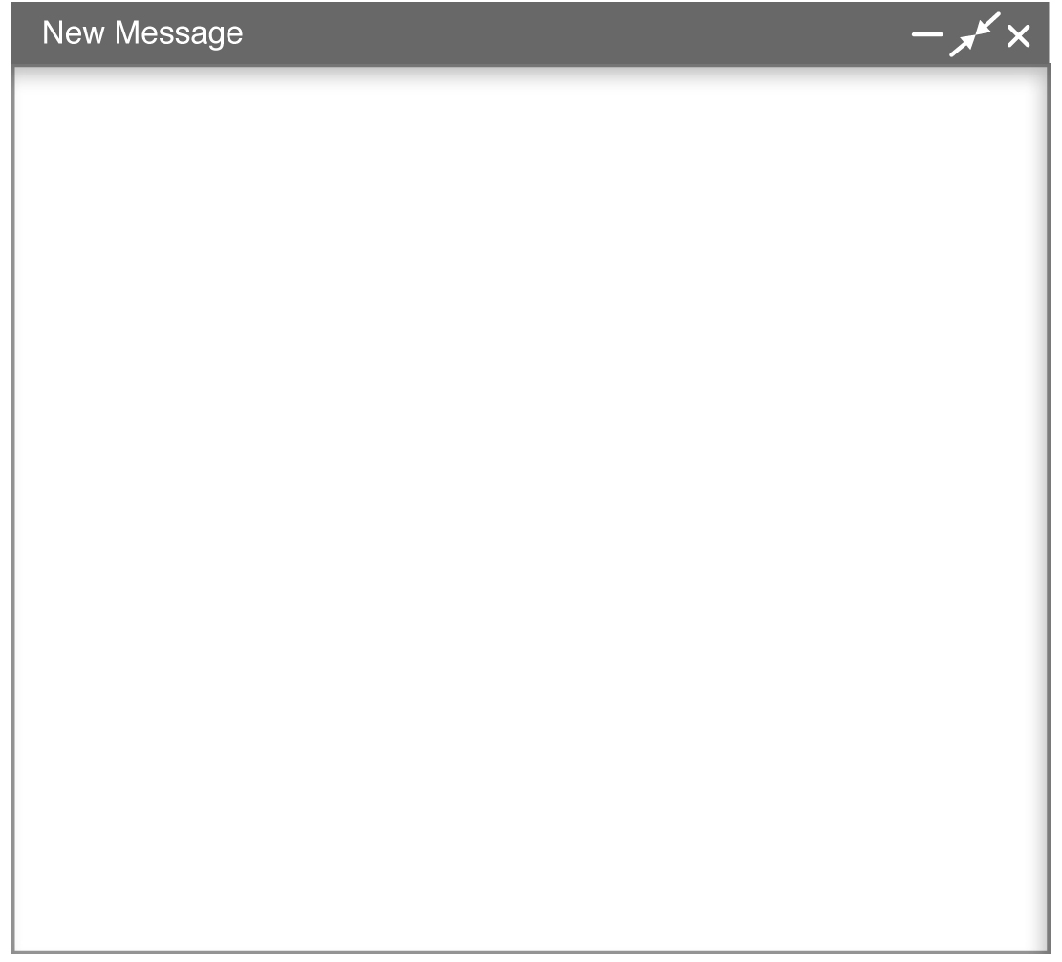
Hello from New York!
I’m having a fantastic time. Today is shopping day, so I’m visiting different shops. I wanted something to wear with shorts at the beach, so I ^{1.} ............................................... a red ^{2.} ............................................... , but it didn’t ^{3.} ............................................... nicely. According to the label, it was my ^{4.} ............................................... , but
it was too ^{5.} ............................................... . I found a black and yellow ^{6.} ............................................... for my black jeans. For Dad, I found a ^{7.} ............................................... . His is really old and the money keeps falling out. Now I’m looking for a present for Mum. I hope
I find something!
Love,
Charlotte
grammar
4 Choose the correct answer.
1 She’s wearing a / an / the interesting outfit.
2 We haven’t got any / some / a gloves.
3 There’s an / the / a wallet on the shelf. Is it yours?
4 There is some / any / a beautiful jewellery in the shop.
5 Have you got a / some / any scarves?
5 Choose the correct answer. Then complete the sentences with a, an, the, some or any.
Use each word once.
1 I’m cold because I haven’t got ............................................... coat / belt.
2 The shoe shop has got ............................................... nice pockets / high heels.
3 I’m buying ............................................... outfit / umbrella for my sister’s birthday party.
4 The green T-shirt is ugly, but I like ............................................... red top / sock.
5 He doesn’t buy expensive clothing because he hasn’t got ............................................... wallets / money.
6 Complete the text with a, an, the, some or any.
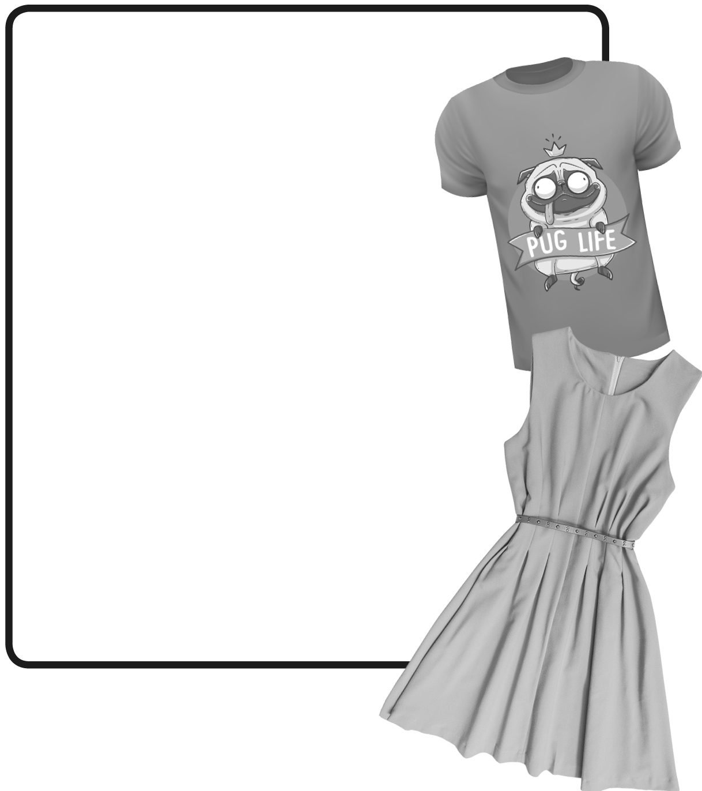
Have you got ^{1.} ............................................... ideas
for dresses or T-shirts? Well,
^{2.} ............................................... innovative company
can help you design your own clothes.
The company, Picture This Clothing,
sells templates – blank drawings – of
clothing. They’ve got templates for
T-shirts, dresses, leggings and hats, but
they haven’t got ^{3.} ...............................................
trousers yet. You buy ^{4.} ...............................................
template, print it and then colour it
or put ^{5.} ............................................... interesting
objects on it. The next step is to take a
picture with ^{6.} ............................................... mobile
phone and send it to Picture This
Clothing. ^{7.} ............................................... company
creates clothes according to your
design. It’s ^{8.} ............................................... amazing
idea, and it all started because the
owner’s daughter wanted to design
her own dress!
VOCABULARY
1 Choose the correct answer to show you understand the meaning of the words in bold.
1 Choose / Pay for / Try on items at the checkout counter.
2 Shops make / sell / lend products.
3 Items on special offer are usually not expensive / free / expensive.
4 Nicole bought a dress yesterday, but she took it back. She returned it to the shop / borrowed it / took it home.
5 The shop gave Chloe a refund. She paid for the item / got her money back / found the right size.
2 Complete the sentences with the words below.
added up  charge  on sale  advertisement  off
1 Look! These jackets are 50% ............................................... .
2 In about two weeks, all the winter clothes will be ............................................... .
3 How much did they ............................................... to fix your phone?
4 I ............................................... all the numbers, but I got 97, not 100.
5 Look at this ............................................... for flip flops – only £5 a pair.
3 Unscramble the words. Then use the words to complete the sentences according to the pictures.
pecteri  shac  gceheanx  dercti racd  gecahn
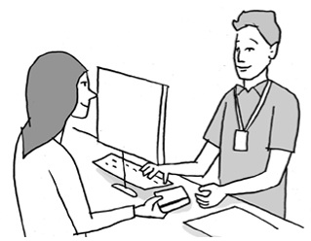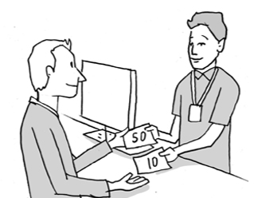
1
2
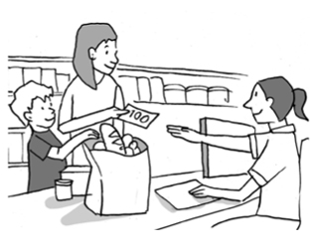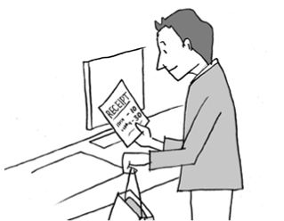
3
4
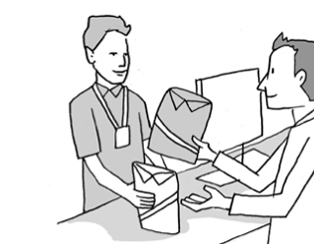
5
1 Tina gave her ............................................... to the salesperson.
2 I gave the cashier £50 and got £10 ............................................... .
3 My mum paid in ............................................... at the supermarket.
4 Rob always checks his ............................................... when he buys something.
5 You can ............................................... that shirt for this white one.
3
grammar
4 Choose two correct answers.
1 There are many / much / a lot of nice items in that shop.
2 Unfortunately, they don’t recycle many / much / a lot of paper.
3 There are a lot of / many / much styles to choose from.
4 There aren’t much / many / a lot of children in the shopping centre now.
5 The machine doesn’t use a lot of / many / much electricity.
5 Complete the questions with how much or how many.
1 ............................................... sugar is there in the coffee?
2 ............................................... pockets have the trousers got?
3 ............................................... cash is there in the wallet?
4 ............................................... handbags has she got?
5 ............................................... water have we got?
6 Choose the correct answers to complete the dialogue.
 Sue: You always look great, Linda. ^{1.} How much / How many / Many time do you spend choosing
clothes every morning?
 Lyn: I don’t spend ^{2.} many / much / some time because I got ^{3.} some / an / a personal chatbot
from Intelistyle.
Sue: What’s that?
Lyn: It’s ^{4.} an / a / any app. You show it ^{5.} any / an / the items in your cupboard and it makes fashion recommendations. It gives you ^{6.} an / a lot of / any options, so you can choose.
Sue: ^{7.} How much / How many / Some people already use the Intelistyle chatbot?
Lyn: Not ^{8.} some / much / many. But Intelistyle put together ^{9.} a / any / an outfit during the 2019 London Fashion Week, and fashion experts really liked it.

