VOCABULARY
1 Unscramble the words and write them under the correct pictures.
ugel  prstlea  paplto  okoxettb  sbapnituhr  tojcrrpoe
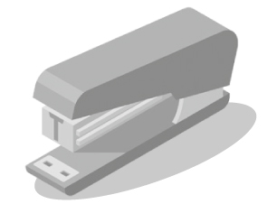
1
2
3
.............................................. .............................................. ..............................................
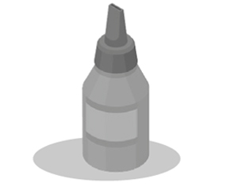
4
5
6
.............................................. .............................................. ..............................................
2 Choose the correct answer to show you understand the meaning of the words in bold.
1 We use scissors to paint pictures / cut paper / do maths.
2 You use a compass to draw circles / triangles / rectangles.
3 You often eat / play / write on a whiteboard.
4 A dictionary tells us the meaning of a word / where a country is / when events happened.
5 We often use an atlas in sport / literature / geography lessons.
6 You can use a map to find a train / place / kitchen.
3 Complete the sentences with the words below.
tablets  flash drive  paints  microscope  calculator
1 Tim finished his project and saved it on a .............................................. .
2 My .............................................. really helps me solve maths problems.
3 Some students have got .............................................. to search for things online.
4 In my science lesson, I used a .............................................. to look at very small things.
5 What kind of .............................................. are you using in your art lessons now?
grammar
4 Complete the sentences with the words in brackets. Use the Present Continuous affirmative.
1 Nick and Hannah ................................................................. (ride) their bikes to school.
2 Kate ................................................................. (take) a photo of a flower.
3 David ................................................................. (write) in his notebook.
4 Lisa and Paul ................................................................. (study) maths.
5 Look at the pictures below and correct the sentences in Exercise 4. Use the words below and
the Present Continuous affirmative and negative.
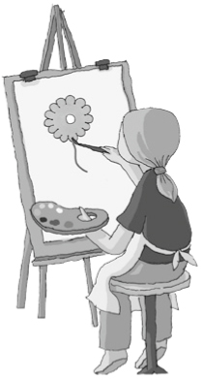
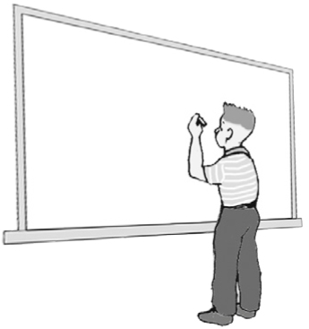
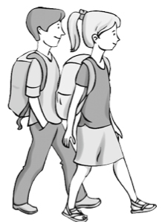
Kate
David
Hannah
Nick
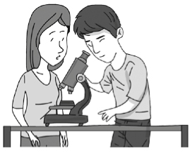
Paul
Lisa
1 Nick and Hannah
aren’t riding their bikes to school.
They are walking to school.
2 Kate

3 David

4 Lisa and Paul

6 Write questions for the answers in bold. Use the Present Continuous.
1
Yes, I’m using a calculator now.
2
No, Mr Jones isn’t writing on the whiteboard at the moment.
3
I’m saving my history project on my flash drive right now.
4
Nina and Tom are sitting near the window.
5
Emma is playing football with Lily.

VOCABULARY
1 Fill in the missing letters.
Forms of transport with two wheels
1 e ..... ..... c ..... ..... i ..... b ..... k .....
2 m ..... ..... ..... r ..... ..... ..... e
3 s ..... ..... ..... ..... ..... r
Forms of transport with four wheels
4 t ..... ..... i
5 m ..... ..... ..... v ..... .....
Form of transport with more than four wheels
6 l ..... ..... r .....
Forms of transport on water
7 s ..... ..... p
8 f ..... ..... r .....
9 b ..... a .....
Forms of transport in air
10 a ..... ..... ..... p ..... ..... n .....
11 h ..... ..... ..... c ..... ..... t ..... .....
Forms of public transport
12 t ..... ..... I .....
13 u ..... d g ..... ..... ..... n .....
14 tr ..... .....
2 Choose the correct answer.
1 Sam sails / drives / rides his boat on the sea.
2 My friends and I drive / take / sail the bus to school.
3 My uncle drives / takes / rides a scooter.
4 Jenny’s dad sails / drives / rides us to school in his car.
3 Complete the sentences with words from Exercises 1 and 2.
1 My mum .............................................. the train to work every day.
2 My friend’s dad drives a .............................................. . He delivers food to supermarkets.
3 People often fly in an .............................................. when they want to go abroad.
4 We are travelling from island to island in a small .............................................. .
5 My aunt and uncle bought a .............................................. because they have got five children.
3
grammar
4 Complete the sentences with the verbs in brackets. Use the Present Simple or Present Continuous.
1 Ann often ................................................................. (ride) her bike to school.
2 .............................................. you .............................................. (go out) now?
3 Bill ................................................................. (sail) his boat now.
4 When .............................................. school .............................................. (start) every morning?
5 Lara ................................................................. (not travel) on the underground every day.
6 I ................................................................. (not take) a taxi to the museum at the moment.
5 Write sentences with the words below. Use the Present Simple or Present Continuous.
1 what / they / paint / at the moment / ?

2 my dad / never / drive / to work / .

3 Uncle Jim / ride / his motorbike / right now / .

4 where / you / often / meet friends / ?

5 people / not usually fly / to school / in a helicopter / .

6 Complete the e-mail with the verbs in brackets. Use the Present Simple or Present Continuous.
Hi Steve,
We are in London now and we ^{1.} ................................................................. (have) a great time. Believe it or not, it ^{2.} ................................................................. (not rain) at the moment! Once a month, we ^{3.} ................................................................. (come) to
this amazing city because my mother ^{4.} ................................................................. (love) seeing shows and my father ^{5.} ................................................................. (like) going to museums. We ^{6.} ................................................................. (visit) the London Transport Museum at the moment. I ^{7.} ................................................................. (not walk) around with my family. I ^{8.} ................................................................. (explore) an old underground station as part of the Hidden London exhibition. I ^{9.} ................................................................. (not know) much about London during World War II, so I ^{10.} ................................................................. (learn) many things now. ^{11.} .............................................. you .............................................. (enjoy) your school holidays, too?
Mike

