VOCABULARY
1 Choose the correct answer.
1 In 2020, Brad Pitt won his first Oscar, for best character / supporting actor, in the film Once Upon a Time
in Hollywood.
2 The trailer / soundtrack for the new Spider-Man film looks fantastic. I love the special effects.
3 The costume designer / make-up artist is making a hat.
4 Some lead roles / viewers like watching comedies.
5 A good heroine / hero is kind. She helps people.
2 Complete the sentences with the words below.
hero  setting  audience  make-up artist  soundtrack  plot
1 The ............................................... is waiting for the film to start.
2 This film’s music is great! I want the ............................................... .
3 The ............................................... of the film is Earth, 2158.
4 Batman is a ............................................... . He fights crime.
5 The ............................................... of the book is hard to follow.
6 The ............................................... makes the actors’ faces look perfect for their role.
3 Complete the text with the words below.
scenes  character  lead role  special effects  director
Amy Fox is playing the ^{1.} ............................................... in a new film by Hollywood ^{2.} .............................................. Dan Todd.
In an interview, Todd says, “This film has got action ^{3.} .............................................. , romance and comedy.
It’s also got amazing ^{4.} .............................................. . Amy is a funny person and her ^{5.} .............................................. in
the film is funny, too. You’ll love it!”
grammar
4 Choose the correct answer.
1 I am hating / hate horror films, so I don’t watch / am not watching them.
2 Kim isn’t wanting / doesn’t want to see a science-fiction film, so I am looking for / look for another film now.
3 My brother loves / is loving making videos. His friend is helping / helps him right now.
4 We are buying / buy popcorn now. It is smelling / smells great!
5 I am watching / watch a film at the moment, but I am not understanding / don’t understand it.
5 Complete the questions with the verbs in brackets. Use the Present Simple or Present Continuous. Then match the questions to the answers below.
1 .............................................. the film .............................................. (start) right now?
2 Where .............................................. the story (take place)?
3 .............................................. you .............................................. (like) the heroine of the film?
4 .............................................. we .............................................. (go) to the cinema now?
5 What .............................................. you .............................................. (think) of the Minions film?
..... a Yes, we are.
..... b It all happens in New York.
..... c I love it! It’s very funny.
..... d Yes, it is. Come quickly!
..... e No, I don’t.
6 Complete the text with the verbs in brackets. Use the Present Simple or Present Continuous.
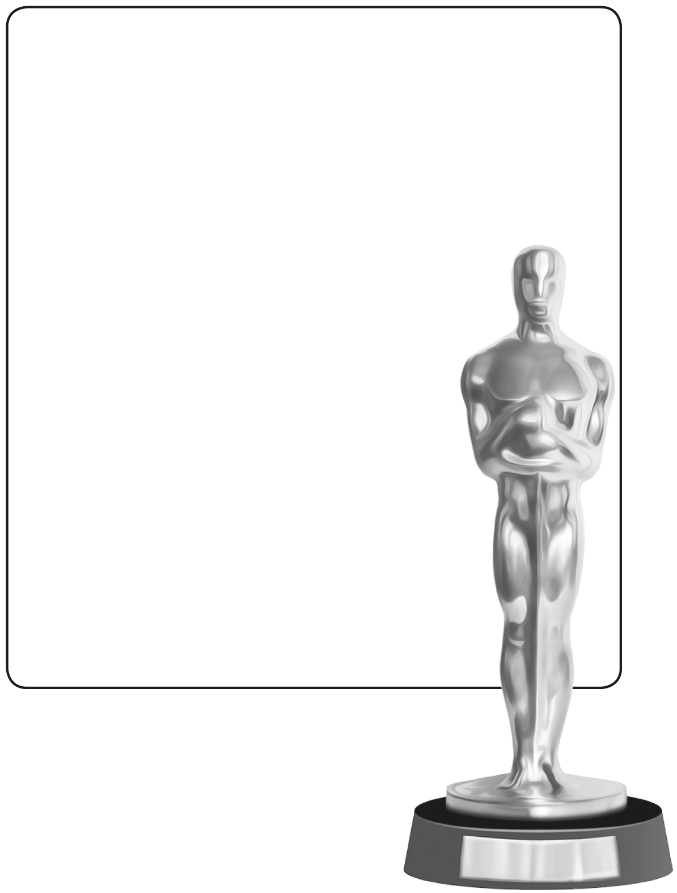
^{1.} .............................................. you .............................................. (like) films?
My sister Beth ^{2.} ................................................................. (love) films and she often ^{3.} ................................................................. (go) to the cinema. But right now, she ^{4.} ................................................................. (not go) anywhere because the Academy Awards ceremony – the Oscars – is on TV. I ^{5.} ................................................................. (watch) the Oscars with her now.
There are 24 Oscar award categories and the
best actors, actresses, films, costume
designers, make-up artists and directors ^{6.} ................................................................. (win) awards.
Right now, stars ^{7.} .................................................................
(walk) down the red carpet. They
^{8.} ................................................................. (not wear)
jeans and T-shirts. They’ve all got
expensive suits and dresses because they ^{9.} ................................................................. (not want)
to look bad in tomorrow’s newspapers. Beth
and I haven’t got that problem, so what
^{10.} .............................................. we ..............................................
(wear)? Pyjamas, of course!
VOCABULARY
1 Unscramble the letters to write the names of the sports. Then match the sports to the pictures.
..... 1 fglo ..............................................
..... 2 aaetkr ..............................................
..... 3 ylelvlalob ..............................................
..... 4 Idgernloilalbr ..............................................
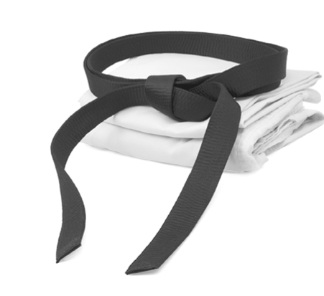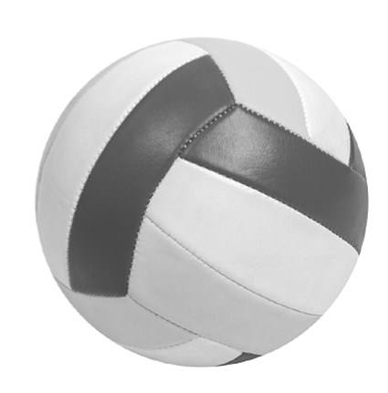
a
b
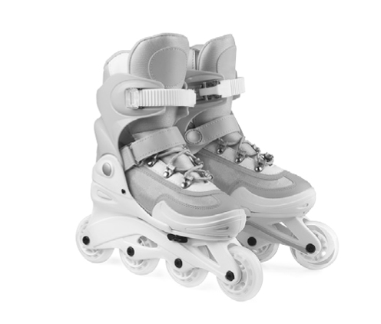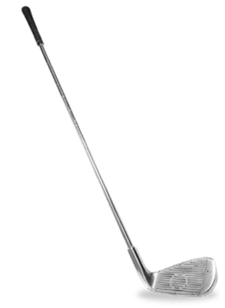
c
d
2 Match A to B to make sentences.
A B
1 A swimming pool has got ..... a at the beach.
2 A football pitch has got ..... b water in it.
3 You wear goggles ..... c one long net on it.
4 A referee makes ..... d to protect your eyes.
5 A tennis court has got ..... e two goals on it.
6 Some lifeguards work ..... f the players follow the rules.
3 Complete the sentences with the words below.
champion  defeated  bat  goalkeepers  scored
1 Brazilian footballer Pelé .............................................. 767 goals in 831 games.
2 Footballer Iker Casillas from Spain was one of the best .............................................. in the world.
3 American swimmer Michael Phelps won 28 Olympic medals. He was a .............................................. .
4 Roger Federer.............................................. Marin Cilic in the 2017 Wimbledon tennis final.
5 Cricket player Kieron Pollard threw his .............................................. at another player in a game in 2014.
3
grammar
4 Complete the sentences with the verbs in brackets. Use the Present Simple or the Present Continuous. Then match the sentences to the sports below.
1 Dan .............................................. (pick up) a heavy ball right now.
2 They usually .............................................. (wear) belts with special colours.
3 She .............................................. (not go) into the water without her goggles.
4 Clive and Sam .............................................. (not wear) goalkeeper gloves at the moment.
..... a swimming ..... c karate
..... b football ..... d bowling
5 Write questions with the words below. Use the Present Simple or the Present Continuous.
Then answer the questions about yourself.
1 your friends / play / football / at weekends

2 when / your class / usually / have / history lessons

3 you / wear / trainers / at the moment

4 your friend / exercise / at the sports centre / now

6 Complete the text with the verbs in brackets. Use the Present Simple or the Present Continuous.
Dr Watkins ^{1.} ................................................................. (check) a patient now. Another patient ^{2.} .................................................................
(run) on an underwater machine and a third patient ^{3.} ................................................................. (receive) acupuncture.
All three patients are elite athletes, but they ^{4.} ................................................................. (not compete) at the moment.
Dr Watkins and the other doctors at the clinic ^{5.} ................................................................. (help) them recover from sports
injuries right now, so they ^{6.} ................................................................. (come) to the clinic twice a week. The clinic is
expensive, but the patients ^{7.} ................................................................. (not pay) for their treatment. That’s because
they are dogs, and their owners always ^{8.} ................................................................. (make) the arrangements. The clinic ^{9.} ................................................................. (not treat) humans. It’s a sports medicine clinic for animals!

