VOCABULARY
1 Fill in the missing letters. Then match the activities to the pictures.
1 r ..... ..... d m ..... g ..... z ..... n ..... s
2 m ..... ..... t fr ..... . ..... nds
3 pl ..... y c ..... mp ..... t ..... r g ..... m ..... s
4 d ..... sp ..... rt
5 l ..... st ..... n t ..... m ..... s ..... c
6 s ..... nd m ..... ss ..... g ..... s
7 m ..... k ..... v ..... d ..... ..... s
8 g ..... sh ..... pp ..... ..... .....
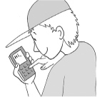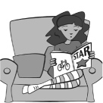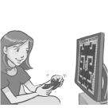
a
b
c
d
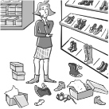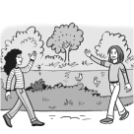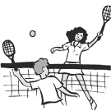
e
f
g
h
2 Match A to B. Pay attention to the activities in bold.
A
1 I rarely talk to my friends on the phone.
2 I am very musical.
3 I always walk to school.
4 I often look for information online.
5 I usually watch films at home.
6 My mother never prepares dinner.
7 I often do sport.
B
..... a I rarely go to the cinema.
..... b I surf the web with my phone.
..... c I play football four times a week.
..... d My father usually cooks meals for us.
..... e I play the guitar and I sing.
..... f I never ride my bike.
..... g We usually chat online.
grammar
3 Complete the sentences with the affirmative or negative form of the verbs in brackets.
Use the Present Simple.
1 Lionel Messi ............................................... professional tennis. He ............................................... football. (play)
2 People ............................................... breakfast in the morning. They ............................................... breakfast in the evening. (have)
3 Justin Bieber ............................................... computer games. He ............................................... music videos. (make)
4 People ............................................... to a restaurant to watch films. They ............................................... to a cinema. (go)
5 Students ............................................... sport in sports lessons. They ............................................... sport in science lessons. (do)
4 Complete the questions below with the verbs in brackets. Use the Present Simple. Then answer
the questions about yourself.
1 What music ............................................... you ............................................... (like)?

2 ............................................... the students in your class ............................................... (tidy) the classroom?

3 ............................................... your best friend often ............................................... (send) you messages?

4 ............................................... your mother ............................................... (ride) a bike?

5 How often ............................................... you ............................................... (go) shopping?

5 Complete the text with the verbs in brackets. Use the Present Simple.
Tina S is a famous teenager from France. Millions of people ^{1.} .............................................. (watch) her videos on YouTube. What ^{2.} .............................................. she .............................................. (do) in the videos? She ^{3.} .............................................. (not sing) or act. She ^{4.} .............................................. (play) the guitar. This keeps Tina very busy. So, she ^{5.} ............................................. often
.............................................. (not watch) TV and she ^{6.} .............................................. often .............................................. (not chat) online like most teenagers her age. What ^{7.} .............................................. Tina .............................................. (plan) to do next? She ^{8.} .............................................. (not like) talking about her plans for the future. She just ^{9.} .............................................. (want) to have fun.

VOCABULARY
1 Unscramble the words under the pictures.
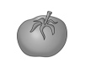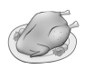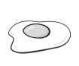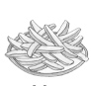
1
2
3
4
otaomt kciehcn geg shicp
............................................... ............................................... ............................................... ...............................................
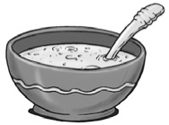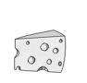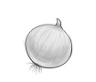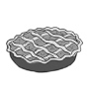
5
6
7
8
upos sehece nnoio eip
............................................... ............................................... ............................................... ...............................................
2 Match the food items to the descriptions.
A B
1 hamburger ..... a a long yellow fruit
2 juice ..... b an ingredient in sushi
3 orange ..... c a popular fast food
4 rice ..... d a fruit drink
5 banana ..... e a fruit and the name of a colour
3 Find six food items in the puzzle. Then write the correct words next to the clues.
k | l | h | a | p | s | o
a | e | o | p | l | a | b
l | m | a | p | e | l | r
a | p | k | l | m | a | e
c | a | k | e | o | d | a
p | o | t | a | t | o | d
l | m | h | a | m | s | o
1 a type of meat from a pig ...............................................
2 a popular dessert ...............................................
3 We use this vegetable to make chips. ...............................................
4 a basic food item in sandwiches ...............................................
5 a red, yellow or green fruit ...............................................
6 It’s got vegetables in it. ...............................................
grammar
4 Choose the correct answer.
1 My mother always wash / washes her hands before she has a meal.
2 I don’t / doesn’t eat hamburgers every day.
3 Do / Does you often cook meals?
4 My friend doesn’t watch / watches cooking shows.
5 Do they drink / drinks orange juice in the morning?
5 Complete the sentences with the verbs in brackets. Use the correct form of
the Present Simple.
1 Rob ............................................... (not eat) tomatoes because he is allergic to them.
2 ............................................... people usually ............................................... (have) pizza for breakfast?
3 We ............................................... often ............................................... (not make) chips at home.
4 Where ............................................... Ava ............................................... (buy) this bread?
6 Write sentences with the words below. Use the correct form of the Present Simple.
1 the boys / not / have lunch / at school / .

2 Dan / often / go shopping / for food / ?

3 Sara / teach / cooking / to other teens / .

4 when / the cooking show / start / ?

7 Complete the dialogue with the verbs in brackets. Use the correct form of
the Present Simple and complete the short answers.
Ross: Tina. ^{1.} ............................................... you often ............................................... (cook) meals?
Tina: Yes, I ^{2.} ............................................... . I ^{3.} ............................................... (make) a delicious chicken with rice.
Ross: Where ^{4.} ............................................... you ............................................... (find) your recipes?
Tina: I often ^{5.} ............................................... (search) the web for recipes.
Ross: ^{6.} ............................................... your mother often ............................................... (give) you recipes?
Tina: No, she ^{7.} ............................................... . She ^{8.} ............................................... (not cook). My father is the cook in our house.

