1 The words below appear in the text in Exercise 2. Write the words in your own language.
You can use a dictionary.
1 rivalry ............................................... 3 spacecraft ...............................................
2 goal ............................................... 4 success ...............................................
2 Read the text about the first astronauts.
THE RACE TO SPACE
Their goal was to send the first astronauts into space. But once again, the Soviet Union won the race. On 12th April, 1961, Yuri Gagarin flew in the Vostok 1 spacecraft and became the first human to travel in space. Gagarin received many medals and awards for his amazing work, including the “Hero of the Soviet Union”, a very big award for Soviet people.
The USA continued with the Mercury Project. On 5th May, 1961, about three weeks after Yuri Gagarin’s great success, Alan Shepard became the first American to travel into space. In 1962, John Glenn went into space and orbited Earth three times.
Thanks to these astronauts, we know more about space.
In the past, there was a big country called the Soviet Union. It included Russia and several other countries. In the 1950s, there was a rivalry between the Soviet Union and the USA. On 4th October, 1957, the Soviet Union sent Sputnik 1, the world’s first artificial satellite, into space. The Americans weren’t happy because they wanted to be the first in space exploration.
So, the race began. The USA’s space agency, NASA, introduced their first astronauts to the world on 9th April 1959. The Mercury Project was the name of their project and their astronauts were the Mercury Seven because there were seven of them. Their goal was to send the first astronauts were the Mercury Seven because there were seven of them.
3 Complete the sentences with the correct form of there was or there were according to the text.
1 ................................................................. other countries in the Soviet Union in addition to Russia.
2 ................................................................. a satellite in space before 1957.
3 ................................................................. seven astronauts in the Mercury Project.
4 ................................................................. one astronaut in the Vostok 1.
4 Complete the sentences with the correct countries and the correct form of the verbs in brackets.
Use the Past Simple affirmative.
1 ................................................................. ............................................... (send) the first satellite into space.
2 ................................................................. ............................................... (call) their astronauts the Mercury Seven.
3 ................................................................. ............................................... (continue) to work on the Mercury Project after the
Vostok 1 success.
4 Alan Shepard ............................................... (become) the first person from ................................................................. to travel to space.
5 Correct the mistakes in the sentences below according to the text.
1 The first person travelled into space in 1957.

2 The Soviet Union chose seven people for their space project.

3 The USA received awards and medals for their work in space.

4 Yuri Gagarin orbited Earth three times in 1962.

6 Look at the fact file about one of the astronauts. Write a paragraph about him.
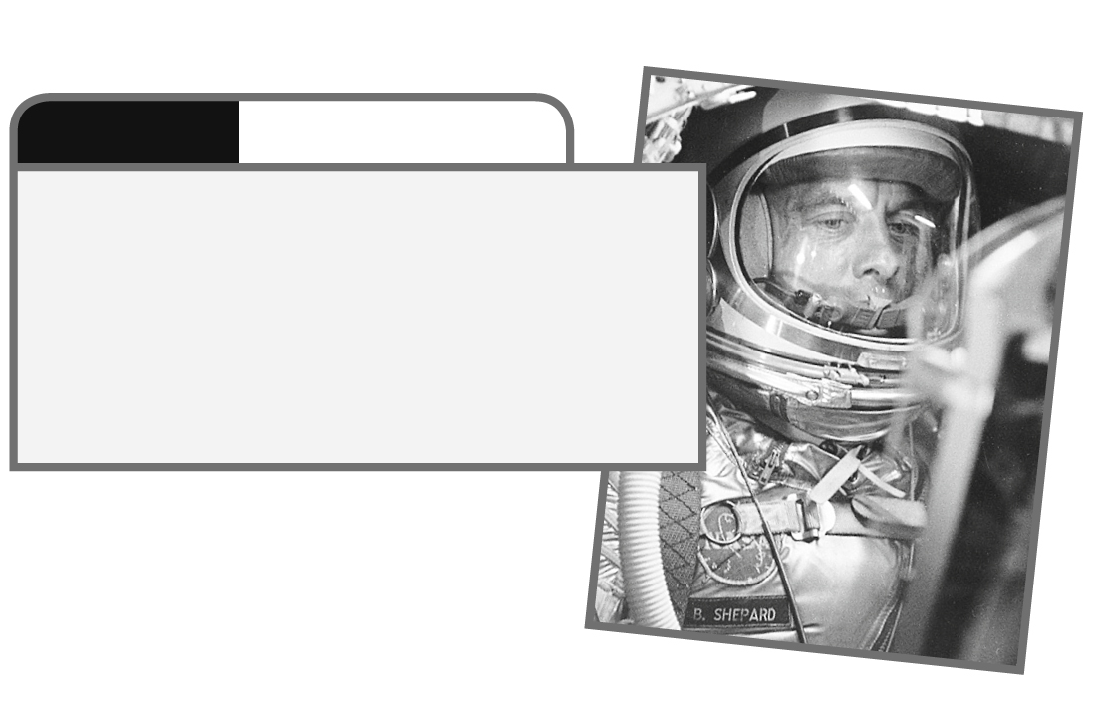
FACT FILE
ALAN SHEPARD
Name: Alan Shepard
From: the USA
Family: three daughters
Job: astronaut for NASA, businessman
Fun Fact: walked on the moon in 1971

