VOCABULARY
1 Look at the picture and complete the sentences with the words below.
church  park  bakery  café  chemist’s
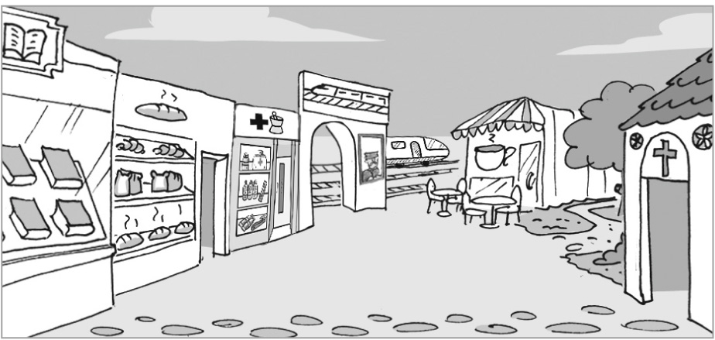
1 The ............................................... is between the bookshop and the chemist’s.
2 The ............................................... is opposite the bookshop.
3 The ............................................... is next to the train station.
4 The ............................................... is opposite the train station.
5 The ............................................... is between the church and the café.
2 Complete the sentences with the places below.
port  library  police station  restaurant  sports centre  department store
1 We often eat at an Italian ................................................................ .
2 The ................................................................ sells clothes and furniture.
3 Take him to the ................................................................ ! He’s got my bag!
4 You can play tennis at the ................................................................ .
5 You take books from the ................................................................ without buying them.
6 There are many boats at the ................................................................ .
3 Complete the sentences with suitable places.
1 Doctors work in a h ..... ..... ..... ..... ..... ..... ..... .
2 There are many shops at the s ..... ..... ..... ..... ..... ..... ..... c ..... ..... ..... ..... ..... .
3 There is a funny film on at the c ..... ..... ..... ..... ..... .
4 Most people buy food at the s ..... ..... ..... ..... ..... ..... ..... ..... ..... ..... .
5 Last summer, we stayed at a lovely h ..... ..... ..... ..... .
6 There’s a dinosaur exhibition at the m ..... ..... ..... ..... ..... .
grammar
4 Complete the sentences with the verbs in brackets. Use the Present Continuous.
1 I ................................................................ (study) at the library right now.
2 The restaurant ................................................................ (close) now.
3 We ................................................................ (not listen) to music at the moment.
4 The boys ................................................................ (run) to church.
5 Mark ................................................................ (not go) to the café now.
5 Complete the e-mail with the verbs in brackets. Use the Present Continuous.
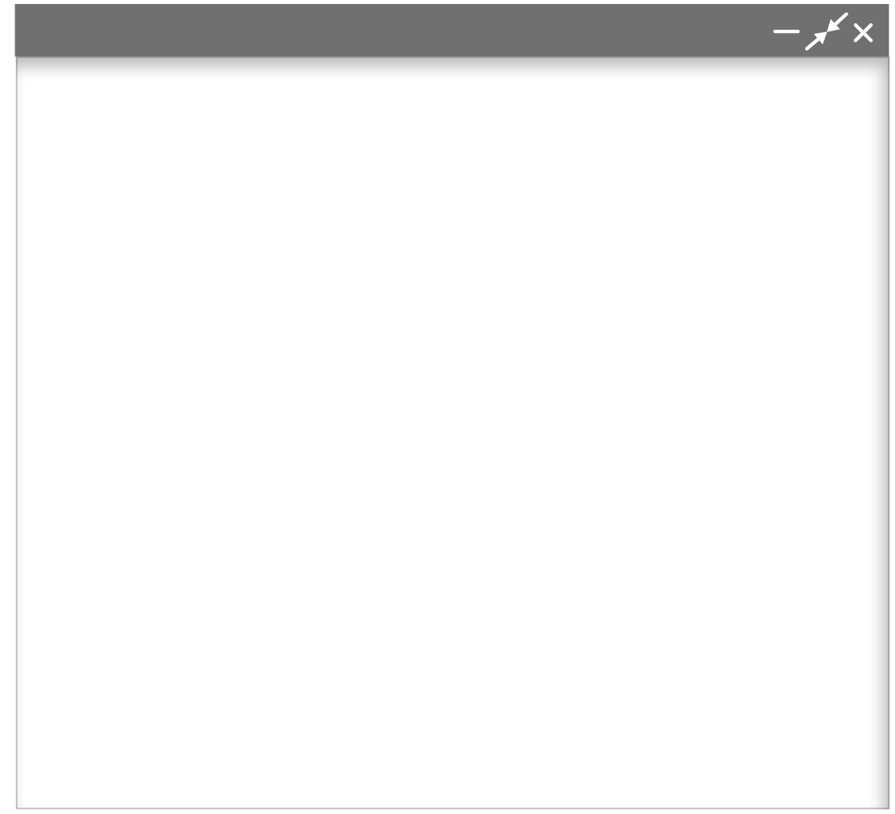
Hi Paul,
What ^{1.} ............................................... you ............................................... (do) this summer? I ^{2.} ............................................... (visit) Kyoto in Japan with
my family. Right now, we at Kyoto train station. No, we ^{3.} ............................................... (not travel) on a train now. This station
has got shopping centres, an art museum, restaurants,
a theatre and a hotel. At the moment, my sister ^{4.} ............................................... (buy) clothes in the Isetan Department Store. It’s got 13 floors! My brother and I don’t like shopping,
so we ^{5.} .............................................. (sit). My brother ^{6.} .............................................. (order) food for lunch now. We’re at the Kyoto Ramen Koji
on the 10th floor of the station. It’s got eight restaurants
with different types of Japanese soup called ramen. My brother ^{7.} ............................................... (not wait) for my sister because he’s very hungry!
Talk to you later.
Dan
New Message
6 Write questions with the words below. Use the Present Continuous.
Then answer the questions according to the e-mail in Exercise 5.
1 Dan and his family / travel / in Europe

2 what / Dan’s sister / buy / at the moment

3 where / Dan / have lunch

4 what / Dan and his brother / eat

VOCABULARY
1 Find nine film genres in the puzzle below. Then write them below the correct pictures.
c | a | n | c | o | m | d | f | t | a | a | w |   1  ...............................................
r | h | b | r | c | f | a | g | h | c | n | e
i | o | v | a | z | a | s | y | r | t | i | s
m | r | o | m | a | n | c | e | i | i | m | t
e | r | h | a | c | t | i | o | n | o | a | e
s | o | a | r | i | a | i | b | l | z | t | r
i | r | j | m | u | s | i | c | a | l | e | n
c | o | m | e | d | y | g | x | r | s | d | y
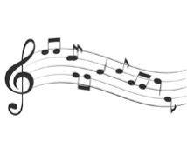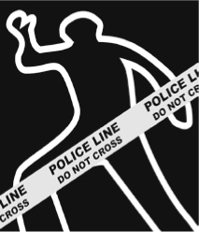
2
3
4
5
............................................... ............................................... ............................................... ...............................................

6
7
8
9
............................................... ............................................... ............................................... ...............................................
2 Complete the genres.
1 It is always funny. c...............................................
2 It is usually in the USA in the 1800s. w...............................................
3 It is usually about an exciting trip. a...............................................
4 It has often got violence and it frightens people. h...............................................
5 It has got more dialogue than action. d...............................................
3 Choose the correct answer.
1 Emma Stone sings in the western / documentary / musical La La Land.
2 Game of Thrones is a fantasy / comedy / crime TV programme. It takes place in an imaginary country.
3 Many action / animated / horror films, like Aladdin and The Lion King, are creations of Disney.
4 People travel in space in Star Wars. It’s a series of romance / horror / science-fiction films.
5 National Geographic has got many interesting dramas / documentaries / comedies about unusual animals.
grammar
4 Choose the correct answer.
1 I don’t go / am not going to the cinema every week.
2 The woman in front of me wears / is wearing a big hat. I can’t see anything.
3 Do they buy / Are they buying the tickets now?
4 Alex doesn’t watch / isn’t watching films on school days.
5 We don’t wait / aren’t waiting outside right now. We’re in the cinema.
5 Complete the sentences with the verbs in brackets. Use the Present Simple or
the Present Continuous.
1 My sister ................................................................ (often watch) comedies on TV.
2 I ................................................................ (not wait) inside the cinema right now. I’m outside.
3 Dan and Ken ................................................................ (not usually read) film reviews.
4 ............................................... Anna ............................................... (eat) popcorn at the moment?
5 The workers ................................................................ (clean) the cinema now.
6 ............................................... Lucy ............................................... (work) at the cinema on Saturdays?
6 Complete the text with the verbs in brackets. Use the Present Simple or
Present Continuous.
It’s April 2016. Many people in London ^{1.} ................................................................ (talk) about the Star Wars film, Rogue One: A Star Wars Story. That’s because you can see many places in London in the film. In one scene, Galactic soldiers are at the Canary Wharf Underground station in East London. They ^{2.} ................................................................
(not ride) on the Underground, but they ^{3.} ................................................................ (walk) through the station. They ^{4.} ................................................................ (wear) white uniforms and masks. Thousands of people ^{5.} ................................................................ (travel) through the Canary Wharf station every day, but they ^{6.} ................................................................ (not usually meet) Galactic soldiers. This only ^{7.} ................................................................ (happen) in films.

