VOCABULARY
1 Complete the sentences according to the pictures.
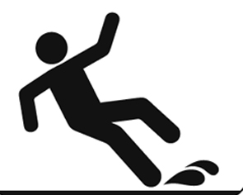
1
2

3
1 The ............................................... took us to hospital.
2 Ben ............................................... and ............................................... because the floor was wet.
3 It’s important to have a ............................................... in the car.
2 Complete the sentences with the words below.
broke his leg  killed  called for help  hurt
1 Jenny ................................................................... her hand when she caught the ball.
2 The fire was fatal. It ................................................................... three people.
3 She ................................................................... by phoning emergency services.
4 Leo ................................................................... when he went skiing last week.
3 What is Joey saying? Complete the speech bubble with the words below.
prevent  accidents  safe  dangerous  injure
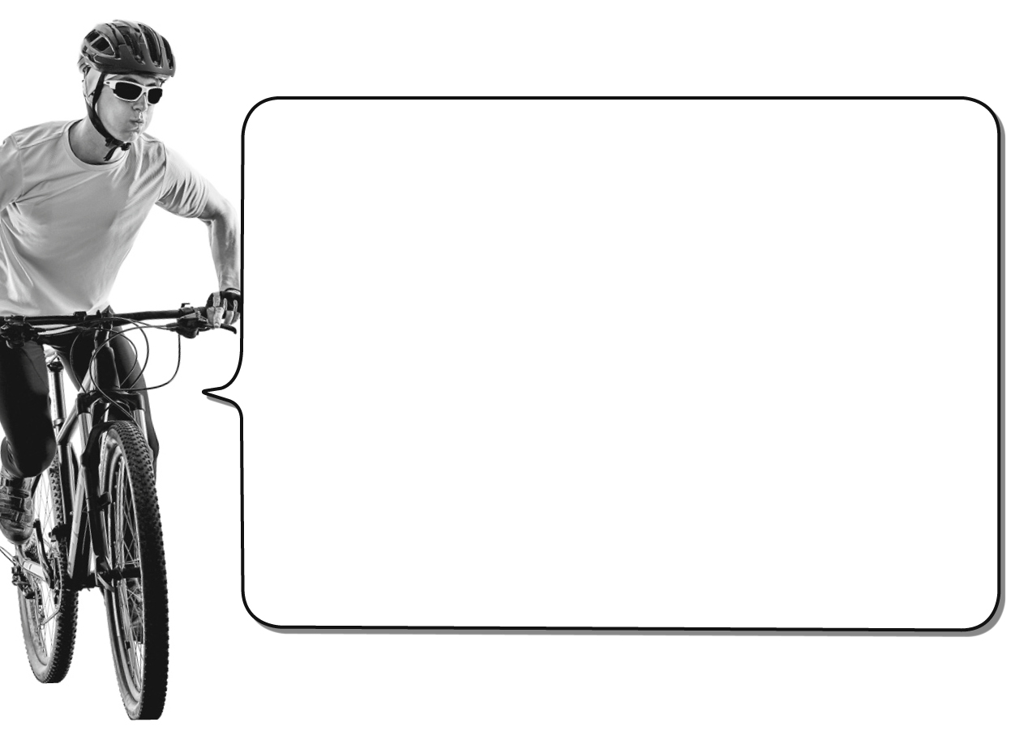
Hi! I’m Joey and I love riding my bike. Here are two tips to stay ^{1.} ............................................... on the road.
• Every year, many children ^{2.} ............................................... themselves riding a bike and some must go to hospital. You can ^{3.} ............................................... this by riding on bike paths and not on the roads.
• It is ^{4.} ............................................... to cycle at night because it’s dark. Many ^{5.} ............................................... happen because drivers can’t see cyclists. Put reflectors on your bike so drivers can see you.
grammar
4 What didn’t Harry do yesterday? Look at the pictures and write sentences. Use the phrases below and the Past Simple negative.
take the train  tidy his room  study for the test  answer his phone
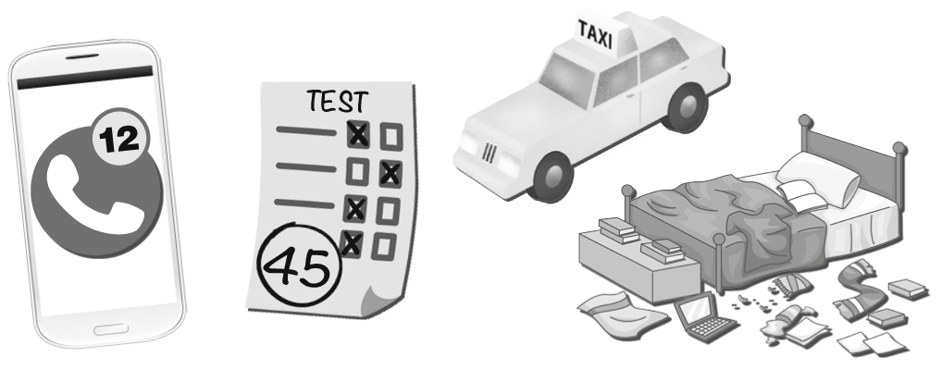
1
2
3
4
1
2
3
5 Rewrite the sentences using the words in brackets and the Past Simple negative.
1 I studied Chinese last year. (French)

2 Kevin fell in the park. (at home)

3 My aunt worked in a hospital. (school)

4 Sarah got hurt playing basketball. (football)

5 We had a car accident last week. (yesterday)

6 Complete the sentences with the verbs below. Use the Past Simple negative.
drive  go  break  hear  slip
1 My dad injured his leg, but he ................................................................... it.
2 The cleaner was careful, so he ................................................................... on the wet floor.
3 Tom ................................................................... to school yesterday because he was ill.
4 The child called for help, but his parents ................................................................... him.
5 Jenny rode in an ambulance. Her parents ................................................................... her to hospital.

VOCABULARY
1 Choose the correct answer.
1 At my school, the students must carry / rescue / stand up when the teacher comes in.
2 Rachel gave up / won / held and received a medal.
3 I trained / forgot / competed the winner’s name.
4 Simon arrived / lay down / lost just before the race started.
2 Match A to B. Pay attention to the words in bold.
A
1 Dad carried a bottle of water with him.
2 Tanya trained for the tennis competition.
3 The race was difficult, but he didn’t give up.
4 Ted’s mum got lost.
5 Tom rescued our dog, Sally, from the fire.
B
..... a He finally finished after four hours.
..... b Luckily, they are both safe now.
..... c She practised every day.
..... d She didn’t know how to get home.
..... e He stopped to drink several times.
3 Choose the correct answer to show you understand the words in bold.
1 You can lie down … .
a in bed b on a chair c in a cupboard
2 You can lose … .
a a celebration b a game c a party
3 You can hold … .
a a playground b a train c a first-aid kit
4 You can find your way … .
a in your room b out of a forest c in a tree
5 You can compete … .
a in the Olympic Games b in a department store c at a bus stop
3
grammar
4 Complete the questions with the verbs in brackets. Use the Past Simple. Then match them
to the correct answer.
1 When ............................................... women ............................................... (begin) running marathons in the Olympics?
2 ............................................... Jason ............................................... (win) the skateboarding competition last year?
3 ............................................... you ............................................... (get lost) in the forest?
4 Where ............................................... you ............................................... (ski) last winter?
5 What ............................................... you ............................................... (do) last weekend?
..... a No, I found my way.
..... b I trained for the marathon.
..... c in 1984
..... d Yes, he did!
..... e in the Alps
5 Write questions with the words below. Use the Past Simple. Then answer the questions so they
are true for you.
1 where / you / go to school / five years ago

2 you / compete / in a competition / last year

3 what / you / wear / yesterday

4 when / you / begin / studying English

6 Complete the text with the verbs in brackets. Use the correct form of the Past Simple.
James Boole is a skydiver and filmmaker. In 2009, he ^{1.} ................................................................... (fall) over 1,800 metres from the sky. He ^{2.} ................................................................... (not open) his parachute in time and he ^{3.} ................................................................... (travel) at
a speed of 160 km/h. Believe it or not, the fall ^{4.} ................................................................... (not kill) him, but Boole ^{5.} ................................................................... (have) several injuries. So, ^{6.} ............................................... Boole ............................................... (stop) skydiving? No. Twelve months later, he ^{7.} ................................................................... (jump) from the top of Mount Trento in Italy.

