1 The words below appear in the text in Exercise 2. Write the words in your own language.
You can use a dictionary.
1 brain .............................................. 3 guided ...............................................
2 remove ............................................... 4 awake ...............................................
2 Read the text about an unusual operation.
patient plays music during brain surgery
asked Fabbio to sing the tunes. The MRI machine scanned Fabbio’s brain and showed the areas reacting to the music. The doctors developed a 3-D map of his brain with the test results. This map guided the doctors and helped them control any damage.
Fabbio was awake during the operation. He sang the piano tunes again, and there was a music professor in the room to listen for any mistakes. As a final test, the doctors asked Fabbio to play a simple tune on the saxophone.
The operation succeeded, and Fabbio returned to a normal life. He is fit and healthy now, and he can enjoy music again.
Dan Fabbio teaches music and plays the saxophone. A few years ago, his ability to hear music suddenly changed. He no longer heard music in stereo, and orchestras and bands didn’t sound the same. Then doctors told him the news. There was a tumour in his brain and that was the cause of his problems. Luckily, the tumour was benign, so it wasn’t dangerous. But it was on the right side of his brain, in the part responsible for musical ability. Fabbio was very anxious because his career was in danger. It was important to remove the tumour, but the operation was dangerous, too.
For six months before the operation, doctors did tests on Fabbio’s brain. While Fabbio was in an MRI machine, they played recordings of piano music and
3 Complete the sentences according to the text. Use the affirmative or negative form of
there was or there were.
1 .............................................. a problem with Fabbio’s ears.
2 .............................................. any tumours on the left side of his brain.
3 .............................................. an orchestra in the operating room.
4 .............................................. pictures of Fabbio’s brain.
5 .............................................. only doctors in the room with Fabbio during the operation.
4 Write questions about the text with the words below. Then answer the questions.
Use the Past Simple.
1 how / Fabbio’s / musical ability / change

2 why / the tumour / cause / problems

3 what / Fabbio / sing / to the doctors

4 why / the doctors / develop / the map

5 what / the professor / do / during the operation

5 Write a paragraph about the events in the pictures. Use the Past Simple and there was / there were.
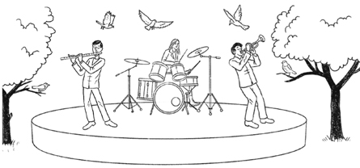
1
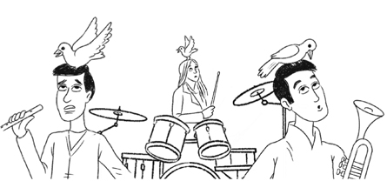
2
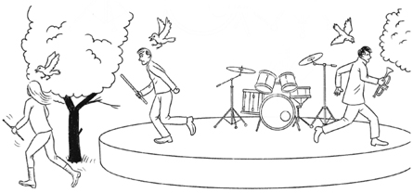
3

