VOCABULARY
1 Unscramble the words. Then write the words under the correct picture.
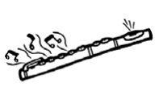
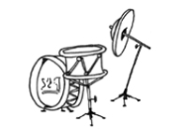
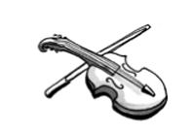
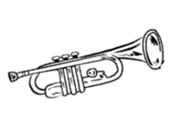


1 mruds
a
b
c
d
e
f
2 rmpttue
3 teufl
4 lecol
5 ralncite
6 iovlni
2 Complete the sentences with the words below.
video clips  orchestra  fan  studio  recording  performances
1 Tom plays the violin in a classical ............................................... . They give ............................................... all over the country.
2 Lauren is a ............................................... of Katy Perry. She loves watching her ............................................... on YouTube.
3 The singer was in the ............................................... for eight hours. He made a ............................................... of his new song.
3 Complete the e-mail with the words below.
tunes  lyrics  bands  songwriter  live concert  stage

Hi Ben,
I was at the annual Glastonbury Festival in England last week. Every year, rock and pop ^{1.} ............................................... participate in the festival. The best musicians in the world appear on ^{2.} ............................................... at Glastonbury. Coldplay
gave a ^{3.} ............................................... this year. I love Coldplay’s singer, Chris Martin. He helps write the ^{4.} ............................................... and ^{5.} ............................................... for most of Coldplay’s songs. I think
he’s a great ^{6.} ............................................... !
Jenny
grammar
4 Complete the sentences with the verbs in brackets. Use the Past Simple.
1 The audience ............................................... (love) my trumpet solo.
2 He ............................................... (write) his own songs for his album.
3 We ............................................... (not go) to the music club last week.
4 I ............................................... (not see) Ryan at the festival.
5 They ............................................... (buy) tickets online a week ago.
6 The band ............................................... (not give) a concert in Chicago yesterday.
5 Write questions about the Eurovision song contest. Use the Past Simple.
Then match the questions to the answers.

1when / the first / Eurovision contest / take place
.................................................................................................................................................
2how many points / the UK / give / ABBA / in the 1974 Eurovision contest
.................................................................................................................................................
.................................................................................................................................................
3ABBA / lose / the contest / that year
.................................................................................................................................................
4which country / Céline Dion / represent / in 1988
.................................................................................................................................................
5what song / Lulu / sing / in the 1969 Eurovision contest
.................................................................................................................................................
6how many times / Cliff Richard / participate / in the Eurovision contest
.................................................................................................................................................
..... anone
..... b1956
..... cSwitzerland
..... dBoom-Bang-A-Bang
..... etwice
..... fNo. They won.
6 Complete the text with the verbs in brackets. Use the Past Simple.
On 15th October 2014, the heavy metal band The Defiled ^{1.} ............................................... (give) a live concert
on a moving iceberg in the middle of the Greenland Sea. How ^{2.} ............................................... the band ............................................... (transport) their instruments and equipment to the iceberg? They ^{3.} ............................................... (fly) from
London to Iceland. Then, they ^{4.} ............................................... (sail) by boat. Local people ^{5.} ............................................... (help)
the band organise their equipment and get ready for the big event. The concert wasn’t like other concerts
by The Defiled. The audience ^{6.} ............................................... (not stand) in front of the band, and they ^{7.} ...............................................
(not dance) to their music. Instead, they ^{8.} ............................................... (sit) in boats around the iceberg. It was a very
unusual experience!
VOCABULARY
1 Circle the word that doesn’t belong.
1 respect: a teacher • the environment • a phone
2 develop: an idea • lunch • an app
3 decorate: a holiday • a house • a T-shirt
4 control: a class • an outfit • an aeroplane
5 admire: a friend • the time • clothes
2 Complete the sentences with the words below.
hang out  succeed  realised  refused  attract
1 That ugly hat will ............................................... too much attention.
2 The president ............................................... to answer the reporter’s question.
3 I’m sure Brenda will ............................................... in her new job.
4 In the summer, my friends and I like to ............................................... at the swimming pool.
5 Sue ............................................... it was late, so she left quickly.
3 Complete the words in the questions in A. Then match the questions to the answers in B.
A
1 What do you want to a ..... ..... ..... ..... ..... e in the future?
2 Do you r ..... ..... ..... ..... t buying your new phone?
3 How did the children b ..... ..... ..... ..... e at the museum?
4 Why do people g ..... ..... ..... a ..... ..... y old clothes?
B
..... a They were very good. They listened to the guide.
..... b They don’t want them any more.
..... c I would love to design a line of sports clothes.
..... d Yes, it was very expensive and I don’t really like it.
3
grammar
4 Write sentences about the concert. Use the correct form of there was / there were
and the words below.
a rock band  a violin player  guitar players  drums  fans on stage
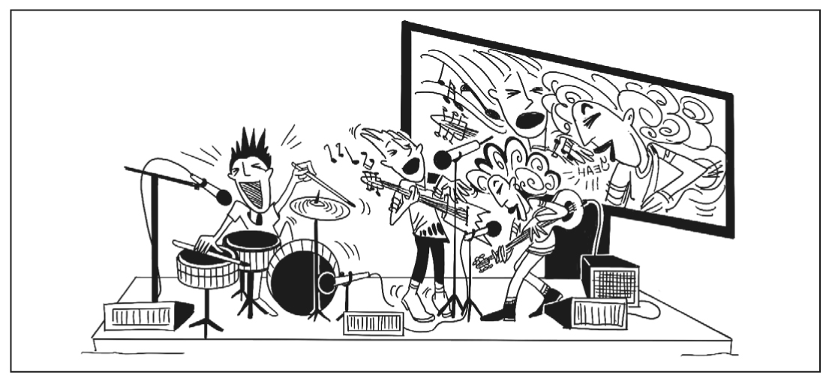
Last Saturday
1
2
3
4
5
5 Write questions with was there or were there. Then answer the questions about the
picture in Exercise 4.
1 ............................................... a screen near the stage?

2 ............................................... any microphones on stage?

3 ............................................... a dancer on stage?

4 How many musicians ............................................... in the band?

6 Complete the text. Use the correct form of there was / there were.
I went to a food festival yesterday. ^{1.} ............................................... many exhibits, but my favourite was an exhibit
called “Musical Cheese.” Some time ago, ^{2.} ............................................... an experiment in Switzerland. A cheese
maker and some researchers played music to blocks of cheese. ^{3.} ............................................... nine blocks of
Emmental cheese in the experiment. The researchers put each cheese in a different box. ^{4.} ...............................................
a machine in each box, and it played a song over and over again, 24 hours a day. ^{5.} ...............................................
a different song in each box. ^{6.} ............................................... classical tunes in one box, hip-hop in another, rock in
a third, and more. After six months, the researchers examined the cheeses. ^{7.} ............................................... any
difference between them? Yes – each kind of music affected the cheeses differently, and every cheese
had a unique flavour!

