VOCABULARY
1 Match pairs of letter groups to make words. Then write the words below the correct pictures.
cur  fri  coo  show  she  cup  so  ta
tains  er  If  dge  ble  board  fa  ker
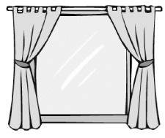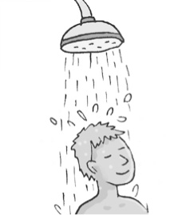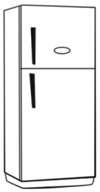
1
2
3
............................................... ............................................... ...............................................
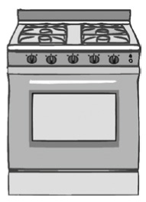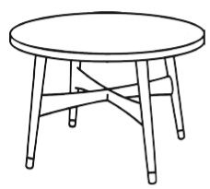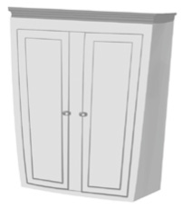
4
5
6
............................................... ............................................... ...............................................
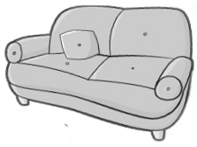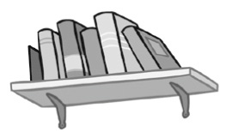
7
8
............................................... ...............................................
2 Complete the words.
1 an item to sleep in b...............................................
2 a room for cooking k...............................................
3 a room to sit with visitors l............................................... r...............................................
4 an item you put on the floor r...............................................
5 a place to keep a car g...............................................
6 a place with trees and flowers g...............................................
3 Complete the sentences with the words below.
bathroom  dining room  bedroom  chair  sink  toilets  flat  desk
1 There are dirty dishes in the ............................................... .
2 I keep my clothes in my ............................................... .
3 You can sit on that ............................................... .
4 My dad has got a computer on his ............................................... .
5 Jake is in the ............................................... . He’s having a shower.
6 We’re having a big meal in the ............................................... .
7 In public places, there are usually separate ............................................... for men and women.
8 Our ............................................... is on the sixth floor.
grammar
4 Complete the sentences about a typical house. Use the affirmative or negative form of
There is / There are.
1 ................................................................ usually a sink in the dining room.
2 ................................................................ sometimes a TV in the living room.
3 ................................................................ usually beds in the garden.
4 ................................................................ sometimes eggs in the fridge.
5 ................................................................ usually chairs in the toilet.
5 Write questions with the words below. Use the interrogative form of there is / there are.
Then answer the questions about a typical house.
1 usually / a cooker / in the dining room

2 usually / cupboards / in the kitchen

3 usually / a sofa / in the living room

4 usually / tables / in the toilet

6 Complete the text using the correct form of there is / there are.
In Hallam, Pennsylvania, ^{1.} ................................................................ a house in the shape of a shoe. Inside the house,
^{2.} ................................................................ three bedrooms, two bathrooms and a living room. ^{3.} ................................................................
also a kitchen. ^{4.} ................................................................ people living in the house? No, ^{5.} ................................................................ .
But the house is sometimes open for tours. ^{6.} ................................................................ an ice cream shop inside the
house, so visitors can eat, and ^{7.} ................................................................ a museum to teach people about the house’s
interesting history.

VOCABULARY
1 Match the words to the geographical features in the picture.
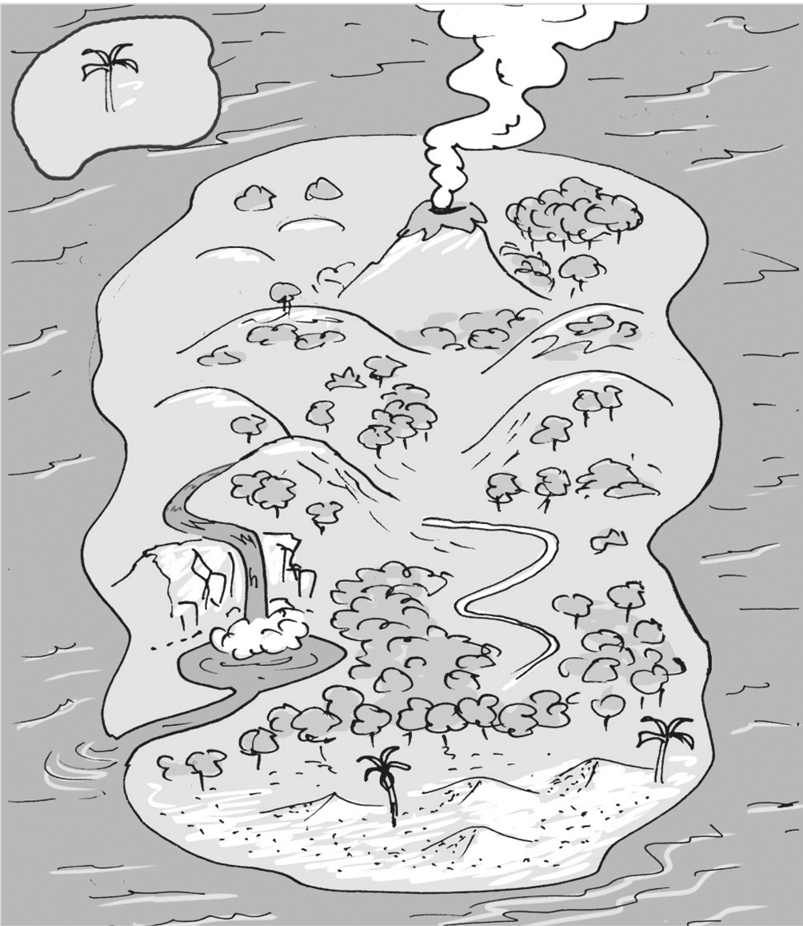
g
a
b
c
d
e
f
..... 1 sand dune ..... 5 valley
..... 2 beach ..... 6 waterfall
..... 3 island ..... 7 hill
..... 4 volcano
2 Circle seven geographical features. Then complete the sentences with the words from the puzzle.
r | k | m | o | u | n | t | a | i | n
i | l | g | c | c | l | i | f | h | i
v | a | h | e | l | a | r | o | o | e
e | l | h | a | i | o | u | r | m | v
r | a | v | n | d | e | s | e | r | t
f | k | l | u | f | o | s | s | u | m
v | e | l | c | o | a | s | t | k | e
1 The Pacific is an ............................................... .
2 There are some beautiful beaches along the ............................................... of California.
3 There are many trees in the ............................................... .
4 It takes five hours to walk up this ............................................... .
5 The Danube is a long ............................................... in Europe.
6 It is difficult to find water in the ............................................... .
7 A ............................................... is an area of water with land all around it.
grammar
3 Match A and B to make sentences.
A B
1 There aren’t any ..... a waterfall in this river.
2 There isn’t a ..... b islands in this lake.

3 Is there a ..... a parks near your house?
4 Are there any ..... b valley between the mountains?

5 There are some ..... a sand on this beach.
6 There isn’t any ..... b sand dunes in this desert.

7 Is there a ..... a house on that hill?
8 Is there an ..... b active volcano in your country?
4 Complete the sentences below using the correct form of there is / there are
or a, an, the, some or any.
1 ............................................... some hills in this park.
2 We haven’t got ............................................... lakes near our home.
3 Is there ............................................... hotel on that mountain?
4 I love swimming, but ............................................... a beach near my house.
5 This is a photo of ............................................... River Thames.
6 There are ............................................... beautiful towns in this valley.
7 There is ............................................... orange bird in that tree.
8 ............................................... any water in this desert?
5 Correct the mistakes in bold.
1 Are there some banana trees on this beach?

2 There is an beautiful island near the coast.

3 There are any forests in this area.

4 There aren’t a waterfalls in that park.

