Vocabulary
1 Which sports are the people doing in the picture? Match the sports to the people.
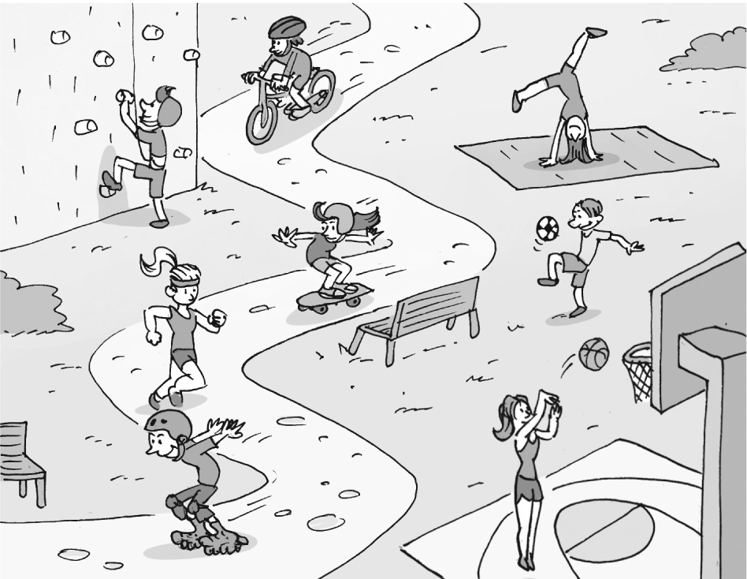
g
a
b
c
d
e
f
..... 1 football ..... 5 gymnastics
..... 2 running ..... 6 climbing
..... 3 cycling ..... 7 basketball
..... 4 skateboarding
2 Complete the sentences with the verbs below.
kick  hit  jump  throw  catch
1 In football, you ............................................... the ball with your feet.
2 My mother always says, “Don’t ............................................... on your bed!”
3 ............................................... the ball into the basket.
4 My dog can ............................................... a ball.
5 Don’t ............................................... the other players.
3 Complete the sentences with the words below.
cycling  skiing  swimming  snowboarding  dancing  judo  tennis
1 You hit a ball with a racquet in ............................................... .
2 My sister loves ............................................... . She studies ballet.
3 You go ............................................... in water.
4 ............................................... and ............................................... are winter sports. You do them on a mountain.
5 ............................................... is a type of martial art.
6 You ride a bike when you go ............................................... .
grammar
4 Complete the sentences with can or can’t.
1 A baby ............................................... walk.
2 A gymnast ............................................... usually jump high.
3 Young children ............................................... drive cars.
4 Cats ............................................... climb up trees.
5 Dolphins ............................................... live on land.
5 Complete the sentences with the adverb form of the adjectives in brackets.
1 Joe is a slow runner. He can’t run ............................................... (quick).
2 The boys love judo. They go ............................................... (happy) to judo lessons twice a week.
3 I travel 30 kilometres a day on my bike, so I can ride 20 kilometres ............................................... (easy).
4 I’m a terrible football player. I play really ............................................... (bad).
5 Our dog jumps over a two-metre wall. He can jump very ............................................... (high).
6 Pam sometimes walks 25 kilometres to the coast. She can walk ............................................... (far).
6 Write questions with the words below. Use can and the adverb form of the adjectives.
Then answer the questions so they are true for you.
1 your friends / play / basketball / good

..................................................................
2 your father / catch / a ball / easy

..................................................................
3 you / swim / fast

..................................................................
4 your best friend / throw / a ball / far

..................................................................
5 your mother / dance / beautiful

..................................................................

Vocabulary
1 Which items of clothing are missing? Match the words to the pictures.
1 shirt 3 socks 5 boots
2 coat 4 trainers
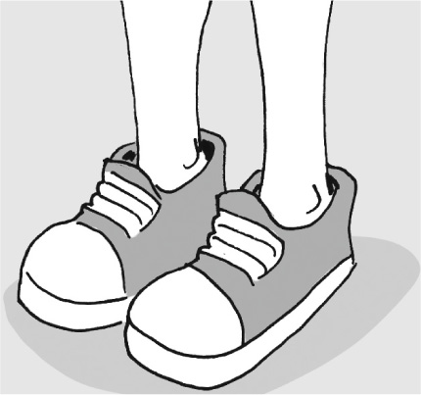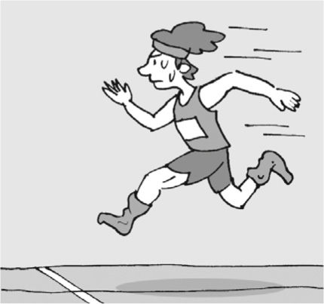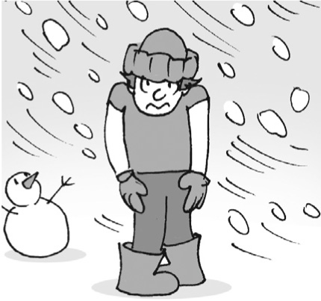
a
b
c
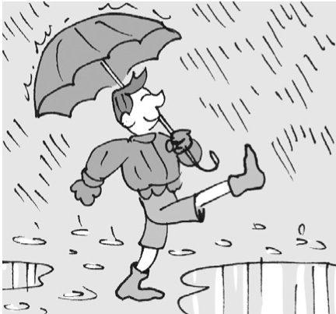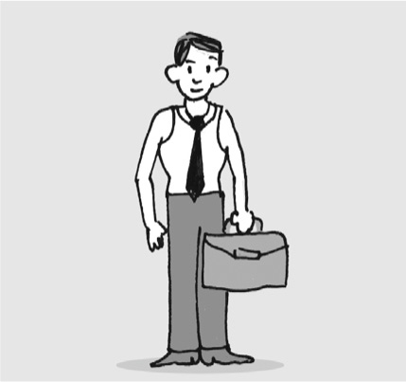
d
e
2 Choose the item that doesn’t belong in each category.
1 Items for feet: socks  shoes  dress
2 Items to keep legs warm: T-shirt  trousers  jeans
3 Winter clothes: jacket  shorts  coat
4 Summer clothes: sweater  sandals  swimsuit
3 Complete the sentences with the words below.
skirts  underwear  boots  sweater  swimsuit  hat
1 You wear a ............................................... on your head.
2 People usually wear a ............................................... to do water sports.
3 You can wear a ............................................... over a shirt.
4 People wear ............................................... under their clothes.
5 Girls sometimes wear ............................................... instead of trousers.
6 People wear ............................................... on their feet in wet or cold weather.
grammar
4 Complete the sentences with must or mustn’t.
1 You ............................................... take those jeans. They aren’t yours.
2 A dancer ............................................... buy special shoes.
3 People in Alaska ............................................... wear warm clothing in winter.
4 Don’t look! You ............................................... see my dress until this evening.
5 This school has got a uniform. Students ............................................... come to school in it every day.
6 You ............................................... register for the competition before Tuesday.
5 Read the rules for a fashion competition. Then complete the sentences with must, mustn’t
and the verbs in brackets.

COMPETITION: design and make clothes from plastic.
RULES:
Type of clothes: a dress or skirt
Materials: glue and plastic bags, such as shopping bags or rubbish bags – no other material
Closing date: register by 15th August
How to register: complete the registration form and send a picture of your dress or skirt
Other information: don’t copy any other design
1 Participants ............................................... (make) a dress or skirt.
2 Participants ............................................... (use) plastic bags.
3 Participants ............................................... (send) their forms after 15th August.
4 Participants ............................................... (include) a picture with their forms.
5 Participants ............................................... (copy) other people’s designs.
6 Complete the text with the verbs below and must or mustn’t.
let  fall  wear  learn  be
Athletes ^{1.} .................................................................. the rules of their sport before entering competitions. Here are some rules:
 Runners ^{2.} .................................................................. shirts during races. Clothes protect the runner’s body from the sun.
 Gymnasts ^{3.} .................................................................. people see their underwear. It ^{4.} .................................................................. the same
colour as their clothes.
 In tennis competitions, players can wear a hat, but it ^{5.} .................................................................. off their head.

