VOCABULARY
1 Complete the sentences about Jen’s life and match them to the correct pictures.
moved in  got a job  got divorced  fell in love  graduated
was born  got married
1 Jen ............................................... in 1987 in City Hospital.
2 Jen’s parents ............................................... ten years after that.
3 Jen studied history at university and ............................................... in 2009.
4 A year later, she ............................................... as a teacher in a school.
5 In 2012, Jen met Dave and they ...............................................
6 Jen and Dave ............................................... two years later.
7 In 2015, Jen and Dave bought a house and ...............................................
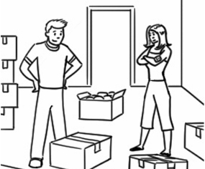
a
b
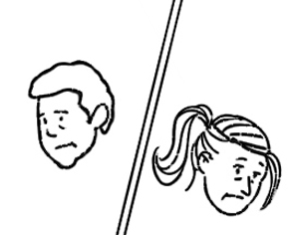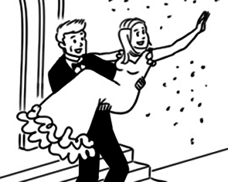
c
d
e
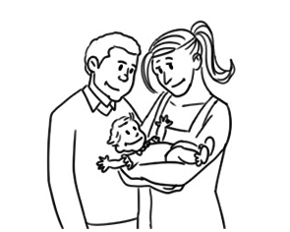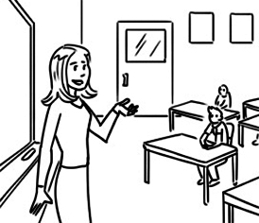
f
g
2 The words and phrases in bold are in the wrong sentences. Write them next to the correct sentences.
1 My parents grew up their 20th wedding anniversary yesterday. ...............................................
2 Ed and Lisa left school for two months before they got divorced. ...............................................
3 Joe and Rebecca were very sad when their grandfather had a baby last year. ...............................................
4 My sister celebrated last week, and now I’m an aunt! ...............................................
5 William died when he was 16 and now he is learning to be a mechanic. ...............................................
6 I separated in England, but now I live in France. ...............................................
grammar
3 Complete the sentences with can or can’t.
1 We ............................................... bake a cake now. I’ve got everything we need.
2 I ............................................... play tennis this week because my arm hurts.
3 Penny ............................................... move into her new house today. It isn’t ready.
4 Are you hungry? We ............................................... order pizza.
5 We ............................................... have a party at my house. My parents gave me permission.
4 Complete the sentences with the verbs below and could or couldn’t.
play  answer  see  go  get
1 I ................................................................. all the questions in the test last week. It was easy.
2 My sister ................................................................. a job easily. It took her a long time to find one.
3 Abby ................................................................. to school yesterday because she wasn’t well.
4 Sarah ................................................................. the piano when she was eight years old. She can still play now.
5 We ................................................................. the mountains yesterday because it was cloudy.
5 Write questions with can or could. Then answer them so they are true for you.
1 you / ride a bike / ten years ago

2 your father / play / the guitar

3 you / read / when you were four years old

4 your parents / drive / 20 years ago

5 your friends / speak / English / well

VOCABULARY
1 Match A to B to form sentences. Pay attention to the words in bold.
A
1 We could see footprints
2 There was a robbery
3 The woman went to prison
4 There weren’t any fingerprints
5 The security guards
6 He planned to murder
B
..... a for two years.
..... b another criminal.
..... c were standing at the entrance.
..... d at the First National Bank.
..... e in the snow.
..... f because they were wearing gloves.
2 Circle the words and use them to complete the sentences below.
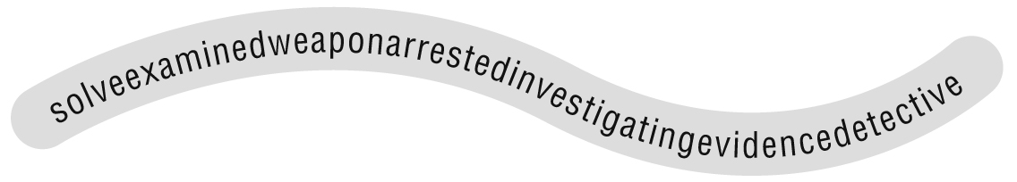
1 The woman used a knife as a ............................................... .
2 It took two years to ............................................... the crime.
3 The ............................................... is asking the people some questions.
4 The police ............................................... Mrs Sanders’ son yesterday.
5 The police looked for ............................................... in the house and in the garden.
6 Detectives are ............................................... the crime right now.
7 The police ............................................... the video of the robbery.
3 Complete the words in the sentences below. Then number the sentences in the correct order.
..... a The police c ..... ..... g ..... t the robbers.
..... b They s ..... ..... l ..... some expensive necklaces.
..... c Three c ..... ..... m ..... ..... ..... ..... s went into a jewellery shop.
..... d Two p ..... ..... i ..... ..... o ..... ..... ..... c ..... ..... s were near the shop.
3
grammar
4 Match A to B. Then complete the sentences with must or mustn’t.
A
1 I want to do well in the test.
2 The criminal murdered a man.
3 My meeting starts at 9.00.
4 Here is the weapon from the murder.
5 Stealing is a crime.
B
..... a I ............................................... be late.
..... b You ............................................... touch it. It’s evidence.
..... c I ............................................... study every day.
..... d We ............................................... take things from other people.
..... e The police ............................................... catch him.
5 Complete the sentences with the verbs below. Use should or shouldn’t.
speak  eat  go  watch  wear
1 I think the criminal ................................................................. to prison.
2 The students ................................................................. when the teacher is talking.
3 ............................................... we ............................................... this film? Is it good?
4 You ................................................................. those jeans. They look great on you.
5 You ................................................................. vegetables. They are healthy.
6 Choose the correct answer.
Detectives ^{1.} could / mustn’t / must solve crimes and catch criminals every day – that’s their job. But ^{2.} can / could / must ordinary people solve crimes, too? The answer is yes. To do this, they ^{3.} could / shouldn’t / should have good analytical skills. Detectives ^{4.} can’t / must / could speak to people during an investigation, so they ^{5.} could / can’t / should have good communication skills. One of the first private detectives in Victorian England was Ignatius Pollaky, a Hungarian immigrant. He had amazing skills and he ^{6.} can / must / could understand criminals’ minds. The police often asked Pollaky to help them. There were criminals from other countries living in England, but they ^{7.} shouldn’t / couldn’t / can’t speak English. Pollaky ^{8.} can / could / must speak six languages, so he helped the police talk to these people and solve crimes.

