VOCABULARY
1 Complete the words according to the pictures.
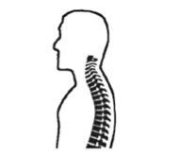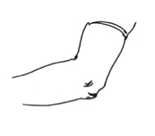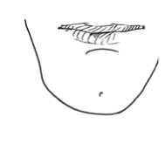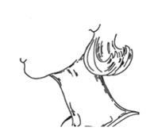
..... p ..... ..... e
1
..... l ..... o ....
2
..... ..... ..... n
3
..... ..... c .....
4
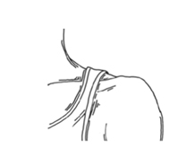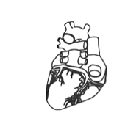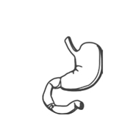
s ..... ..... u ..... ..... er
5
..... e ..... ..... t
6
..... t ..... ..... .....ch
7
2 Complete the sentences with the words below.
intestines  ankle  bones  brain  thumbs  ribs
1 There are 26 ............................................... in the human foot.
2 Your ............................................... help you process food.
3 Your ............................................... protect your lungs and heart.
4 Your ............................................... is between your foot and your leg.
5 Most primates have got fingers and ............................................... .
6 Your ............................................... is your body’s control centre.
3 Match the boys’ health problems in A to the effects in B. Pay attention to the words in bold.
A B
1 Larry broke his wrist. ..... a He can’t stand straight now.
2 Mike’s got a bad back. ..... b It hurts to put his left shoe on.
3 Dave has got a problem with his lungs. ..... c He can’t write.
4 Eric injured his knee. ..... d It’s difficult for him to breathe.
5 Andy broke his toe. ..... e He can’t bend his leg.
grammar
4 Complete the sentences with the correct form of can or could.
1 I hurt my arm yesterday. Now I ............................................... move it.
2 Ben was ill. He ............................................... go to school.
3 ............................................... you run 10 km in the past?
4 ............................................... you talk to me now?
5 Write a new sentence. Use should or shouldn’t and the words in brackets.
1 John has got bad teeth. (eat sweets)

2 You look tired. (go to sleep early)

3 I hurt my arm. (play tennis)

4 They need more exercise. (join a sports club)

6 Complete the sentences with must or mustn’t.
1 Racing car drivers wear helmets because they ............................................... protect their heads.
2 Children ............................................... carry heavy bags. It’s bad for their backs.
3 You ............................................... know English to get this job.
4 He ............................................... play in the street. It’s dangerous.
7 Choose the correct answer.
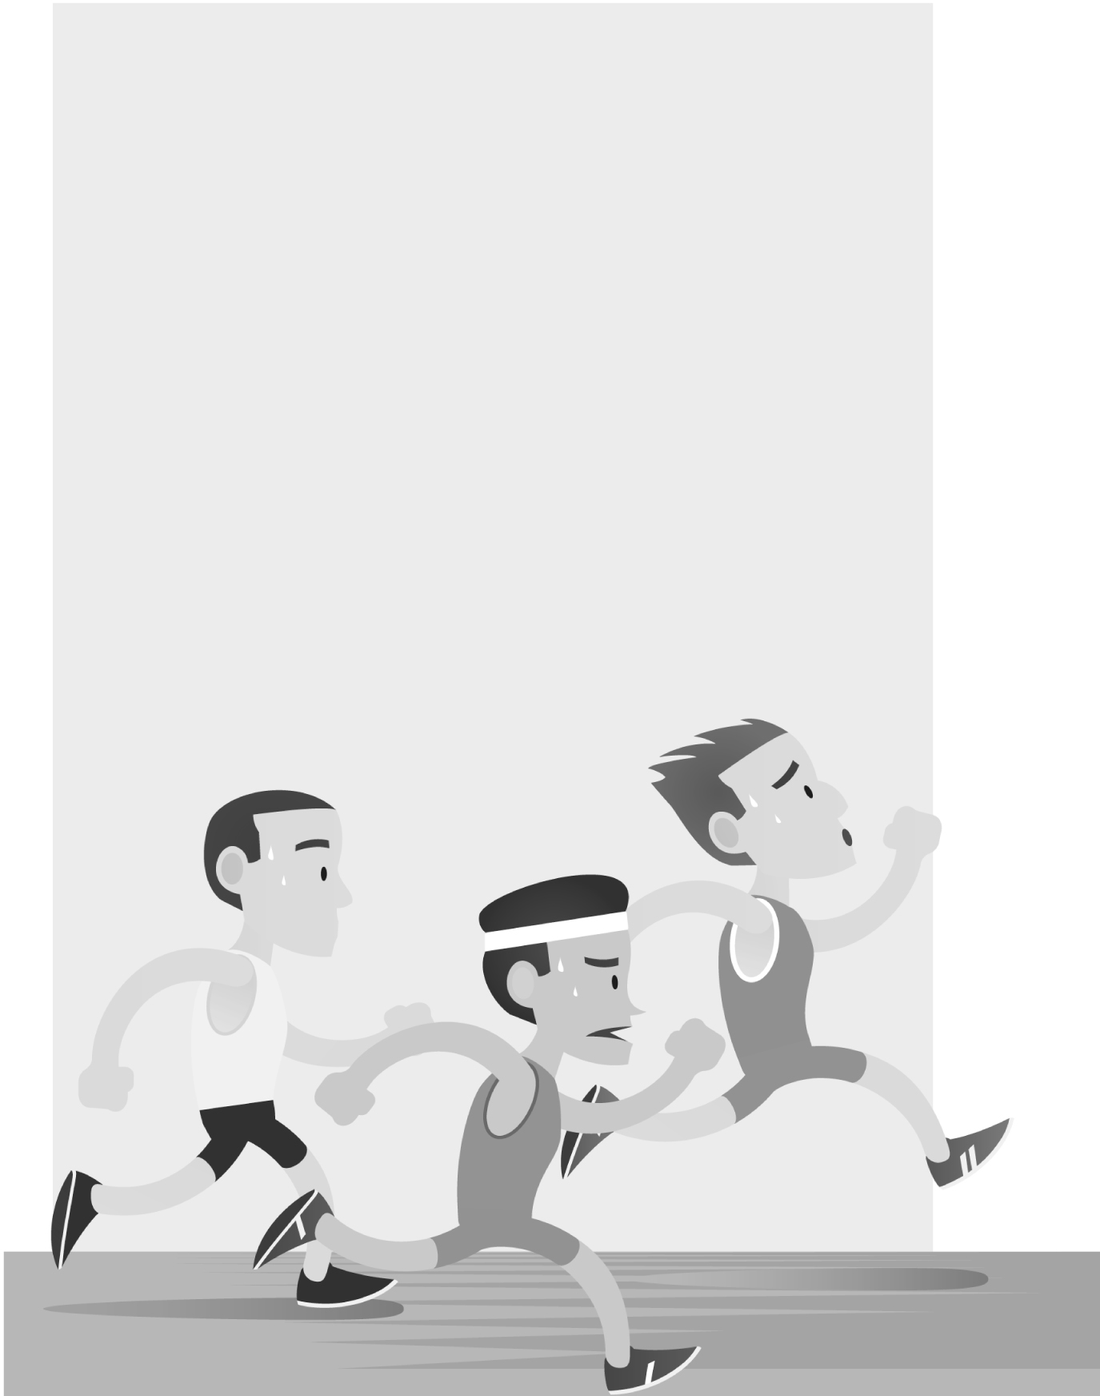
Most people ^{1.} can / can’t / must run a half-marathon
easily. It’s 21 kilometres and athletes ^{2.} mustn’t / must / can train for some time before an event. So imagine running a
half-marathon after a terrible accident. Dean Otto ^{3.} can’t / shouldn’t / couldn’t feel his legs after a car crashed into
his bike on 24th September, 2016. Most of the doctors
were pessimistic about his ability to walk again, but Dr Matt McGirt thought he ^{4.} couldn’t / could / shouldn’t help Otto,
so he operated on him. After the operation, Otto ^{5.} could / couldn’t / can move his toes, and soon he was walking and even running. While Otto was in hospital, Will Huffman, the driver of the car, visited him. It’s hard to believe, but Otto
and Huffman became friends. Thanks to Otto, Dr McGirt
and Huffman decided they ^{6.} must / mustn’t / should
start running. The three men completed a half-marathon
together on 24th September, 2017. They used the race to collect money for a spine injury
rehabilitation programme.
VOCABULARY
1 Choose the correct answer.
1 Hamburgers have got more minerals / vitamins / calories than apples.
2 Sour / Baked / Frozen potatoes are healthier than chips.
3 Pasta is usually cooked / fresh / raw after 8-12 minutes in boiling water.
4 Orange juice contains a lot of wholemeal / vitamins / carbohydrates.
5 Fried / Salty / Boiled vegetables are cooked in hot water.
2 Complete the sentences with the words below.
salty  fried  healthy  fresh  protein
1 People should eat ............................................... food with a lot of vitamins and minerals.
2 You should eat fish and meat for ............................................... .
3 ............................................... food with a lot of oil is unhealthy.
4 Sea water is ............................................... , so you can’t drink it.
5 It’s important to wash ............................................... fruit and vegetables before eating them.
3 Complete the sentences with suitable adjectives.
1 Ice cream is a f ..... ..... ..... ..... ..... food.
2 You mustn’t eat r ..... ..... chicken.
3 Lemons are very s ..... ..... ..... , but my sister loves them.
4 S ..... ..... ..... ..... drinks aren’t good for us because they contain a lot of sugar.
5 I love curry because I like s ..... ..... ..... ..... food.
3
grammar
4 Complete the sentences with the affirmative or negative form of have to.
1 My father ............................................... stop eating fast food because of his high cholesterol.
2 She ............................................... make any sandwiches. We’re having lunch at a restaurant.
3 I ............................................... bake a cake for the party. What cake should I make?
4 We ............................................... go shopping. We haven’t got any vegetables.
5 Students ............................................... bring lunch to school any more. There’s a cafeteria now.
5 Write questions with the words in the chart. Use the correct form of have to.
lions
Mum
you
the students
she
cook
be home
work
eat
study
by 11.00
for an exam
meat every day
the vegetables now
late today
1 ?
2 ?
3 ?
4 ?
5 ?
6 Choose the correct modal to complete the text.
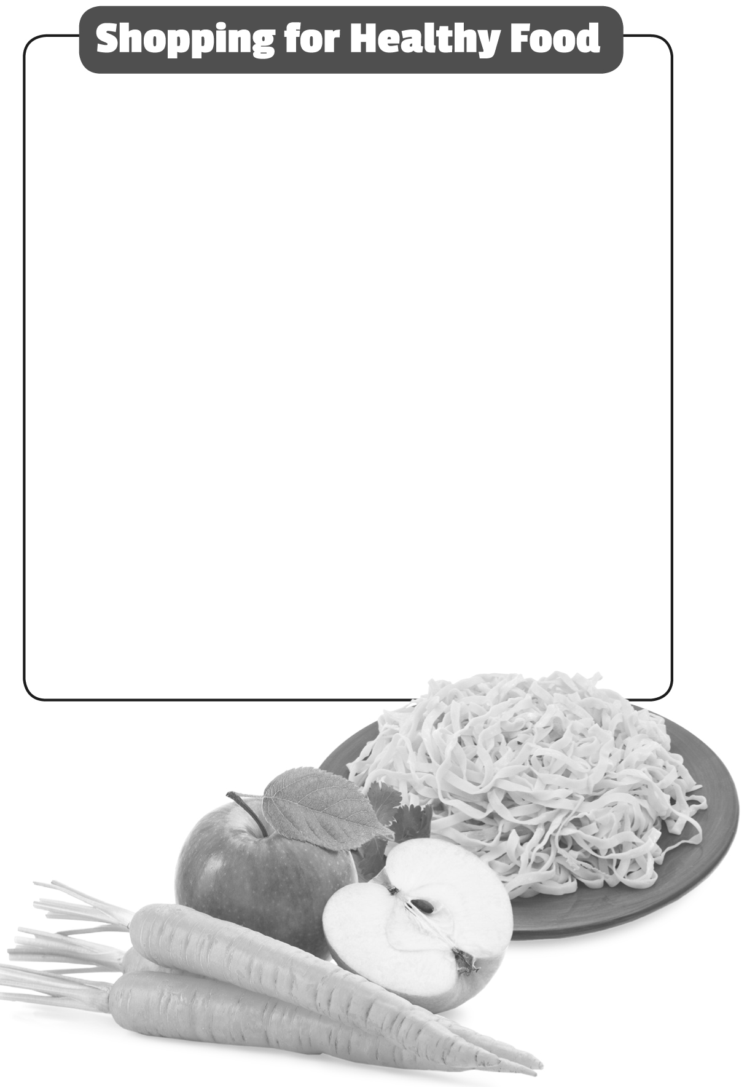
●Carbohydrates such as bread, pasta and rice give you
a lot of energy, so you ^{1.} don’t have to / shouldn’t /
can’t forget to buy some carbohydrates when you’re shopping for food. You ^{2.} can / must / have to get wholemeal bread and pasta at supermarkets, so you
^{3.} shouldn’t / mustn’t / don’t have to go to a special health food shop to buy these products.
●Read the information on food items. Companies
^{4.} have to / don’t have to / should give honest
information about their products, so you can check
how healthy they are.
●Variety is very important when shopping for healthy food. You ^{5.} should / must not / don’t have to buy the
same fruit and vegetables every week. Remember, everyone ^{6.} should / doesn’t have to / has to eat, but
you ^{7.} should / must / don’t have to enjoy your food,
too!

