Vocabulary
1 Complete the sentences describing the pictures with the words below.
rain  clouds  cold  lightning
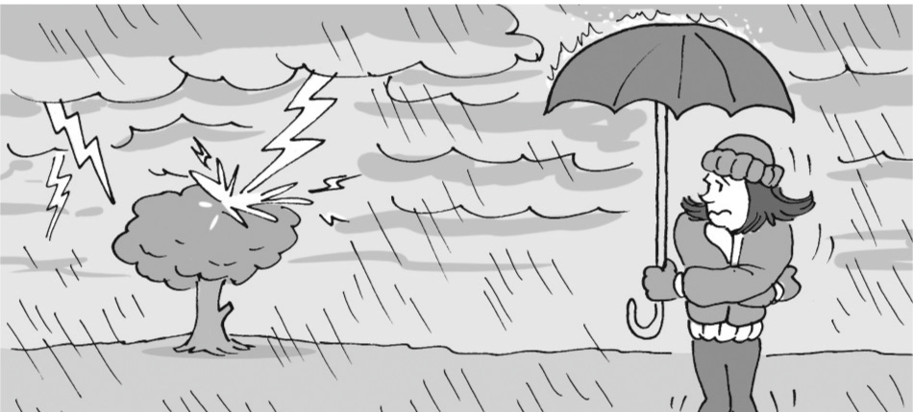
1 There are dark ............................................... in the sky.
2 ............................................... is hitting a tree.
3 The girl is ............................................... .
4 ............................................... is falling.
sun  dry  hot  wind

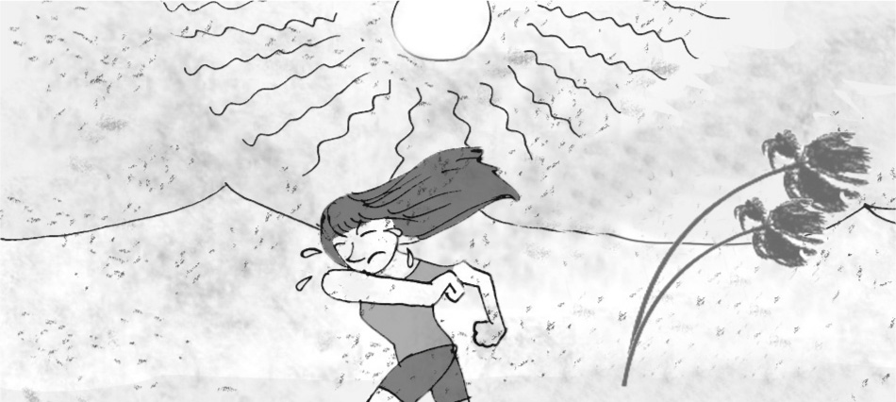
5 The girl is very ............................................... .
6 The ............................................... is high in the sky.
7 There’s a strong ............................................... .
8 There isn’t any water because the place is ............................................... .
2 Complete the sentences with the words below.
ice  fog  warm  wet  temperature
1 It’s 25°C today. It’s nice and ............................................... .
2 We measure ............................................... in Celsius.
3 Do you want some ............................................... in your cola?
4 I can’t see anything because there is ............................................... .
5 There’s water in my phone! It’s ............................................... .
3 Complete the words in the sentences.
1 In the winter, the trees are white with s ..... ..... w.
2 I saw lightning, but I didn’t hear the t ..... ..... ..... ..... ..... r.
3 Stay in the house. A s ..... ..... ..... m is starting.
4 It’s c ..... ..... l outside. It’s about 15°C.
grammar
4 Look at Katie’s Instagram pictures from last week and complete the sentences with was, were,
wasn’t and weren’t.
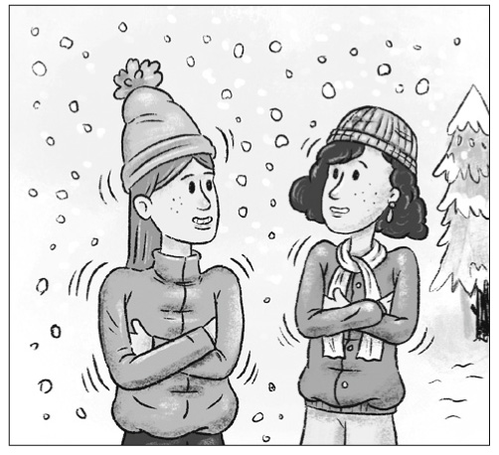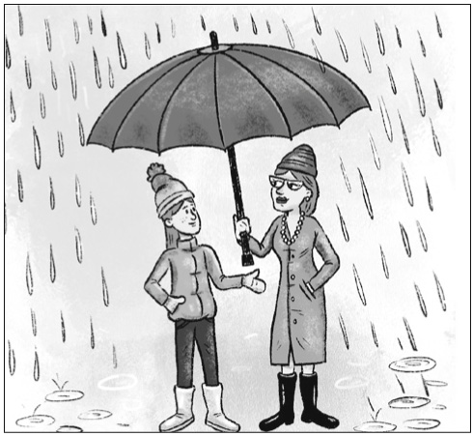
Monday
Tuesday
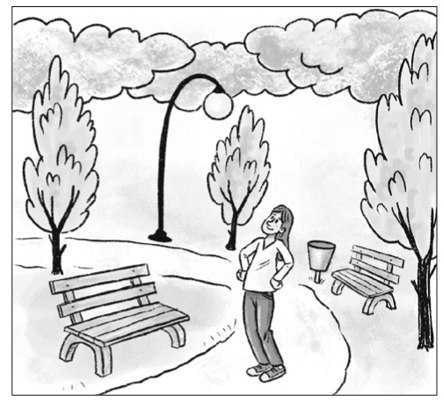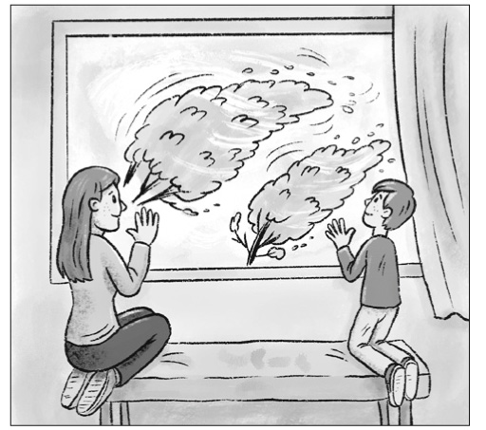
Wednesday
Thursday
1 Katie and her friend ............................................... cold on Monday. It ............................................... snowy.
2 It ............................................... rainy on Tuesday, but Katie and her mum ............................................... wet.
3 It ............................................... cloudy on Wednesday, but it ............................................... rainy.
Katie ............................................... in the park.
4 Katie and her brother ............................................... outside on Thursday. The weather ............................................... good.
It ............................................... a stormy day.
5 Complete the questions with Was or Were.
1 ............................................... it rainy yesterday?
2 ............................................... you and your friends at the park last weekend?
3 ............................................... you cold last night?
4 ............................................... your mother at home yesterday afternoon?
5 ............................................... it sunny last week?
6 Answer the questions in Exercise 5 so they are true for you.
1
2
3
4
5
6

Vocabulary
1 Complete the crossword.
Across
3 a dangerous fish
7 a colourful insect
9 a pink farm animal
10 a reptile without legs
Down
1 a big, orange, white and black cat
2 a bee is an example of this
4 a type of bird
5 a small amphibian
6 a big mammal in the ocean
8 king of the jungle
 |  |  |  |  |  | ¹
 |  |  | ²
 |  |  | ³
 | ⁴ |  |  |  | ⁵ |  |  |  |  | ⁶
⁷ |  |  |  |  |  |  | ⁸
 |  |  | ⁹
 |  |  |  |  |  | ¹⁰
2 Complete the sentences with the words below.
mice  spiders  sheep  elephants  cows  horses  rabbits  turtles
1 There are ............................................... on the beach. They’re returning to the ocean.
2 ............................................... live in Asia and Africa. They are enormous and are usually grey.
3 In westerns, cowboys ride on ............................................... .
4 ............................................... are very small mammals. People are often frightened of them.
5 Most ............................................... are small and have got long ears. They are popular pets.
6 ............................................... have got eight legs.
7 ............................................... and ............................................... usually live on farms.
grammar
3 Complete the sentences with the affirmative or negative form of There was or There were.
1 ................................................................. some ducks in the lake yesterday. They were white.
2 ................................................................. any rain last month, so the land is dry.
3 ................................................................. a beautiful bird in our garden a minute ago. It isn’t here now.
4 ................................................................. any pets in my mother’s house when she was young.
5 ................................................................. an old dog in the park this morning. It was black and white.
4 Sally’s grandfather was a farmer 50 years ago. She is asking him questions about his farm.
Complete her questions with Was there or Were there.
1 ................................................................. a tractor on the farm?
2 ................................................................. any dogs inside the house?
3 ................................................................. a horse on the farm?
4 ................................................................. any pigs on the farm?
5 ................................................................. any neighbours near your home?
5 Look at Sally’s grandfather’s picture. Then answer the questions in Exercise 4.
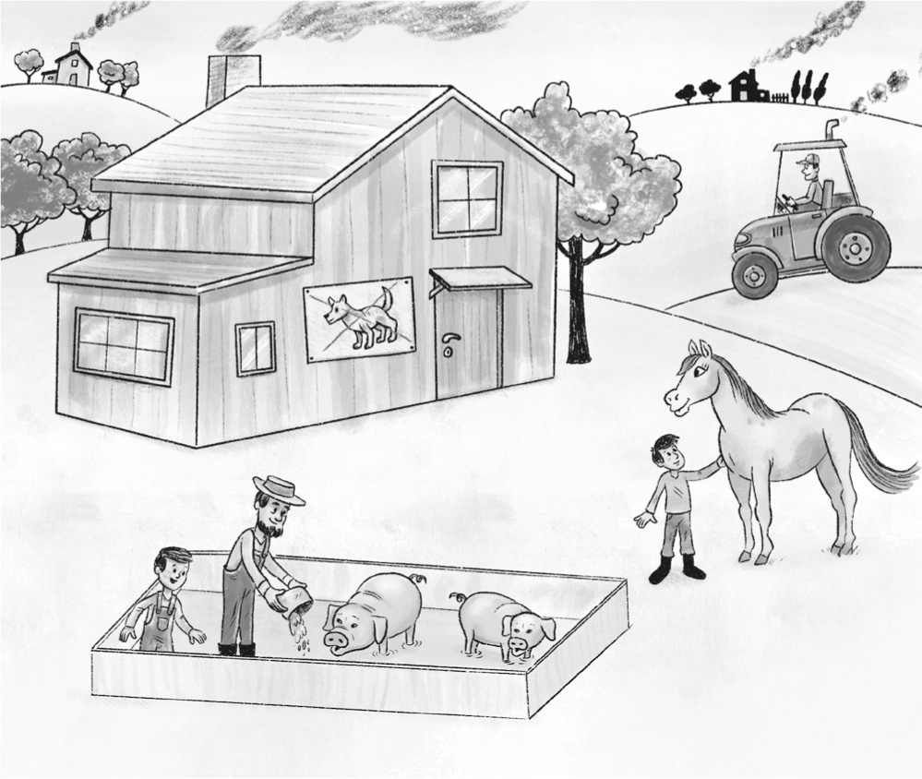
1
2
3
4
5

