VOCABULARY
1 Complete the descriptions of the pictures with the adjectives below.
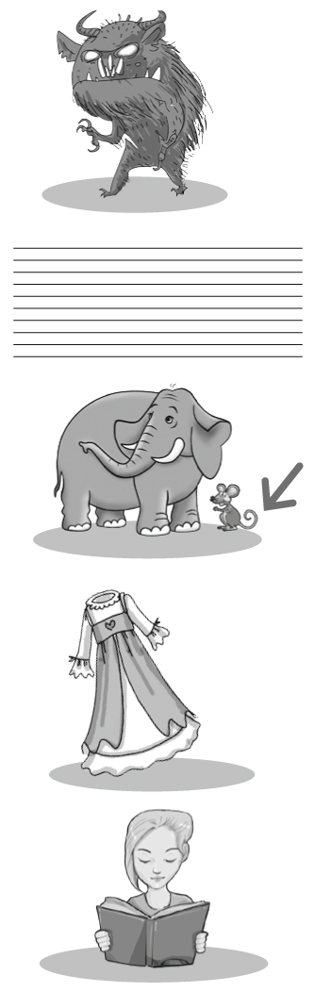
interesting  old-fashioned  tiny  frightening  thin
1 a ............................................... monster
2 a ............................................... black lines
3 a ............................................... mouse
4 an ............................................... dress
5 an ............................................... book
2 Match A to B. Pay attention to the adjectives in bold.
A
1 I loved the film.
2 There’s only one necklace like this in the world.
3 That dog is very big.
4 Don’t go to the new restaurant.
5 It’s hot today.
6 I can’t wear those shoes.
B
..... a It’s unique.
..... b My feet are very wide.
..... c It was wonderful!
..... d The temperature is above normal.
..... e It’s huge!
..... f We had a horrible meal there.
3 Complete the words in the sentences below.
1 Julia wore a p ..... ..... ..... ..... ..... dress to the party yesterday. She looked great.
2 The film was b ..... ..... ..... ..... ..... , so we left in the middle.
3 Jenny loves clothes and she always looks t ..... ..... ..... ..... ..... .
4 There are no m ..... ..... ..... ..... ..... buildings in the old part of town.
5 I’ve got thin hair, but my sister’s hair is t ..... ..... ..... ..... .
6 My mother doesn’t like driving on n ..... ..... ..... ..... ..... roads.
grammar
4 Write sentences with the words below. Use the comparative form of the adjective.
1 the pink dress / pretty / the green dress

2 a butterfly / beautiful / a bee

3 my mark / good / your mark

4 my sister / athletic / me

5 our house / big / our grandparents’ flat

5 Look at the pictures. Complete the sentences below with the comparative form of the adjectives
below.
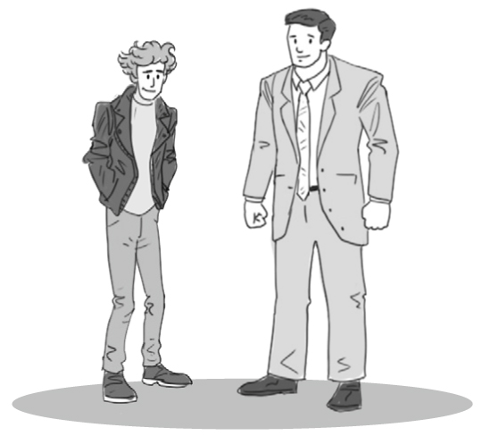
Luke
Pete
trendy  curly  tall  thin  old-fashioned
1 Pete is ................................................................................... Luke.
2 Luke is ................................................................................... Pete.
3 Luke’s hair is ................................................................................... Pete’s hair.
4 Pete’s clothes are ................................................................................... Luke’s.
5 Luke’s jacket is ................................................................................... Pete’s.
6 Rewrite the sentences with the words in brackets. Do not change the meaning of the original sentence.
1 My story is boring, but Ann’s story isn’t. (interesting)

2 William is hard-working, but Tom isn’t. (lazy)

3 Fred’s house is old, but Joe’s house is new. (modern)

4 Dan’s hair is blond and Bill’s hair is black. (dark)

5 Sammy is ten and Rick is 14. (young)

VOCABULARY
1 Choose the correct answer.
1 The music was very loud. It was too simple / slow / noisy.
2 Tom Cruise is a famous / hungry / difficult actor.
3 I’m worried / rude / careful about tomorrow’s exam.
4 I didn’t win the race. I was too calm / quick / slow.
5 Mum was lucky / angry / careful because I was late.
6 We were hungry / thirsty / nervous, so we had a big meal.
2 Complete the sentences with the words below.
careful  quick  calm  simple  rude  lucky  polite  nervous
1 Kate is a very ............................................... person. She doesn’t often get angry.
2 Be ............................................... when you cross the road.
3 Beth is ............................................... . She got a new phone for her birthday.
4 I’m ............................................... about my presentation because I don’t like public speaking.
5 It’s not nice to shout at someone. It’s very ............................................... .
6 Josh always says “please” and “thank you”. He’s very ............................................... .
7 We had a ............................................... meal because we didn’t have much time.
8 I can do this. It’s ............................................... .
3 Unscramble the words and complete the mini-dialogues.
1 A: How was the test yesterday?
B: It was very ............................................... (ffcudliti). I don’t think I did very well.
2 A: You look hot! Do you want a drink?
B: Yes, please. I’m ............................................... (yhtirst).
3 A: Are you walking home now?
B: No, my dad is coming because I’m ............................................... (fariad) to walk by myself at night.
4 A: Did you go to the beach today?
B: Yes, it was so ............................................... (tieuq). No one was there!
3
grammar
4 Choose the correct answer.
1 This apple is yours / ours / mine, but you can have it.
2 I haven’t got scissors. Can I use ours / yours / mine?
3 Kathy and I have got the same bag. These bags are ours / theirs / yours.
4 Dave likes crime books. I’m certain this book is hers / yours / his.
5 Milly doesn’t like cats. This cat isn’t ours / hers / mine.
6 Where do Dean and Elinor live? Is that house yours / his / theirs?
5 Complete the sentences with the correct possessive pronoun below.
mine  yours  his  hers  ours  theirs
1 This jacket isn’t Sarah’s. The blue one is ............................................... .
2 Barbara and Paul have got a small dog. That big dog isn’t ............................................... .
3 This is our house and the black car outside is ............................................... , too.
4 My brother rode his electric bike to school, so the bike in the garage isn’t ............................................... .
5 My jewellery is unique. That ordinary ring isn’t ............................................... .
6 Did you find your calculator? Is this ............................................... ?
6 Match A to B. Then complete the sentences with the correct possessive pronoun.
A
1 Is this your motorbike?
2 Where is Jenny’s house?
3 Has Simon got new sunglasses?
4 I didn’t bring my phone to school today.
5 My friends and I are very hungry.
6 Ben and Lara are walking in the park.
B
..... a It’s next to the park. The big, white one is ............................................... .
..... b Yes, those are ............................................... . They are very trendy!
..... c Those pizzas are ............................................... . We ordered them.
..... d No, it isn’t ............................................... . It’s my uncle’s.
..... e That huge dog with them is ............................................... .
..... f Can I use ............................................... ?

