VOCABULARY
1 Complete the puzzle according to the pictures.
Across Down
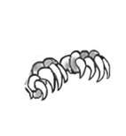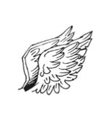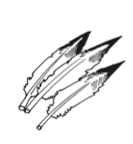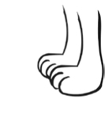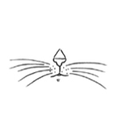
1
4
6
8
2
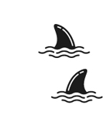

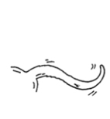
¹

²
³²
⁴
⁵
⁶
⁷
⁸
3
5
7
 | c |  |  | w
 |  |  |  |  |  |  |  |  |  | f
w
 |  |  |  |  |  |  |  | b
 |  |  | f |  |  | t
 | p
2 Write the words.
1 the hair of an animal f ..... .....
2 a part of the body used for flying w ..... ..... ..... .....
3 covers the body of a person or an animal s ..... ..... .....
4 covers a bird’s body f ..... ..... ..... ..... ..... ..... .....
5 a long, hard body part on the head of some animals h ..... ..... .....
3 Complete the animal facts with the words below.
poisonous  harmless  exotic  protected
species  invasive  endangered
Animal Facts
There are about 950,000 ............................................... of
insects on Earth.
There are only about 2,500 Bengal tigers in the wild,
so they are an ............................................... animal.
The whale shark is the world’s largest fish, but it only
eats small fish and it’s ............................................... to humans.
The grey squirrel is an ............................................... animal in England because it comes from the USA and it causes damage to the land.
The king cobra is the world’s longest and most
............................................... snake. One bite can kill a person in under 15 minutes.
It’s illegal to hurt or kill ............................................... animals. We must keep them safe.
Bearded dragons aren’t ordinary reptiles. They’re quite ............................................... , but people often keep them as pets.
1
2
3
4
5
6
7
grammar
4 Complete the sentences with the verbs below. Use will.
not exist  become  see  go
1 The rhino .................................................................. extinct soon.
2 In the future, many species .................................................................. in the wild.
3 I hope I .................................................................. on safari to Africa.
4 What animals ............................................... we ............................................... in the park?
5 Look at Ron and Glenda’s plans for their trip to Madagascar. Write three
affirmative and three negative sentences. Use be going to.
 | Ron | Glenda
volunteer at the lemur rescue centre | ✓ | ✓
visit Ranomafana National Park | x | ✓
take scuba diving lessons | ✓ | x
swim with whale sharks | x | x
1
2
3
4
5
6
6 Write the words in the correct order to form sentences. Use the Present Continuous with future meaning.
1 later today / you / what / do / ?

2 at the nature reserve / start / tomorrow / he / his job / .

3 they / what time / on Tuesday / leave / ?

4 tonight / not come / Colin / to the concert / .

7 Complete the sentences with the verbs in brackets. Use the Present Simple with future meaning.
1 Today, the park .................................................................. (not open) until 11.00 am.
2 When ............................................... the train ............................................... (arrive)?
3 The bus .................................................................. (leave) in an hour.
4 What time ............................................... the tour ............................................... (end)?
VOCABULARY
1 Choose the correct answer.
1 Cats make him bleed / sneeze. I think he’s allergic to their fur.
2 I’ve got a bad cold / tablet, so I’ll stay home today.
3 I’ve got a cough / an upset stomach. I think I ate something bad.
4 Luckily, my mum is in pain / recovering. She’s feeling better.
2 Complete the sentences with the words below.
bite  breathing problems  sting  sore throat
1 Dan is crying. He’s got a bee ............................................... on his leg.
2 When my allergies are bad, I have ............................................... .
3 You should drink tea with honey when you’ve got a ............................................... .
4 I’ve got a mosquito ............................................... on my face. It’s big and red.
3 What are the people saying? Complete the speech bubbles with the words above each.
tablet  gets worse  headache  in pain
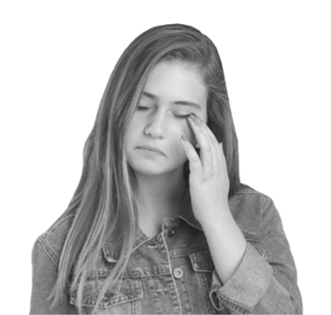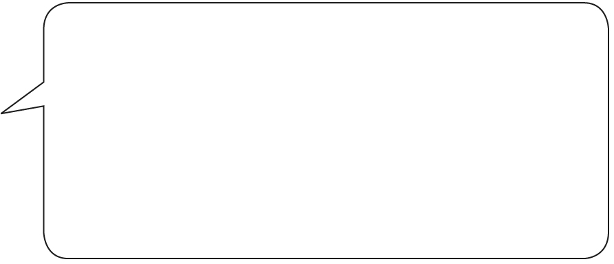
Sandy
I’ve got a terrible ^{1.} ............................................... .
The light is hurting my eyes and I’m really
^{2.} ...............................................! I took a
^{3.} ............................................... , so hopefully it will go
away soon. If it ^{4.} ............................................... , I’ll go to the doctor.
bandage  cut  bleeding
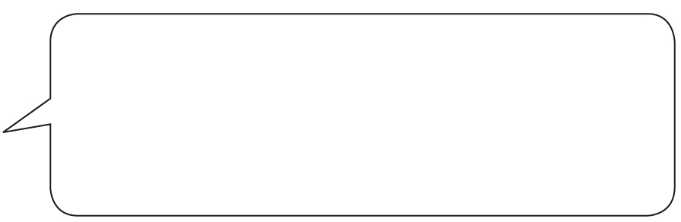
Ed
I’ve got a bad ^{5.} ............................................... on my leg
while I was playing football. It was
^{6.} ............................................... , so the coach put
a ^{7.} ............................................... on it.
get better  coughing  flu
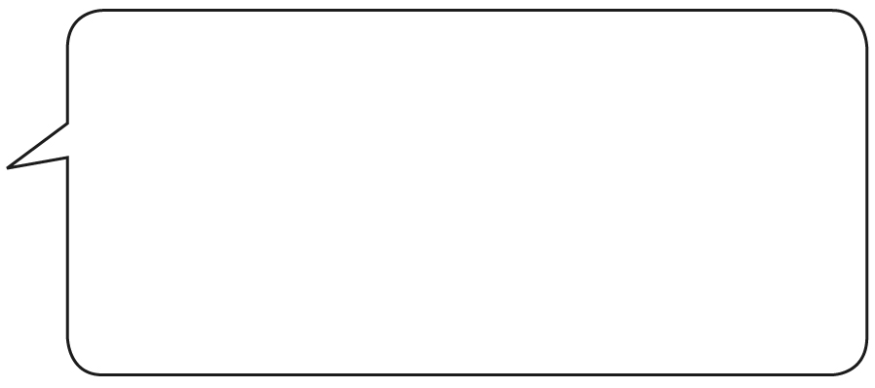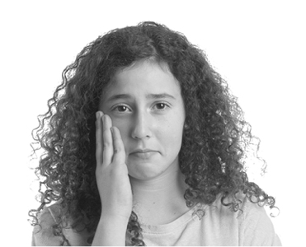
Diane
Last night, I couldn’t sleep because I was
^{8.} ............................................... all the time. This.
morning, I also had a high temperature.
I hope I haven’t got ^{9.} ............................................... .
If I don’t ^{10.} ............................................... by tomorrow, I’ll got to the doctor.
3
grammar
4 Complete the sentences. Use the First Conditional.
1 Your foot ................................................................. (be) fine if you ................................................................. (not walk) on it for three weeks.
2 If Mike ................................................................. (not make) an appointment, the doctor ................................................................. (not see) him.
3 I ................................................................. (take) a tablet if this tea ................................................................. (not help).
4 If Amy’s sore throat ................................................................. (not get) better, she ................................................................. (not go) on the trip.
5 Match A to B. Then complete the sentences with the verbs in brackets. Use the First Conditional.
A
1 Carl ............................................... (get) better
2 If you ............................................... (eat) more fruit and vegetables,
3 You ............................................... (infect) others
4 If Donna ............................................... (not rest),
B
..... a you ............................................... (be) healthier.
..... b she ............................................... (not recover).
..... c if he ............................................... (take) this medicine.
..... d if you ............................................... (sneeze) on them.
6 Complete the tips with the verbs in brackets. Use the First Conditional.
Coronaviruses (CoV) are a large family of viruses. They can be dangerous, but if you
^{1.} ................................................................ (follow) some basic steps, you ^{2.} ................................................................ (have)
a smaller chance of infection.
• Washing your hands is very important. If you ^{3.} ................................................................ (not wash) your
hands often or well, you ^{4.} ................................................................ (help) the virus spread. Put your hands under
water and then add soap. If you ^{5.} ................................................................ (count) to 20 while washing, the soap ^{6.} ................................................................ (have) time to kill the virus.
• You ^{7.} ................................................................ (prevent) infecting others if you ^{8.} ................................................................ (sneeze)
into a tissue or into your elbow.
• The coronavirus can spread from animals to people, so raw meat and eggs can be dangerous.
You ^{9.} ................................................................ (be) safer if you ^{10.} ................................................................ (not eat) raw
animal products.

