Vocabulary
1 Complete the adjectives.
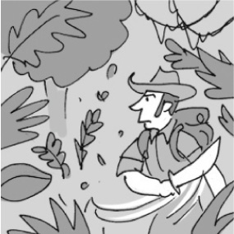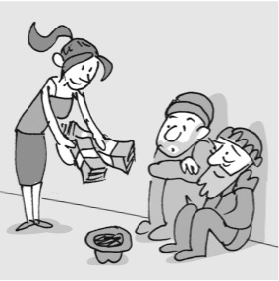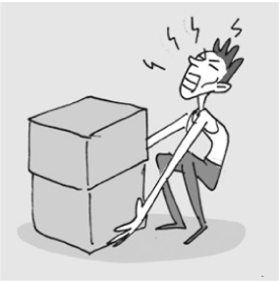
1
2
3
a ..... ..... ..... ..... ..... ..... ..... ..... ..... ..... g ..... ..... ..... ..... ..... ..... ..... w ..... ..... .....
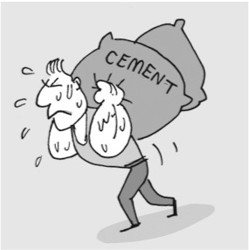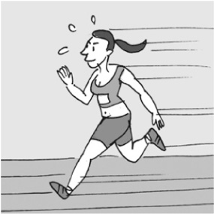
4
5
h ..... ..... ..... - w ..... ..... ..... ..... ..... ..... a ..... ..... ..... ..... ..... ..... .....
2 Write five sentences with the words below.

You must
be a / an
honest
brave
strong
creative
funny
person to
lift 100 kilograms.
appear in a comedy.
work in a bank.
rescue people from
a fire.
be an artist.
1
2
3
4
5
3 Circle the correct answer.
1 Everyone likes Carol. She’s very lazy / nice / shy.
2 Mark gets 100% in exams. He’s very clever / kind / athletic.
3 Rosie hates hard work. She’s brave / strong / lazy.
4 Mary talks to everyone. She’s very creative / friendly / honest.
5 Alice is really creative / shy / brave, so it’s hard for her to make new friends.
6 My uncle often helps us. He’s very weak / kind / funny.
7 Tom knows that he did well in the exam. He’s very weak / lazy / confident.
grammar
4 Write the Past Simple form of the verbs below.
1 stop ...............................................
2 practise ...............................................
3 watch ...............................................
4 try ...............................................
5 visit ...............................................
6 walk ...............................................
7 live ...............................................
8 plan ...............................................
5 Complete the sentences with the Past Simple form of the verbs in brackets.
1 The teacher ............................................... (ask) us some difficult questions yesterday.
2 We ............................................... (clean) the house last Saturday.
3 My father ............................................... (study) French for 10 years.
4 Our friends ............................................... (travel) to Africa last year.
5 I ............................................... (copy) the sentences into my notebook.
6 Bob ............................................... (cry) because he was sad.
7 I ............................................... (watch) a film on TV last night and I ............................................... (like) it.
8 Lucy ............................................... (stop) to help a sick dog. She ............................................... (carry) it to the vet.
6 Complete the text with the Past Simple form of the verbs in brackets.
A van was in an accident in Texas, USA, several years ago. Men from the local fire department ^{1.} ............................................... (arrive) at the scene. The driver of the van ^{2.} ............................................... (study) snakes and
there were 30 dangerous snakes in the van. The reptiles ^{3.} ............................................... (climb) out onto the road and they ^{4.} ............................................... (escape). First, the men ^{5.} ............................................... (help) the driver and his passenger. They ^{6.} ............................................... (wait) for an ambulance to arrive. Then, they ^{7.} ............................................... (start) to catch
the snakes.

Vocabulary
1 Unscramble the verbs in brackets to complete the sentences.
1 We must ............................................... (iudlb) stronger homes in the future.
2 Luckily, storms don’t usually ............................................... (tseyrdo) our homes.
3 After natural disasters, people sometimes ............................................... (eicever) help from the government.
4 That boy can’t swim. ............................................... (vaes) him!
5 We must ............................................... (totcrep) animals in danger.
2 Choose the correct answer.
1 The Olympic Games … in Greece about 2,700 years ago.
a destroyed c began
b protected
2 Leonardo da Vinci … a flying machine, but people never used it.
a became c happened
b invented
3 Larry Page and Sergey Brin … Google and it changed our lives forever.
a saved c received
b created
4 In 2016, five islands … under the Pacific Ocean. People never saw them again.
a began c disappeared
b ended
3 Complete the sentences with the words below.
become  end  fly  happen  discover
1 I want to travel the world and ............................................... new places.
2 We waited for the storm to ............................................... . Then, we went outside.
3 An earthquake can ............................................... anywhere in the world.
4 Supersonic aeroplanes ............................................... very fast.
5 Paul wants to ............................................... a famous artist.
grammar
4 Find eight verbs in the Past Simple form. Then complete the chart below with the verbs
from the puzzle.
b | w | w | b | u | i | l | t
f | e | r | e | g | a | v | e
l | l | c | o | n | w | b | t
e | z | m | a | t | t | l | p
w | k | d | l | m | e | y | b
r | o | d | e | f | e | l | l

Base form | Past Simple form
become | 1
build | 2
fall | 3
fly | 4
give | 5
go | 6
ride | 7
write | 8
5 Complete the sentences about famous people. Use verbs from Exercise 4 in the Past Simple form.
1 Billionaire Chuck Feeney ............................................... almost all his money to charity, and he lives a modest life.
2 In 2017, Mark Beaumont ............................................... a bike around the world.
3 The Wright brothers ............................................... the first aeroplane.
4 Margaret Thatcher ............................................... the first female Prime Minister of the UK.
6 Complete the text with the verbs in brackets. Use the Past Simple.
When Albert Einstein was very young, he wasn’t a good student and his teachers ^{1.} ............................................... (think)
he wasn’t clever. When he was 17, he ^{2.} ............................................... (begin) studying physics and maths at the Swiss
Institute of Technology. After that, he ^{3.} ............................................... (teach) physics at university. He ^{4.} ...............................................
(write) more than 300 articles, and in 1921, he ^{5.}............................................... (win) the Nobel Prize in physics.

