VOCABULARY
1 Find five verbs in the puzzle. Then complete the sentences with the verbs you found.
d | i | s | a | g | r | e | e | t
b | v | l | y | l | d | l | p | w
h | r | l | p | e | k | j | t | p
e | m | i | p | n | t | e | t | j
a | p | q | n | d | j | y | e | q
r | t | m | t | g | d | k | v | p
1 He’s speaking quietly. I can’t .............................................. him.
2 I .............................................. with Mike. I think he’s wrong.
3 I haven’t got a calculator. Can you .............................................. me yours?
4 Luke and his brother .............................................. a football to school every day.
5 People usually .............................................. their clothes in their bedroom.
2 Choose the correct answer to show you understand the words in bold.
1 You can collect plastic bottles / ice cream / mountains.
2 Jessica is sorry / nervous / happy because she finished her project.
3 My dad repaired my bike, so I need a new bike / can ride it / can’t ride it.
4 When you sell something, you get food / clothes / money.
5 You can donate pubs / laptops / planets.
3 Complete the sentences with the words below.
borrowed  volunteer  return  agreed  promise
1 Sally and Jane .............................................. to study for the test together.
2 I’m going to .............................................. the books to the library today.
3 Natalie didn’t have an atlas, so she .............................................. mine.
4 I .............................................. to be home by 8.00 pm.
5 I love animals, so I .............................................. at the animal shelter.
grammar
4 Complete the sentences with the verbs in brackets. Use be going to.
1 I .................................................................................... (borrow) my brother’s bike on Saturday morning.
2 Anna and I .................................................................................... (finish) our school project tomorrow morning.
3 ................................................................. Jane ................................................................. (collect) the clothes for the charity shop tomorrow afternoon?
4 Simon .................................................................................... (not play) tennis on Sunday.
5 ................................................................. Cathy and Tim ................................................................. (compete) in the London Marathon
next April?
5 Write sentences with the words below. Use be going to.
1 Kim / not drive / to the shopping centre / in an hour / .

2 I / do / my homework / this afternoon / .

3 Tom / volunteer / at the zoo / next week / ?

4 Jessica and Susan / see / a show / on Wednesday / .

5 you / repair / your bike / soon / ?

6 Complete the news report with the verbs in brackets. Use be going to.
It’s Volunteers’ Week next week and people around the UK ^{1.} ................................................................. (do) something to help
others. Which volunteer project ^{2.} .............................................. you ................................................................. (participate) in?
Gaby: My friend Jessica and I ^{3.} ................................................................. (not go) to school today because we ^{4.} ................................................................. (work) in the Oxfam charity shop. We ^{5.} ................................................................. (sell) things like
clothes, books and games.
Henry: My brother ^{6.} ................................................................. (work) in the RSPCA animal shelter. He ^{7.} ................................................................. (not bring) any animals home, but he ^{8.} ................................................................. (help) them at the shelter.
Sam: I ^{9.} ................................................................. (not volunteer) at the animal shelter because I’m allergic to animals, but
I ^{10.} ................................................................. (visit) people in hospital.

VOCABULARY
1 Choose the correct answer.
1 Please pick up / turn off / waste the rubbish from the ground.
2 I am going to reuse / turn on / clean up the lights because it’s dark in here.
3 You can damage / plant / recycle glass and plastic bottles.
4 More people should take public transport so we can throw out / reduce / preserve the number of cars
on the roads.
5 We can endanger / pollute / reuse these bags. Let’s take them with us to the supermarket.
2 Complete the mini-dialogues with the words below.
waste  turn off  pollute  plant
A: What can we do to save electricity?
B: We can ^{1.} .............................................. the TV when we leave our room so we don’t ^{2.} .............................................. electricity.
A: How do cars affect the environment?
B: Cars ^{3.} .............................................. the environment, so we should walk or cycle as much as possible.
A: Are they going to destroy this forest?
B: No, they are planning to ^{4.} .............................................. more trees here.
3 Complete the words in the sentences below.
1 The students volunteered to c ..... ..... ..... n u ..... the area.
2 Tornadoes often d ..... ..... ..... g ..... houses.
3 We must be careful not to e ..... ..... ..... ..... ..... ..... ..... the lives of the animals.
4 I’m going to t ..... ..... ..... w o ..... ..... these old paintbrushes.
5 It’s important to p ..... ..... s ..... ..... ..... ..... these historic buildings.
3
grammar
4 Complete the sentences with the words in brackets. Use the Present Continuous with future meaning.
1 It’s raining, so Matt and Luke ................................................................. (not plant) trees later.
2 Jenny and Rachel ................................................................. (see) a film this afternoon?
3 Jason isn’t feeling well, so he ................................................................. (not go) to school tomorrow.
4 I ................................................................. (have) dinner at a restaurant tonight.
5 We ................................................................. (move) to a new house this summer.
5 Write questions with the words below. Use the Present Continuous with future meaning.
Then look at the pictures and answer the questions.
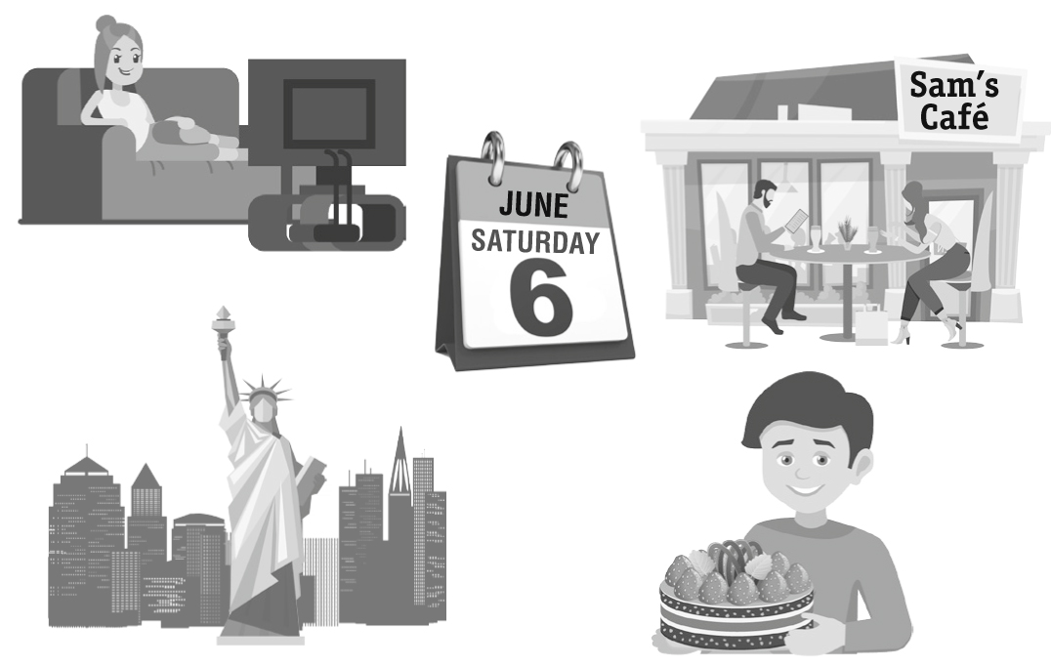
1
2
3
4
5
1 Emma / tidy / her room / this afternoon

2 when / Bob and his friends / clean up / the beach

3 where / Frank and Lucy / meet / tomorrow

4 Richard / travel / to London / next week

5 what / Dan / bring / to the party / tonight

