VOCABULARY
1 Choose the correct answer.
1 lead / overcome / share the group
2 search / notice / survive the dangerous journey
3 locate / sink / quit under the water
4 hide / encourage / dive the treasure
5 dream / organise / follow the leader of the group
2 Complete the sentences with the words below.
searched  encourage  notice  overcame
1 They didn’t .............................................. the lion behind the tree.
2 Did your parents .............................................. you to go to Paris?
3 We .............................................. many difficulties on the trek.
4 The boys .............................................. for a place to hide on the island.
3 Complete the blog entry with the words below.
located  shared  organised  diving  quit  dreamed
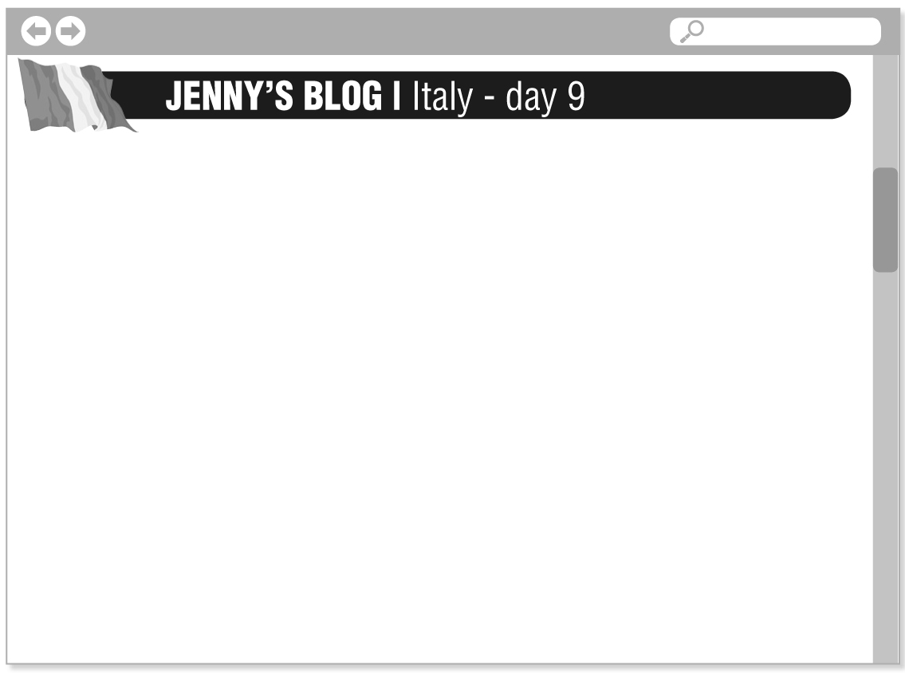
Our group leader, Tom, ^{1.} .............................................. a trip to Mount Etna today. Mount Etna is a famous volcano on the island
of Sicily in Italy. After arriving at Mount Etna, we ^{2.} .............................................. our guide, Gustavo. Then, we started climbing the mountain. It was cold and our feet hurt, but
we didn’t want to ^{3.} .............................................. ! After four hours of climbing, we finally reached the top of the mountain.
The views were amazing! At the end of the day, we sat together and ^{4.} .............................................. our experiences. In the past, I ^{5.} .............................................. about climbing a volcano and now
I’ve finally done it. I’m ready for my next adventure – ^{6.} .............................................. with sharks in Cape Town!
grammar
4 Write sentences with the words below. Use the Present Perfect Simple affirmative.
1 he / climb / the mountain

2 I / hear / the news

3 we / go / on safari / twice

4 the shark / see / the divers

5 Complete the sentences with the verbs below. Use the Present Perfect Simple.
not lead  write  organise  attack  not see
1 They aren’t taking pictures because they ................................................................. anything interesting.
2 I ................................................................. to the travel magazine. I am waiting for their answer.
3 A rhino ................................................................. some tourists. The rescue team is going there now.
4 Tom ................................................................. any jungle expeditions. He takes groups to the desert.
5 The adventurer ................................................................. his notes for the lecture.
6 Complete the questions with the verbs in brackets. Use the Present Perfect Simple. Then match the questions to the answers.
1 Where .............................................. they .............................................. (hide) the treasure?
2 .............................................. you .............................................. (dive) here?
3 How many people .............................................. the rescuers .............................................. (find)?
4 .............................................. she .............................................. (come) down the mountain?
5 .............................................. Sue and Mike .............................................. (be) to Costa Rica?
..... a No, they haven’t. ..... d In the garden.
..... b four ..... e Yes, I have.
..... c Yes, she has.
7 Complete the text with the verbs in brackets. Use the Present Perfect Simple.
^{1.} ............................................. you ............................................. (think) about a bike trip around the world? How about
extreme diving or mountain climbing? Many people dream about exciting activities. But some
people ^{2.} ............................................. actually ............................................. (do) these things.
Stig Avall Severinsen ^{3.} ................................................................. (be) a diver for a long time. But he doesn’t dive
in ordinary places. For example, he ^{4.} ................................................................. (dive) in freezing water – and
without any protective clothing!
Yuichiro Miura from Japan ^{5.} ................................................................. (climb) Mount Everest three times. On his third
trip, in 2013, he was eighty years old!
German cyclists Gil Bretschneider and Peer Schepanski ^{6.} ................................................................. (cycle) in amazing
places. They ^{7.} ............................................. (ride) on paths 7,211 metres above sea level and they’ve got the
record for the highest bike ride ever.
VOCABULARY
1 Complete the sentences with the words below.
find a ride  signpost  went backpacking  spend the night  sleeping bag
1 I can’t ................................................................. to the airport. Who can take me?
2 Last year, Ben ................................................................. in India.
3 Jane forgot to pack her ................................................................. for the trip.
4 I can’t read the ................................................................. . It’s in Chinese.
5 Mike drove home at 11.00 pm. He didn’t want to ................................................................. at our house.
2 Choose the correct answer to show you understand the meaning of the words in bold.
1 You can use a map / car to plan a route.
2 We took the easy trail. We walked on / near the path.
3 We need accommodation for two people. Have you got a room / restaurant at the hotel?
4 Let’s set out now. We don’t want to be bored / late.
3 Complete the camping tips with the phrases below.
Build a campfire  Put up a tent  Pack your bag  Find a campsite
1 ................................................................. . Take warm clothes.
2 ................................................................. . It can rain at night.
3 ................................................................. . You’ll need it to stay warm at night and to cook food.
4 ................................................................. . Choose a dry, flat location.
3
grammar
4 Choose the correct answer.
1 They have … returned from Ecuador.
a yet b ever c just
2 Have you bought your tickets … ?
a never b yet c ever
3 I have … hiked in the jungle.
a never b ever c yet
4 Has she … shown you her pictures?
a yet b never c ever
5 We have … read his book about Mount Everest.
a already b ever c yet
6 She has … started an adventurers’ club.
a yet b recently c ever
5 Complete the sentences with the verbs in brackets. Use the Present Perfect Simple. Then add information to make the sentences true for you.
1 I ................................................................. (not see) an adventure film since ................................................................. .
2 My family ................................................................. (live) in the same house for ................................................................. .
3 My friends and I ................................................................. (not meet) since ................................................................. .
4 My class ................................................................. (study) English for ................................................................. .
5 I ................................................................. (be) a student at this school since ................................................................. .
6 I ................................................................. (not go) swimming for ................................................................. .
6 Complete the text with the verbs in brackets. Use the Present Perfect Simple. Then choose the correct time expression.
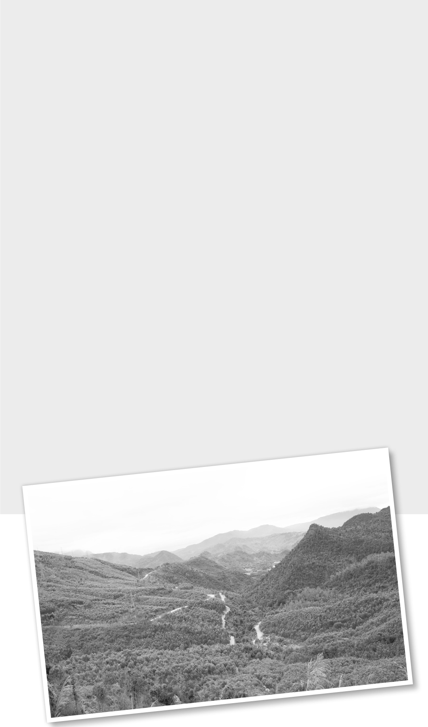
^{1.} ................................................................. you ever / yet
................................................................. (see) the film Blood Road?
I ^{2.} ................................................................ just / never
................................................................. (watch) it, and it was fantastic.
In the film, we learn about an adventure athlete called Rebecca Rusch. Rusch is an amazing woman, and she ^{3.} ................................................................ ever / never
................................................................. (be) afraid of a challenge.
She ^{4.} ................................................................ already / yet
................................................................. (break) many records as an adventure athlete and world-champion mountain biker,
and she ^{5.} ................................................................ (not stop) already / yet. Blood Road is the 1,900 km Ho Chi Minh Trail in Vietnam.
It has got a special meaning to Rusch. Her father was an
air force pilot and his plane crashed in Vietnam. Rusch ^{6.} ................................................................ (dream) of travelling Blood
Road and finding the site of her father’s crash for / since she was young. She ^{7.} ................................................................ (ride) bikes competitively for / since years, so she decided to make
the trip by bike. In the film, we follow Rebecca and
another cyclist on this amazing journey.

