Vocabulary
1 Match the words to the pictures below.
1 sunglasses 3 umbrella 5 jewellery
2 necklace 4 leggings 6 make-up
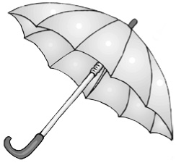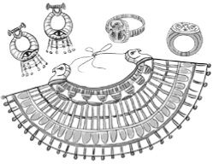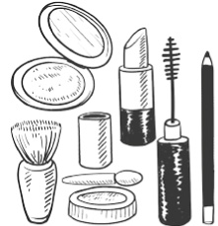
a
b
c
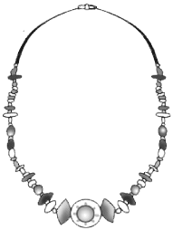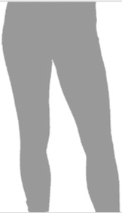
d
e
f
2 Circle two items that belong to each category.
1 Jewellery:
scarf  earrings  bracelet
2 Accessories for hands:
ring  gloves  suit
3 Accessories for the neck:
scarf  necklace  costume
4 Accessories on the head:
cap  hairband  handbag
5 Accessories for eyes:
suit  glasses  sunglasses
3 Complete the sentences with words from Exercise 2.
1 I’m going to wear a vampire ............................................... at the party.
2 My sister often wears a ............................................... around her neck to keep warm in winter.
3 My mother always keeps her money and her sunglasses in her ............................................... .
4 Bill can’t read small letters. He needs ............................................... .
5 I’m not going to buy that ............................................... . The jacket and trousers are both too small.
6 My father doesn’t always wear his wedding ............................................... on his finger.
grammar
4 Write sentences with the words below. Use be going to.
1 I / take / my umbrella / with me / tomorrow

2 my brother / not buy / new sunglasses

3 Jane / make / a Halloween costume / next month

4 we / give / our mother / a new bracelet

5 the boys / not wear / suits / this evening

5 Complete Anne’s blog with the verbs in brackets. Use be going to.
Tomorrow is 25th January and here in Scotland, we ^{1.} ................................................................ (celebrate) Burns Night.
On Burns Night, we remember the life of the poet Robert Burns. Tomorrow afternoon,
I ^{2.} ................................................................ (prepare) a meal for my friends and family. I ^{3.} ................................................................
(not make) an ordinary meal. We ^{4.} ................................................................ (have) traditional Scottish food. People wear Scottish clothes on Burns Night, so the boys ^{5.} ................................................................ (not wear) trousers at the celebration. They ^{6.} ................................................................ (come) to the event in kilts – Scottish skirts for men. Before the meal, my friend Claire ^{7.} ................................................................ (read) a poem by Burns. My brother plays the bagpipes – a Scottish musical instrument. After dinner, he ^{8.} ................................................................ (play) for us.
6 Write questions with the words below. Use be going to. Then answer the questions about
the blog in Exercise 5.
1 Anne / celebrate / the life of a singer / tomorrow / ?

2 what / they / eat / at the meal / ?

3 the boys / wear / trousers / ?

4 when / Anne’s brother / play music / ?

Vocabulary
1 Look at the pictures and find the words in the puzzle.
m | n | g | l | a | s | s | t | n | w | s
u | c | i | c | e | c | r | e | a | m | a
s | i | s | q | f | v | e | s | m | c | u
h | q | h | w | s | y | i | a | u | q | s
r | s | h | o | v | d | b | n | s | f | a
o | c | e | r | e | a | l | c | h | o | g
o | b | o | w | l | e | m | o | r | r | e
m | e | c | s | t | e | a | k | o | k | i
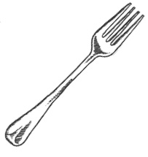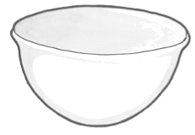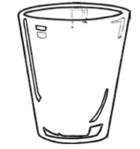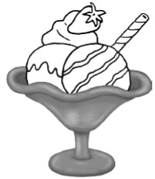
1
2
3
4

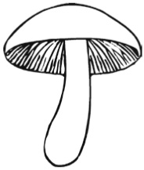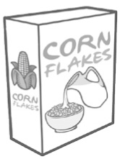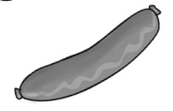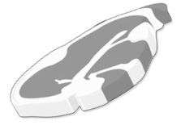
5
6
7
8
2 Choose the correct answer to show you know the meaning of the words in bold.
1 People put sauce on / clean their hands with / sit on a serviette.
2 We eat / make / drink fizzy drinks at parties.
3 You make toast from bread / egg / fruit.
4 You can cut cheese / drink water / eat ice cream with a knife.
5 People eat chips / steak / soup with a spoon.
3 Complete the sentences with the words below.
plate  pork  cup  beef  lamb
1 ............................................... is the meat of a young sheep.
2 People usually put their meal on a ............................................... .
3 ............................................... is the meat of a pig.
4 ............................................... is from a cow.
5 People drink coffee in a ............................................... .
grammar
4 Complete the sentences with the verbs in brackets. Use the Present Continuous
with future meaning.
1 The meal ................................................................. (begin) soon.
2 The chef ................................................................. (not bring) the dessert until later.
3 When ............................................... the guests ............................................... (go) home?
4 I ................................................................. (come) to your party next week.
5 ................................................ Ken ............................................... (cook) the meal tomorrow?
5 Write sentences with the words below. Use the Present Continuous with future meaning.
1 Pamela / leave / tomorrow morning / at 8.00 / .

2 my uncle / not come / for dinner / tonight / .

3 you / begin / your project / this afternoon / ?

4 Dean and Roy / fly / to Moscow / this evening / .

5 where / the students / go / next Tuesday / ?

6 Complete the questions with the verbs in brackets. Use the Present Continuous
with future meaning. Then match the questions and answers.
1 ............................................... you ............................................... (send) a birthday message to your cousin tomorrow?
2 ............................................... the girls ............................................... (get) dressed soon?
3 Where ............................................... Mark ............................................... (meet) his friends tonight?
4 ............................................... the party ............................................... (start) at 8.00?
5 When ............................................... the guests ............................................... (arrive) at your house?
..... a At the park. ..... d No, it isn’t.
..... b At 5.00. ..... e Yes, they are.
..... c Yes, I am.

