VOCABULARY
1 Unscramble the words to complete the sentences.
1 I can see the date and time at the bottom of my computer .............................................. (erecns).
2 Did you receive the .............................................. (eilf)? I sent it to you five minutes ago.
3 We couldn’t hear because the .............................................. (kpseears) weren’t working.
4 I must put paper in the .............................................. (rnitper).
5 Can you connect the .............................................. (rmoitno) to the computer?
2 The words in bold are in the wrong sentences. Write them next to the correct sentences.
1 There’s no Internet. I think there’s a problem with the memory card.
2 Alan always saves his work on his touchscreen. ..............................................
3 My phone’s mouse is full, so I’m deleting photos. ..............................................
4 You must move the external hard drive and click on the picture. ..............................................
5 Dave and Jack love playing their new Wi-Fi. ..............................................
6 In our classroom, there’s a whiteboard with a video game. ..............................................
3 Complete the puzzle with verbs according to the clues.
Across
1 The musicians are starting to … their album today.
4 We … information on our computers.
5 Can you … the documents to my computer?
Down
2 I’m learning to … with the help of this software.
3 How long will it take to … the software on the computer?
4 You can … music to your stereo system from your mobile phone.
 |  |  |  |  |  |  |  | ¹ |  | ²
 |  | ³
 |  |  |  |  |  | ⁴
⁵

 |  |  |  |  |  |  |  | r |  | c
 |  | i
 |  |  |  |  |  | s
t

grammar
4 Write sentences with the words below and the correct form of will.
1 we / have / flying cars / one day / .

2 more people / volunteer / in the future / ?

3 it / not rain / tomorrow / .

4 everyone / use / public transport / in 20 years’ time / ?

5 he / not lend / you / the money / .

6 I’m sure / they / help / us /.

5 Complete the predictions with the verbs below. Use the correct form of will.
use  clean  not drive  not buy  learn
1 Robots ................................................................. houses one day.
2 ............................................. all children ............................................. how to code one day?
3 They ................................................................. the new video game from this website. It’s cheaper in the shop.
4 People ................................................................. cars in the future.
5 ............................................. children ............................................. pencils and paper in school in the future?
6 Write questions with the words below. Then answer them according to your predictions.
1 where / people / live / in the future

2 how / children / get / to school / in 30 years

3 when / people / begin / travelling to Mars

4 what / people / eat in ten years

VOCABULARY
1 Fill in the missing letters. Then match the words to the pictures below.
1 h ..... i ..... ..... ..... y ..... r
2 h ..... ..... s ..... p ..... a ..... t
3 b ..... u s .....
4 t ..... o ..... ..... b r ..... ..... h
5 ..... i l ..... ..... w
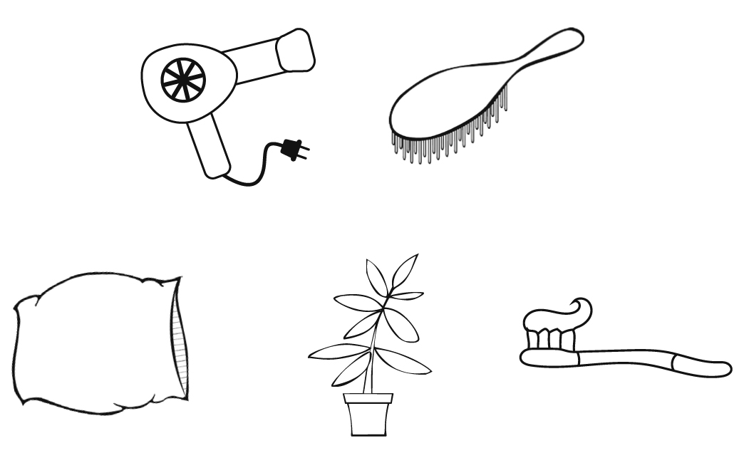
a
b
c
d
e
2 Choose the correct answer.
1 You use a rubbish bin / kettle / key to make tea.
2 You need a towel / houseplant / pillow after you have a shower.
3 You use the charger / air conditioner / hairdryer when it’s hot.
4 It’s dark in here. You should get a lamp / washing machine / soap for this room.
5 Don’t throw plastic bottles in the toothbrush / rubbish bin / brush. You can recycle them.
6 You need a key / lamp / charger for your mobile phone.
3 Unscramble the words below and match them to the clues.
tahototpse  hmopoas  irwvmcoae  yke  psao  wsigahn ahniecm
1 opens or locks a door .............................................
2 heats up food .............................................
3 washes hair .............................................
4 washes body .............................................
5 cleans teeth .............................................
6 cleans clothes .............................................
3
grammar
4 Complete the sentences with the verbs below. Use the First Conditional.
want  not give  put  not be  not use
1 I will be wet if I ................................................................. a towel.
2 If I want to throw out rubbish, I ................................................................. it in the rubbish bin.
3 If you ................................................................. the houseplant water, it will die.
4 If Ted ................................................................. to open the door, he will use his key.
5 The food ................................................................. hot if you don’t put it in the microwave.
5 Match A to B. Then complete the sentences with the verbs in brackets. Use the First Conditional.
A
1 If you ................................................................. (not bring) sandwiches,
2 You ................................................................. (sleep) well
3 If he ................................................................. (turn on) the air conditioner,
4 Jane ................................................................. (borrow) my hairdryer
5 If my brother ................................................................. (not get up) at 7.00 am,
B
..... a he won’t be hot.
..... b he will be late.
..... c if you have a good pillow.
..... d I’ll buy something at the cafeteria.
..... e if her hair gets wet.
6 Write sentences with the words below, adding commas when necessary. Use the First Conditional.
1 if / I / have / a shower / I / feel / better

2 if / you / not buy / shampoo / I / not wash / my hair

3 you / be / here / at 4.30 / if / you / leave / now

4 I / return / this dress / to the shop / if / you / not like / it

5 if / I / sleep / at my grandparents’ house / I / take / my / toothbrush

