VOCABULARY
1 Choose the correct answer.
1 The book was thrilling / awful / ordinary. I read it in one day!
2 Walt Disney transformed old poetry / fairy tales / poems into popular kids’ films.
3 The story Pandora’s Box is an ancient Greek journal / fiction / myth.
4 The cat in Dr Seuss’ The Cat in the Hat is an ordinary / imaginary / ancient character.
5 I loved the Harry Potter books. They were giant / suitable / incredible!
6 I read my poem / myth / legend to the class yesterday. I think they liked it.
7 We didn’t do anything special. It was just an ordinary / ancient / incredible day.
8 The recipes in my new cookbook were terrible! Everything I made was amusing / incredible / disgusting.
2 Circle eight words in the puzzle. Then use the words to complete the sentences below.
a | a | j | o | u | r | n | a | l
f | n | b | r | l | f | a | m | s
i | o | c | a | e | a | s | u | u
c | r | o | i | g | n | c | s | i
t | r | h | a | e | t | i | i | t
i | o | a | r | n | n | i | n | a
o | r | j | m | d | s | t | g | b
n | p | o | e | t | r | y | x | l
t | q | a | w | f | u | l | z | e
1 The book is .............................................. . It was written hundreds of years ago.
2 Is the .............................................. of King Arthur a true story?
3 I laughed when my friend told me that .............................................. joke.
4 The book Divergent is .............................................. . The story isn’t true.
5 is a form of literature. It expresses thoughts and feelings in a creative way.
6 Lucy writes in her .............................................. every night.
7 That isn’t a .............................................. book for a child. Buy something else.
8 I don’t like this story. I think it’s .............................................. !
grammar
3 Complete the sentences with the verbs in brackets. Use the Present Simple Passive.
1 The computer room ................................................................. (not use) on Tuesdays.
2 .............................................. these books .............................................. (recommend) for teenagers?
3 Mobile phones ................................................................. (not permit) in many schools.
4 .............................................. the new book .............................................. (sell) online?
5 Shakespeare’s work ................................................................. (study) by students around the world.
4 Complete the sentences to make them true. Use the affirmative or negative form of
the Present Simple Passive.
1 At Christmas, gifts ................................................................. (give).
2 Magazines ................................................................. (sell) at bakeries.
3 The name of the author ................................................................. ................................................................. (write) on the front of a book.
4 A description of the story .............................................. often .............................................. (print) on the back of a book.
5 Children .............................................. usually .............................................. (teach) to read at age three.
6 A best-selling book .............................................. often .............................................. (make) into a film.
5 Complete the text with the verbs in brackets. Use the Present Simple Passive.
The Sandcastle Empire is a thrilling action book by Kayla Olson. Eden is the main character and
the story ^{1.} .............................................. (tell) by her.
The story ^{2.} .............................................. (set) in the future after a big war. During the war, Eden’s family and
friends ^{3.} .............................................. (kill) by a powerful group called the Wolfpack. Her home
^{4.} .............................................. (destroy), too. Eden escapes, but she ^{5.} .............................................. (force) to work
for the Wolfpack. The prisoners ^{6.} .............................................. (not permit) to leave.
Now, it’s two years later. Only one place in the world ^{7.} .............................................. (not consider) dangerous –
Sanctuary Island. Eden runs away to Sanctuary Island. The people on the island want to fight
the Wolfpack. Eden is happy, but the question is: Is there more danger ahead?
VOCABULARY
1 Which topic is each sentence about? Match the topics to the sentences.
A Homeless People D Residential Areas
B The Mayor E Poverty
C A Traffic Jam
..... 1 Nearly half of the people in the world live on under £2 a day.
..... 2 In August, 2010, people spent five days in their cars on a motorway in China.
..... 3 Millions of people around the world live on the streets.
..... 4 Some parts of the city have got many homes but no shops.
..... 5 Hilmar Moore was the most important person in Richmond, Texas, for over 63 years!
2 Choose the correct answer to show you understand the words in bold.
1 In many cities, you often see graffiti on trees / walls.
2 When you improve something, it gets better / worse.
3 Poor / Rich people sometimes live in slums.
4 The city looks clean / dirty when there is litter on the ground.
3 Complete the mini-dialogues with the words above each. There are more words
than you need.
job opportunities  disadvantage  advantage
1 A: What is a big .............................................. of living in the city?
B: There are more .............................................. , so it’s a better place to work.

speed limit  motorway  traffic jam
2 A: How long does it take to drive to London on the .............................................. ?
B: It usually takes about 30 minutes, but don’t drive over the .............................................. .

open spaces  motorways  suburbs
3 A: Why do you prefer living in the .............................................. ?
B: Because there are more .............................................. than in the city, so it’s quieter.

disadvantage  advantage  crowded
4 A: What is the biggest .............................................. of living in the city?
B: Sometimes, it feels .............................................. because there are so many people.
3
grammar
4 Complete the sentences with the verbs below. Use the Past Simple Passive.
design  build  film  use  give
1 The Statue of Liberty ................................................................. to the US by France.
2 Replicas of famous cities ................................................................. in China.
3 The Sydney Opera House ................................................................. with the help of some of the first computers.
4 The steps in front of the Philadelphia Museum of Art ................................................................. by the actor Sylvester Stallone
in the film Rocky.
5 The trilogy The Hobbit ................................................................. in New Zealand.
5 Write sentences with the words below. Use the Past Simple Passive.
1 when / the Twin Towers / attack / ?

2 London / not establish / by the English / .

3 who / bury / in / the Great Pyramids of Ancient Egypt / ?

4 the ancient city of Troy / not locate / in Greece / .

5 the city of Damascus / build / 11,000 years ago / .

6 Complete the text with the verbs in brackets. Use the Past Simple Passive.
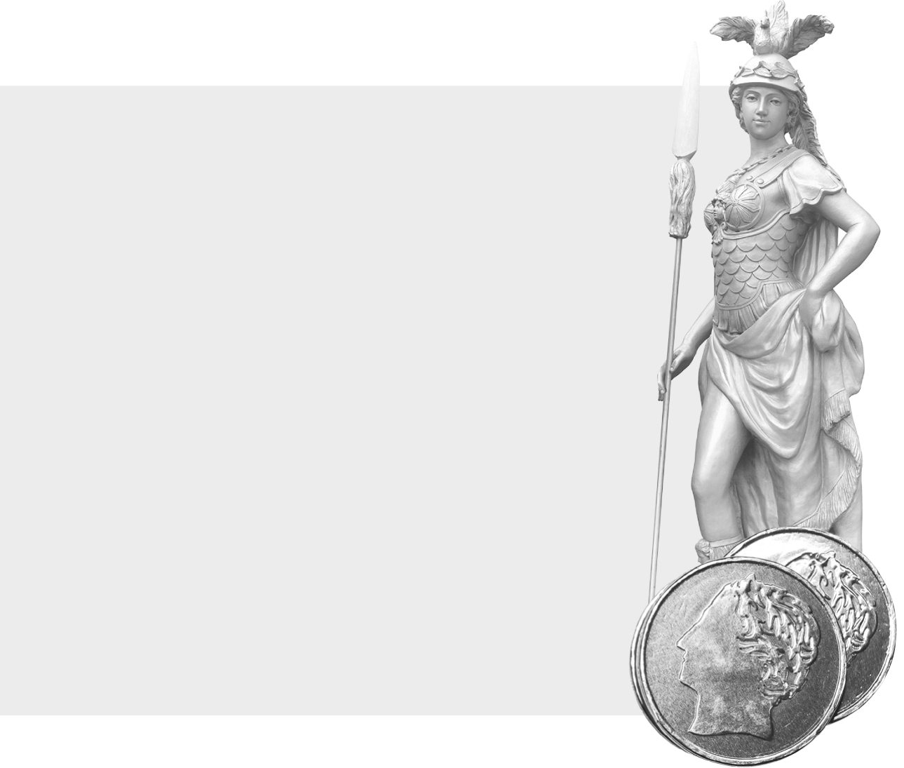
The Egyptian city of Heracleion ^{1.} ............................................. (describe) by the Greek writer Herodotus in the
5th-century BC. According to him, the city was a
great port and it ^{2.} ............................................. (know) for its
money and power. It ^{3.} ............................................. (visit) by
the most beautiful woman in the world, Helen of
Troy, and a thousand ships ^{4.} ............................................. (send)
to Heracleion with her. So why ^{5.} ............................................. Heracleion never ............................................. (discover)? For
many years, historians thought it was a fantasy. Then
some ancient items ^{6.} ............................................. (find) in the
ocean near the coast of Egypt. Statues, gold coins, buildings, 64 ships and many more items ^{7.} ............................................. (uncover). After thousands of
years, the existence of Heracleion ^{8.} ............................................. finally ............................................. (prove).

