1 Write questions with the words below. Use the Present Simple.
1. Sally / go / to the zoo / by bus

2. Sally and Max / give / food / to the animals

3. Sally / clean / the animal houses

4. Sally / like / her work

2 Read the e-mail below. Then answer the questions from Exercise 1. Use short answers.

Hi Jenny,
How are you? I’m fine. I’m at the zoo now. I work at the zoo twice a week after
school. Every Monday and Thursday, I go to the zoo at four o’clock in the afternoon.
I ride my bike because the zoo is near my house. I work with my friend Max.
We give food to the animals. The zoo has got 4,000 animals and they all want to
eat! Then, we clean the animal houses. I usually clean the gorilla house.
Sometimes I play with the baby gorillas. I love them!
My work is great, but it’s not easy. I go home at eight o’clock and I want to go
to sleep.
Sally
1. ………………………………
2. ………………………………
3. ………………………………
4. ………………………………
3 Complete the chart about Sally’s work at the zoo.
Days:
Start at:
Activities:
Goes home at:
4 Complete the chart with your activities.
Days:
Start at:
Activities:
Go home at:
5 Write an e-mail to your friend about your week. Use the Present Simple. Use the chart in Exercise 4 and the e-mail in Exercise 2 to help you.
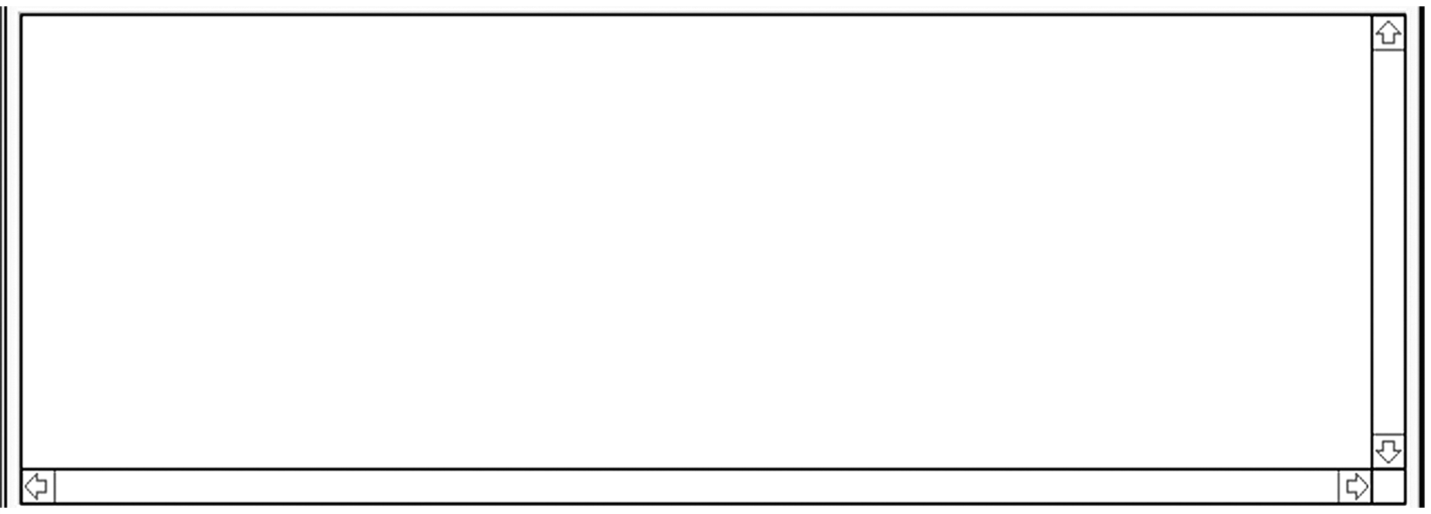
Hi ,

