1 Read the e-mail. Then tick () the sentences T (true) or F (false).
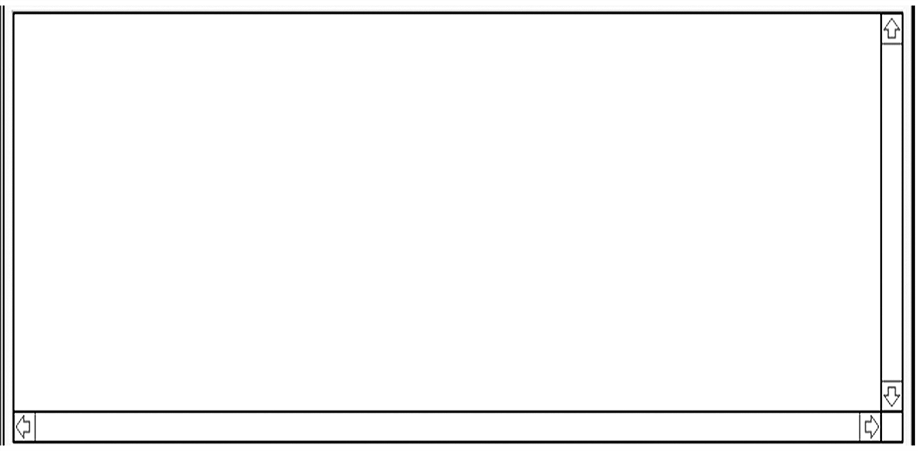
Dear Amy,
How are you? Right now, I’m sitting at a café with my family and I’m looking at the ocean. The water is blue and it’s beautiful. It’s the first day of my holiday. Our boat arrived at the island of Capri on Friday. First, we shopped for scarves and then we went to the beach. Tomorrow, we’re taking a boat to Naples. We’re going to be in Naples for one day. We’re going to eat their famous ice cream and we’re also going to go dancing at a disco.
On Monday, I’m taking a train to Rome. I’m staying with my friend María. She’s got a scooter and we’re going to see the city on her scooter. We’re planning to visit St Peter’s Church but we aren’t going to go to the Vatican Museum because it costs 13 euros! After four days in Rome, we’re taking a bus to Lake Como. We’re going to see the big houses and we’re going to walk in the beautiful gardens near the lake. This is going to be a fantastic holiday!
Amanda
T F
1. Capri is an island.
2. Amanda bought a dress in Capri.
3. She is going to stay in Naples for two days.
4. She is going to sleep in a hotel in Rome.
5. She isn’t going to visit the Vatican Museum.
2 Complete the chart according to the text.
Place | Day | Type of transport | Activities
Capri | Friday | boat | shopping, go to the beach
3 Amy is planning a holiday in the USA. Use the information in the fact file to write about her holiday plans.
Place | Day | Type of transport | Attractions
New York City | 5th July | aeroplane, train | Empire State Building, Statue of Liberty
Washington, DC | 10th July | bus | The White House, The Capitol
Orlando, Florida | 15th July | aeroplane, taxi | Disney World

