**Vocabulary**

**Fundraising ideas**

collect money- do a sponsored swim- have a barbecue -have a bring and buy sale- make a charity CD-organize a jumble sale- sell badges- sell cakes -sell raffle tickets -wash cars

**1 Circle the correct words.**

have / collect a bring and buy sale

1. sell / wash raffle tickets

2. bring / do a sponsored swim

3. organize / make a jumble sale

4. wash / make a charity CD

5. sell / eat badges

6. bring / collect money

7. bring / wash cars

8. have / sell a barbecue

9.sell / eat cakes

**2.Circle the correct fundraising ideas.**

**1. I’ve got lots of meat and I’m going to start the fire at six o’clock.**

collect money / have a barbecue

**2 It will take about half an hour. It will be lovely and clean when I finish.**

sell badges / wash cars

**3 It’s for children in Africa. Put it in the box, please. Thank you very much!**

have a bring and buy sale / collect money

**4 I’m paying her £1 for every 100 metres. So if she finishes, I have to give her £10.**

do a sponsored swim / organize a jumble sale

**5 They say SAVE THE RAINFOREST and they cost 20 pence. Can I put it on your jacket for you?**

sell raffle tickets / sell badges

**6 Tickets are £1 each and you have a chance to win one of these prizes: a weekend for two in Paris, a TV, or a meal for two.**

have a barbecue / sell raffle tickets

**7 We’re singing and our teacher is recording us.**

make a charity CD / collect money

**8 We’ve got chocolate or lemon. They all cost 50 pence.**

sell cakes / sell badges

**3. Match the pictures with the fundraising ideas in the box.**

collect money , have a barbecue, sell badges

sell cakes, sell raffle ticket , wash cars

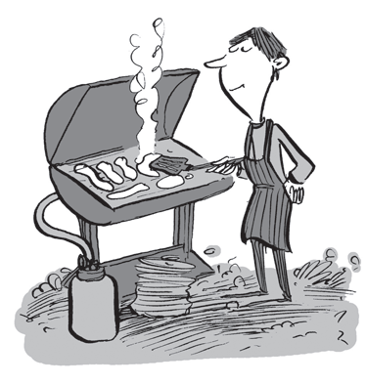

_a)__________________________b)___________________________c)_______________________

c)___________________________d)________________________e)_________________________