VOCABULARY

**Food**

**1. Find and write the names of 7 food items.**

|  |  |  |  |
| --- | --- | --- | --- |
| A | C | E | H |
| I | K | N | O |
| P | R | S | T |

C+H+I+K+E+N = CHICKEN

C _ _ _

C _ _ _ _ _

C _ _ _ _ _

C _ _ _ _

P _ _ _ _

P_ _

R _ _ _

**2. Complete the words.**

*Carrots are vegetables.*

1. Ch*_______* and m*_______* are dairy products.

©

MACMILLAN

EDUCATION

/ Photocopiable material

Where was the hotel?

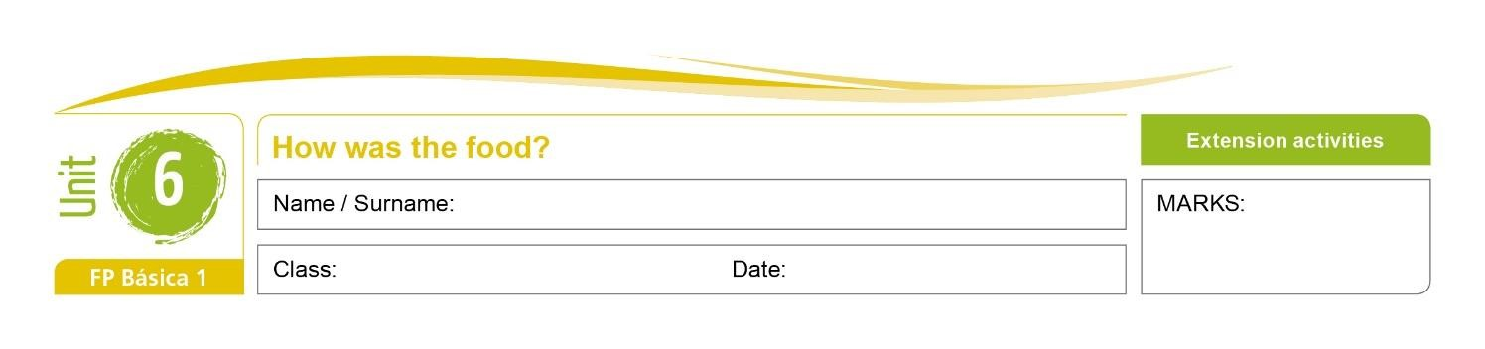

1. F*_______* and m*_______* are protein foods.
2. Br*_______* and p*_______* are carbohydrate foods.
3. A*_______*s are a fruit.
4. Ch*_______* is a meat.

**3. True or false?**

*Sardines are a kind of fruit. False*

1. Bananas are a red or green vegetable.
2. Bread, pasta and rice are types of carbohydrate.
3. Yoghurt is a dairy product.
4. Broccoli and cauliflower are types of fish.
5. A tomato is usually red.

**English – Comunicación y Sociedad 1** 1



# GRAMMAR

***be*: past simple**

1. **Complete the text with *was*, *were*, *wasn’t* or *weren’t*.**

Last week we *were* on holiday in Britain. I (1) ***_________*** with my family and my friend Dylan. We (2) ***_________*** in London and we (3) ***_________*** very happy. There (4) ***_________*** lots of places to visit but there (5) ***_________*** any festivals. The weather (6) ***_________*** very nice, there (7) ***_________*** some rain but it (8) ***_________*** OK. We want to go back again!

1. **Complete the sentences with *was*, *were*, *wasn’t*, *weren’t, some* or *any* in positive (+), negative (-) or interrogative.**

*There ____ _____ milk in the bottle. (-) There wasn’t any milk in the bottle.*

1. There __________ __________ chicken in the fridge. (+)
2. There __________ __________ tomatoes in the salad. (-) 3. There __________ __________ tourists in the town square. (+)
3. __________ there __________ sauce on the pasta?
4. __________ there __________ chips with your chicken?

©

MACMILLAN

EDUCATION

/ Photocopiable material

Where was the hotel?

