# VOCABULARY

**Countries and nationalities**

1. **Complete the sentences with the words in the box.**

Spanish ~~Poland~~ France Italy Australian Moroccan

*Jan is from Warsaw in Poland.*

* 1. Mario lives in __________ . He’s Italian.
  2. Fatima is from Marakesh. She’s __________.
  3. Maria José and Tere are __________. They’re from Zaragoza.
  4. Noah is from Melbourne. He’s __________.
  5. Ines and Adele are French. They are at school in __________.

1. **Complete the table. Write the countries and the nationalities.**

©

MACMILLAN

EDUCATION

/ Photocopiable materials

|  |  |  |
| --- | --- | --- |
| **Name_** | **Country** | **Nationality** |
| *Jan* | *Poland* | *Polish* |
| 1. Mario |  |  |
| 2. Fatima |  |  |
| 3. Maria José and Tere |  |  |
| 4. Noah |  |  |
| 5. Ines and Adele |  |  |

1. **Read the clues and complete the crossword.**

**Across**

2. The Eiffel Tower is … .

1. People from Albacete are … .
2. The samba is a … dance.
3. Jack is from London. He is … .
4. *The Big Bang Theory* is an … TV series.

**Down**

1. Moscow is the capital of … .

1. People from Beijing are … .
2. Granada and Valencia are cities in … .
3. Count Dracula is from … .
4. Warsaw is a … city.

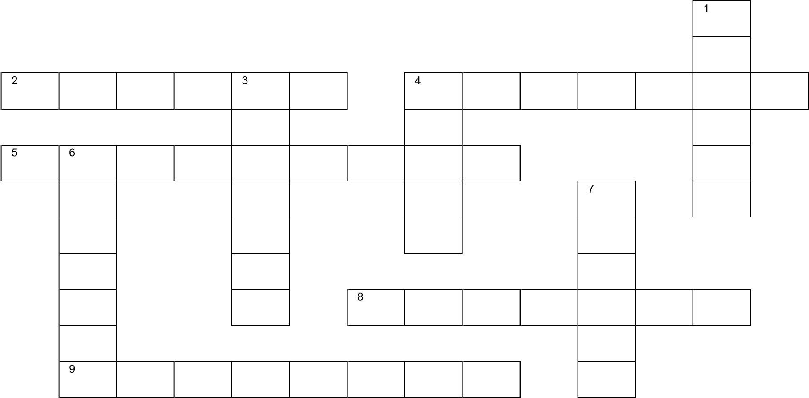

# GRAMMAR

***be*: present simple**

**4. Complete the sentences with the words in the box.**

am ~~is~~ is isn’t are aren’t

*Tokyo* ***is*** *the capital of Japan.*

1. Tintin and Asterix __________ American cartoon characters.
2. Superman __________ a comic book character.
3. Madrid and Barcelona __________ in Spain.
4. Johnny Depp __________ from Ecuador.

©

MACMILLAN

EDUCATION

/ Photocopiable materials

1. __________ I your friend?

**5. Write one affirmative and one negative sentence about five of the famous people or characters in the box.**

~~Donald Trump~~ Spiderman Captain America Diego Costa The Queen of England Asterix Gareth Bale Jennifer Lawrence

©

MACMILLAN

EDUCATION

/ Photocopiable materials

*Donald Trump is from the USA. He isn’t British.*