**[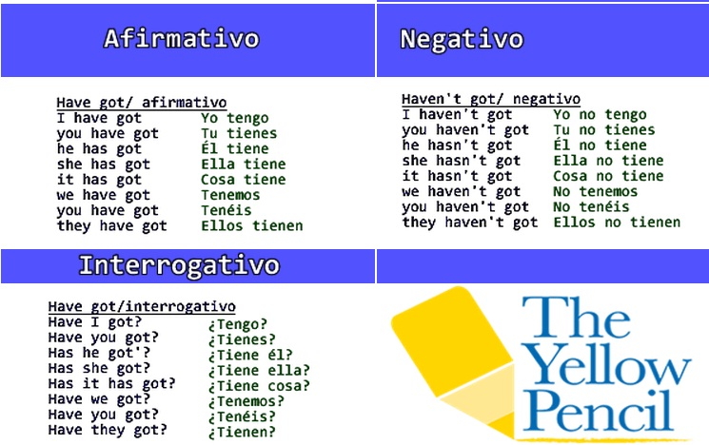](https://www.google.com/url?sa=i&url=http://quintosetenil.blogspot.com/2012/10/verbo-have-got-ingles.html&psig=AOvVaw1P2WWCH3plgkOi3_6Fi7Oa&ust=1589144218528000&source=images&cd=vfe&ved=0CAIQjRxqFwoTCLiAktjVp-kCFQAAAAAdAAAAABAJ)**

**Mira este cuadro, en realidad, hay dos formas en el verbo HAVE GOT**

***--AFIRMATIVA:***

**(yo tengo, tú tienes, él tiene….)**

1. **I,YOU, WE, THEY: HAVE GOT**
2. **HE, SHE, IT : HAS GOT**

**También existe la forma contraida para que sea más corta, sería así:**

***I’ve got ( yo tengo)***

***You’ve got ( tú tienes)***

***He’s got ( él tiene)***

***She’s got ( ella tiene)***

***It’s got ( eso tiene)***

***We’ve got ( nosotros tenemos)***

***You’ve got ( vosotros tenéis)***

***They’ve got ( ellos tienen)***

***--NEGATIVA:***

**I haven’t got: yo no tengo**

**You haven’t got: tú no tienes**

**He hasn’t got : él no tiene**

**She hasn’t got: ella no tiene**

**It hasn’t got: eso no tiene**

**We haven’t got : nosotros no tenemos**

**You haven’t got: vosotros no tenéis**

**They haven’t got: ellos no tienen**

**INTERROGATIVA**

***COMENZAMOS SIEMPRE CON HAVE O HAS SEGUIDO DEL SUJETO:***

***HAVE* YOU  *GOT?***

***HAVE GOT?***

***HAS GOT?***

***HAS GOT?***

***HAS GOT?***

***HAVE GOT?***

***HAVE GOT?***

***HAVE GOT?***

**1.Underline the correct answers. (Subraya la respuesta correcta)**

*They … several memory sticks.*

*a) ‘s got b) ‘ve got*

1. My sister … a new smartwatch.

a) ‘s got b) ‘ve got

2. I … a great Facebook page.

a) ‘s got b) ‘ve got

3. My parents … internet at home.

a) ‘s got b) ‘ve got

4. We … WhatsApp.

a) haven’t got b) hasn’t got

5. He … a new mobile phone.

a) haven’t got b) hasn’t got

**2.Make sentences using the verb *to have* and the words below.**

*We / not / wi-fi / at home / .*

*We haven’t got wi-fi at home.*

1. My office / not / air conditioning / .

2. Julian / a lot of apps / his tablet / .

3. you / Skype / your phone / ?

4. Gavin and Deborah / a new shopping app / .

5. we / any likes on Facebook / ?

**3.Write the short (contracted) form of each verb.**

*We have got We’ve got*

1. I have got
2. You have got
3. He has got
4. She has got
5. They have got

**4. Underline the correct words.**

*She* ***has / have*** *got a new tablet.*

1. Simon has **/ have** got a laptop.
2. My mum **haven’t /** hasn’t got a smartphone.
3. They have **/ has** got three tablets at home.
4. I haven’t **/ hasn’t** got photos on Facebook.
5. We **has /** have got a new email address.

VOCABULARY

**Places in a town**

**1. Add the vowels to complete the words.**

*B A N K*

1. S _ P _ R M _ R K _ T

2. B _ W L _ N G A L L _ Y

3. S H _ P P _ N G C _ N T R _

4. L _ B R _ R Y

5. T _ W N S Q _ _ R _

**2. Circle the places.**

librarysportscentrecinemarestaurantnightclubbank

**2. Write the names of the places in the descriptions.**

*It’s a place where you can dance. Nightclub*

1. It’s a place where you borrow books. ______________________________

2. It’s a place where you can go shopping. ______________________________

3. It’s a place where you can eat. ______________________________

4. It’s a place where you can go bowling. ______________________________

5. It’s a place where you can play sports. ______________________________

**3. True or false?**

*You can dance at a nightclub. True*

1. There are different shops in a shopping centre.

2. You can play sports at a cinema.

3. *Plaza Mayor* is a big town square in Madrid.

4. A sports centre always has a bowling alley.

3. All restaurants close in the evening.