# VOCABULARY

**Jobs**

**1. Order the letters to write the jobs.** *readnerg gardener*

1. rssreedriah
2. iearwt
3. chcnaiem
4. runes
5. cceelinatri

**2. Find and write the names of five jobs.**

|  |  |  |  |
| --- | --- | --- | --- |
| A | C | D | E |
| G | H | I | F |
| M | N | P | R |
| S | T | U | W |

*Example: M E C H A N I C: mechanic* Jobs:

©

**MACMILLAN**

**EDUCATION**

**/**

**Pho**

**tocopiable**

**m**

**aterial**

What do you do?

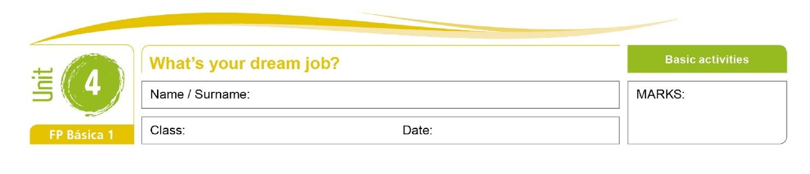

W _ _ _ _ _

G _ _ _ _ _ _ _

N _ _ _ _

P _ _ _ _ _ _

C _ _ _

# GRAMMAR

1. **Find the adverbs of frequency.**

|  |  |  |  |  |  |  |  |  |
| --- | --- | --- | --- | --- | --- | --- | --- | --- |
| G | W | A | Y | S | B | O | N | U |
| S | O | M | E | T | I | M | E | S |
| E | F | K | U | F | L | A | S | U |
| H | T | I | S | Y | A | W | L | A |
| U | E | Y | Q | H | P | U | V | L |
| I | N | E | V | E | R | T | C | L |
| R | M | S | W | E | O | Z | D | Y |

**English – Comunicación y Sociedad 1** 1



1. **Complete the sentences with the correct adverb of frequency.**

*Mum always cooks dinner at 8.00.*

1. My family u______________ gets up late on Sundays.
2. James s______________ works in a café at the weekends.
3. I n______________ eat lunch at home.
4. My Dad o______________ plays football after work.
5. We a______________ eat dinner at home.

**5. Choose the correct word**

There is There are There isn’t ~~There aren’t~~ Is there Are there

___________________ *any Chinese students in the class. There aren’t any Chinese students in the class.*

1. ___________________ two cinemas in this town.
2. ___________________ a cycle lane here. Be careful.
3. ___________________ a bus stop nearby?
4. ___________________ a party on Saturday. I want to go!
5. ___________________ any plants on your terrace?

©

**MACMILLAN**

**EDUCATION**

**/**

**Pho**

**tocopiable**

**m**

**aterial**

What do you do?



**English – Comunicación y Sociedad 1** 2

