# VOCABULARY

## Jobs

1. **Find and circle seven jobs in the word square.**

|  |  |  |  |  |  |  |  |  |  |
| --- | --- | --- | --- | --- | --- | --- | --- | --- | --- |
| J | K | ***H*** | N | U | R | S | E | E | M |
| M | L | ***A*** | W | I | E | S | G | L | E |
| E | A | ***I*** | A | Y | C | D | A | E | C |
| C | O | ***R*** | T | F | E | H | R | C | H |
| H | P | ***D*** | E | E | P | E | D | T | E |
| A | W | ***R*** | L | H | T | A | E | R | W |
| N | E | ***E*** | E | P | I | O | N | I | N |
| I | R | ***S*** | C | U | O | I | E | C | U |
| C | T | ***S*** | I | E | N | U | R | I | R |
| C | H | ***E*** | F | R | I | F | P | A | G |
| D | X | ***R*** | O | E | S | W | L | N | R |
| R | C | W | A | I | T | E | R | N | E |

1. **Complete the job words.**

©

MACMILLAN

E

DUCATION

/

Pho

tocopiable

m

aterial

What do you do?

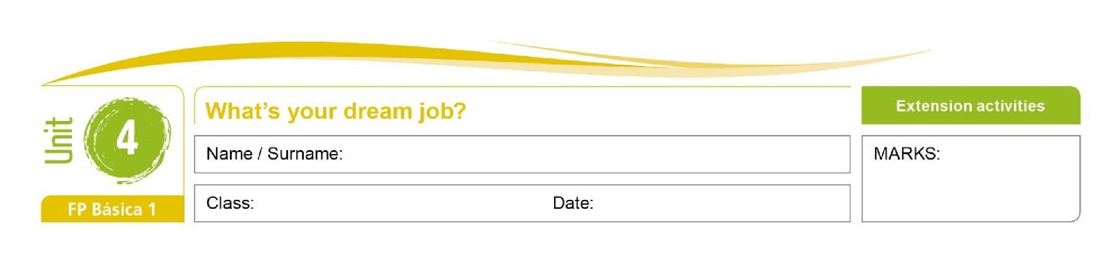

*A hairdresser works in a salon.*

1. A w____________ serves food in a café.
2. A g____________ looks after plants.
3. An e____________ fixes problems with electricity.
4. A n____________ looks after people in hospital.
5. A c____________ cooks food for people in a restaurant.

**3. Match the job to the workplace.**

1. *waiter* a) garden
2. hairdresser b) garage
3. receptionist c) salon
4. nurse d) office
5. chef *e) restaurant*
6. gardener f) hospital
7. mechanic g) kitchen

**English – Comunicación y Sociedad 1** 1



# GRAMMAR

## Adverbs of frequency

**4. Complete the sentences with the correct form and order of the words in brackets.**

*We always do our homework before dinner. (always, do)*

1. Matt and Sally _____________________ late for school. (never, be)
2. My grandparents _____________________ lunch with us on Sundays. (always, eat)
3. Jane _____________________ tired after work. (often, be)
4. I _____________________ in a shop on Saturdays. (work, sometimes)
5. We _____________________ football in the park on Saturdays. (play, usually)

## There is / there are

**5. Complete the text with the words in the box.**

|  |
| --- |
| there’s ~~there are~~ There isn’t there aren’t Is there Are there |

In my town *there are* a lot of shops. There’s a supermarket in the main street and __________________ a greengrocer’s next to my house. __________________ a cinema or a theatre and __________________ any cycle lanes. How about you? __________________ many shops in your town? __________________ a cinema?

©

MACMILLAN

E

DUCATION

/

Pho

tocopiable

m

aterial

What do you do?



**English – Comunicación y Sociedad 1** 2

