# VOCABULARY

## Clothes

**1. Look at the pictures and complete the crossword.**

©

MACMILLAN

EDUCATION

/ Photocopiable material

|  |  |
| --- | --- |
| **Down** | **Across** |
|  |  |

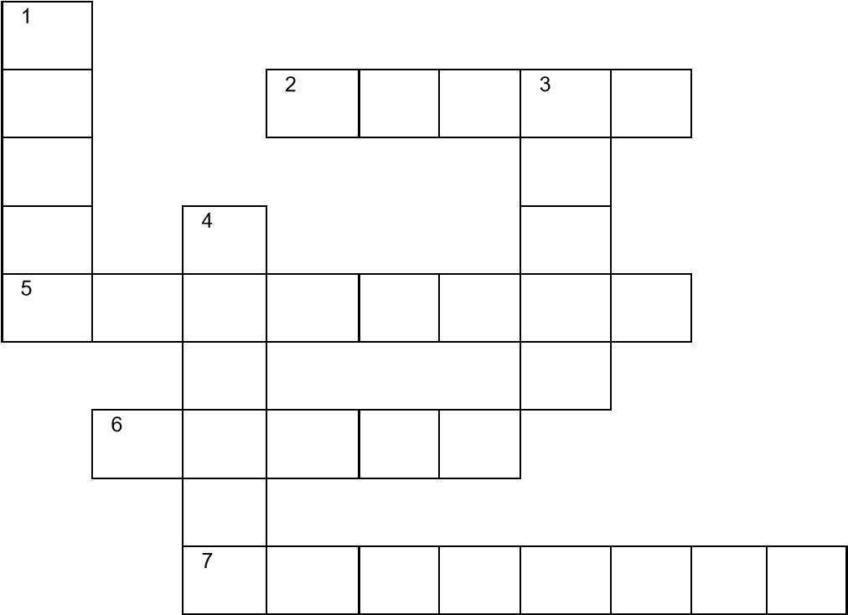

## Colours and clothes

**2. Order the letters to make words to complete the sentences.** *She is wearing a g r e y s k i r t to the office today. (g _ _ _ sk _ _ _)*

1. I’m wearing a b _ _ _ _ c _ _ _. It is cold.
2. He’s wearing w _ _ _ _ t _ a _ _ _ _ _. He’s playing basketball.
3. They’re wearing b _ _ _ _ j _ _ _ _. They look casual.
4. James is wearing a p _ _ _ t _ _.
5. Mum’s wearing a g _ _ _ _ h _ _ today.
6. You’re wearing the new r _ _ t _ o _ _ _ _ _. They look great.

# GRAMMAR

## Present continuous

**3. Complete the questions with the correct form of the verbs in brackets.**

*Is* Joe *having* a shower? (have)

1. ________ you ______________ your homework? (do)
2. ________ they ______________ pasta? (eat)

©

MACMILLAN

EDUCATION

/ Photocopiable material

1. ________ Max ______________ football? (play)
2. ________ we ______________ well? (dance) 5. ________ Bella ______________ TV? (watch)

**4. Complete the short answers to the questions in exercise 3.**

*Is* Joe *having* a shower? (have) Yes, he *is*.

1. Yes, I ________.
2. No, they ________.
3. No, he ________.
4. Yes, you ________.
5. Yes, she ________.

## *can*: ability

**5. Make questions and answers using the words in the boxes.**

|  |  |  |  |  |  |
| --- | --- | --- | --- | --- | --- |
| |  | | --- | | can | | |  |  |  | | --- | --- | --- | | make  speak work think play run |  | football  Chinese 10km  in a team quickly ~~clothes~~ | |

*Can Kieran make clothes?*

©

MACMILLAN

EDUCATION

/ Photocopiable material

1. ________ Emily ________________? Yes, _____ _________.
2. ________ Ned ________________? No, _____ _________.
3. ________ Graham and Gill ________________? Yes, _____ _________.
4. ________ you ________________? No, _____ _________.
5. ________ you and your brother ________________? Yes, _____ _________.