# VOCABULARY

**1.** **Follow the clues and find the missing word.**

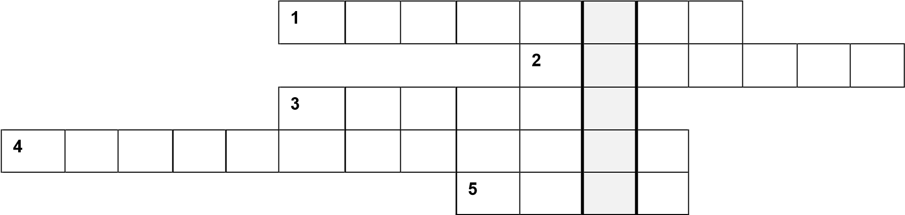

1. A _______________ fixes cars.
2. A _______________ builds houses.
3. A _______________ serves food in a restaurant.
4. A _______________ gives out keys and information about the hotel.
5. A _______________ cooks food.

Marks __/10

**2. Write the jobs that match the descriptions*.***

©

**MACMILLAN**

**EDUCATION**

**/**

**Pho**

**tocopiable**

**m**

**aterial**

What do you do

?

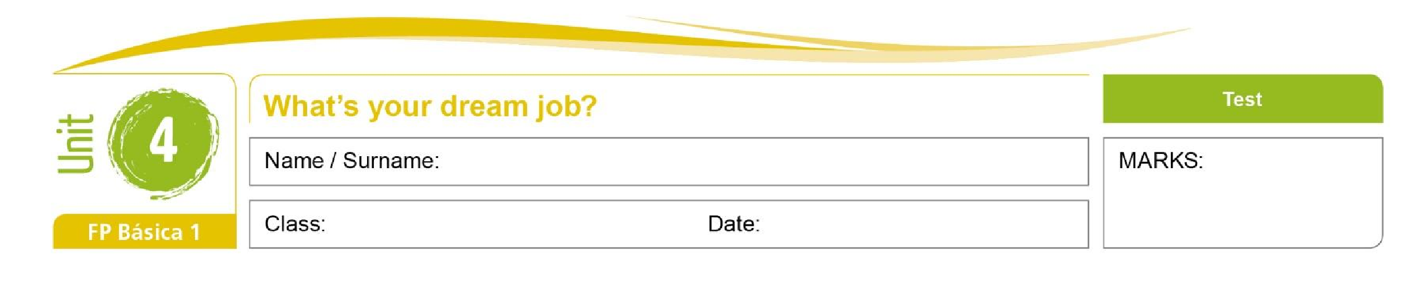

|  |  |  |
| --- | --- | --- |
| 1. He fixes problems with electricity. e**_________________________________** | |  |
| 2. She cuts people’s hair. | h**_________________________________** |
| 3. He paints walls and houses. | p**_________________________________** |  |
| 4. She puts out fires. | f**_________________________________** |  |
| 5. He works outside with plants.    **3. Match the sentences.** | g**_________________________________** | Marks __/10 |
| 1. Julie is a secretary. | a. She works with plants. 1 **____** |  |
| 2. Pete is a chef. | b. The hairdressers are excellent. 2 **____** |  |
| 3. I like this restaurant. | c. The food is always good. 3 **____** |  |
| 4. I always go to this salon. | d. She works in a big office. 4 **____** |  |
| 5. Nadya is a gardener. | e. He cooks in a famous restaurant. 5 **____** |  |

Marks __/10

**Comunicación y Sociedad 1**

# GRAMMAR

1. **Complete table with adverbs of frequency.**

**100%** 1a__________________

* 1. u**__________________**
  2. o**__________________**
  3. s**__________________**

**0%** 5 n**__________________**

Marks __/10

1. **Put the words in the correct order to make sentences.**
2. cycle / work / always / I / to / .

1. is / work / Rob / for / never / late / .

1. Fridays / play / We / on / basketball / sometimes / .

©

**MACMILLAN**

**EDUCATION**

**/**

**Pho**

**tocopiable**

**m**

**aterial**

1. up / Jane / often / early / gets / .

1. at / l / o’clock / get up / eight / usually / .

Marks __/10

1. **Underline the correct words to complete the sentences.**
2. There **is / are** two waiters in this restaurant.
3. There **is / are** a memory stick on the table.
4. There **is / are** three bikes in the garage**.**
5. There **is / are** a good smartphone in the shop.
6. There **is / are** ten people in the office.

Marks __/10

**7. Order the words to make sentences.**

1. in this street / there / Are / shops / any / ?

1. fruit / There / some / on the table / is / .

1. aren’t / students / on my course / There / many / .

1. a full-time mechanic / isn’t / at the garage / There / .

1. there / in this town / a good hairdresser / Is / ?

Marks __/10

## READING

**8. Read the text and circle T (true) or F (false).**

©

**MACMILLAN**

**EDUCATION**

**/**

**Pho**

**tocopiable**

**m**

**aterial**

|  |
| --- |
| My typical day  *Roger*  I get up at half past seven and I leave the house at 8 o’clock. I ride my bike to work. I work in a garage because I’m a mechanic. I like my job. I have lunch at 1 pm. I usually take sandwiches but I sometimes eat in a café. I go home at 5 o’clock and I have dinner at 6 pm. On Wednesday evenings I go to a film club and on Fridays I play football.  *Sue*  I get up at 8 o’clock. I walk to school and I have lunch there at 12.45. It’s never good! I usually finish school at 4 pm and walk home with my friends. But on Tuesdays I go to the computer club and on Thursdays I have judo classes. Tuesdays and Thursdays are very long days! |

1. Roger gets up before Sue.
2. Roger and Sue don’t use public transport in the morning.
3. Roger and Sue don't do sport.
4. Sue has lunch at home.
5. Sue likes the food at school.

Marks __/10

## WRITING

**9. Complete the email with the words in the box.**

~~live~~ to sometimes always part-time study playing often go waiter school

Hi, I’m Rob,

I *live* in Manchester and I (1) **________________** to New Park school. I (2) **________________** gardening. I usually get up at 8.00. I (3) **________________** have lunch at home, but I (4) **________________** eat in a café near (5) **________________**.

On Saturdays I work (6) **________________** I am a (7) **________________** in a café from 9.00 am

(8) **________________** 2.00 pm.

I like (9) **________________** team sports like basketball and football. I (10) **________________** play on Sundays.

Marks __/10

## SPEAKING

**10. Underline the correct options to complete the dialogue.**

**Ethan:** Hi, Harper!

©

**MACMILLAN**

**EDUCATION**

**/**

**Pho**

**tocopiable**

**m**

**aterial**

**Harper:** Hey Ethan, (1) **How you are** / **How are you**?

**Ethan:** Really good. Hey, (2) **do you like** / **are you like** running?

**Harper:** Running? Not really.

**Ethan:** I love it! It’s great exercise.

**Harper:** I know, but (3) I **prefer play** / **prefer playing** volleyball. I usually play at weekends.

**Ethan:** (4) Why **does you prefer** / **do you prefer** playing volleyball?

**Harper:** Because it’s a team sport.

**Ethan:** I (5) also **like playing** / **usually playing** team sports!

Marks __/10

**Vocabulary __/30**

**Grammar __/40**

**Reading __/10**

**Writing __/10**

**Speaking __/10**

**TOTAL __/100**