Easter bunny
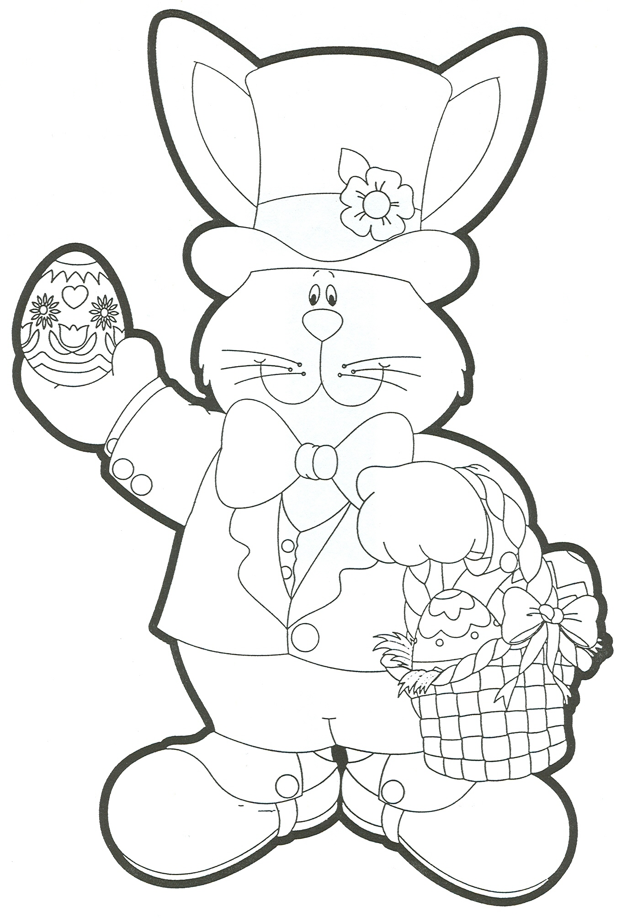

Easter egg

Basket

What is he wearing? Write sentences with these words Hat Jacket Shoes Trousers

He is wearing a red ribbon.
He is wearing

Happy Easter Day!

