4º ESO – Industrial Revolution in Britain
Vocabulary – If there are any words that you do not understand, write them in this box and we will translate them together.

The Industrial revolution took place in Britain between the years 1750 and 1900 and was a period of big changes. There were huge developments in technology which led to a migration of people from rural to urban areas.

Not all of these changes were positive. Conditions in newly created factories and coal mines in particular were dangerous and difficult.

Before the 19th century, manufacturing in Britain took place at home. Products were made to be sold in local markets.

However, after the 19th century, machinery started to be developed that sped up the production process and allowed products to be created on a large scale in factories. This period is known as the industrial revolution.
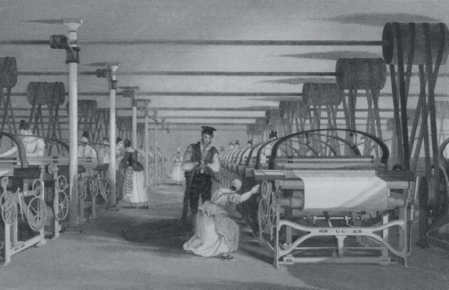
New developments in technology and transport were integral to the industrial revolution, but the British Empire also played a big role in the economy of the industrial revolution.

Technology
In 1778 the steam engine was invented. This meant that many coal mines were opened in the north of England, the midlands, and south Wales so that heat could be generated for these engines.

Conditions in coal mines were very dangerous, there was a risk of tunnels collapsing and there was poisonous gas in the mines. Children as young as 4 worked in the factories and mines.

Children would work 12–14-hour shifts for an average of 36p per week. They would be punished if they were slow or tired. In 1901 Children were banned from working in factories and implemented safety measures for adults that worked there.

Transport
There were many developments in transport to move products between new factories in different cities. During the industrial revolution, roads were improved and in 1820 tarmac was invented.
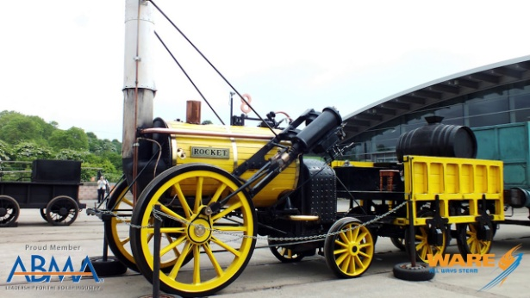
Canals became very important during the industrial revolution. A canal is a man-made waterway that allows ships to pass from one body of water to another.In 1887, the Manchester Ship Canal was built, allowing ships to enter the River Mersey from the Irish Sea and deliver products to Manchester.

The invention of the railway was the most significant development. In 1829, a train called ‘the Rocket’ was created and a railway line was built between the cities of Liverpool and Manchester.

The British Empire
By the mid 1700s, Britain was becoming the world’s most powerful empire. Colonies in North America created a large market for products manufactured in Britain.

Wealth that was generated by the empire encouraged industrialisation. For example, money that was generated from Britain’s role in the slave trade was used to build railways in Britain. Nowadays it is important to recognise that many colonies wereexploited so that the industrial revolution could take place in Britain.

Questions
- When did the Industrial Revolution take place in Britain?

- Where did production take place in Britain before the 19th century?

- What invention triggered the burning of coal?

- Who used to work in the mines and why was this controversial?

- What forms of transport were developed?

- What role did the British Empire play in the Industrial Revolution?

