4º ESO – Suffragism and Feminism before World War I
Vocabulary – If there are any words that you do not understand, write them in this box and we will translate them together.

Introduction
Before the outbreak of World War I women in the UK and the around the world did not have the right to vote, this led to the rising popularity of the Suffragism movement.

The definition of suffragism is the belief that the right to vote should be extended to women.

There were many groups that gained popularity. The main group in the UK was the Suffragettes led by a woman called Emmeline Pankhurst. Suffragism gained popularity around the world at this time, with many countries realising that women deserved the right to vote after seeing their efforts during the war.

The UK Example
Many women in the UK decided to start their own campaign to get the right to vote after politicians failed to fight for their right. In the beginning the movement was peaceful and involved protests, petitions and writing letters to MP’s (Members of Parliament).

This was ineffective and after a while many women were annoyed at the lack of progress.

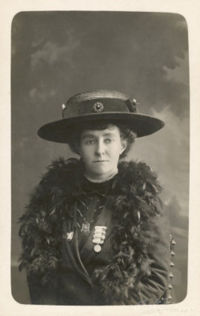
This caused the creation of the Suffragettes by a woman called Emmeline Pankhurst in the city of Manchester. The Suffragettes used more violent actions as they believed this would cause change.
- They broke windows.
- They set fire to buildings.
- They protested and interrupted major events.

The Government banned women from political activity due to the Suffragette’s tactics. They could not attend any political meetings and women who engaged actively with the suffragettes were sent to prison.

The Suffragettes most famous act of resistance was carried out at the 1913 Epsom Derby, a prestigious horse race in Britain. A woman called Emily Davison, a former teacher, ran onto the track and into the horses with a banner calling for votes for women. She was hit by the King’s horse and ultimately died from her injuries.
How did Women receive the vote?
In 1914 World War One started. As a result,the suffragettes suspended their activities to help with the war effort.

Emmeline Pankhurst encouraged women to take jobs in factories that men would normally have. The government also released all suffragettes that were in prison. Women worked in factories, grew food, delivered mail, and worked on the frontlines as nurses.

Before the war women could not vote and only men who were older than 30 could vote. After, due to the efforts of women in the war, some upper-class women were allowed to vote.

Finally, in 1928 all women received the same right to vote as men and in 1969 the age limit to vote in the UK was lowered to 18 years old.

The first woman to be elected to the UK Parliament was a woman called Constance Markievicz. Nowadays women only make up 34% of the UK Parliament with 220 female MPs currently in office. The UK has had three female prime ministers.

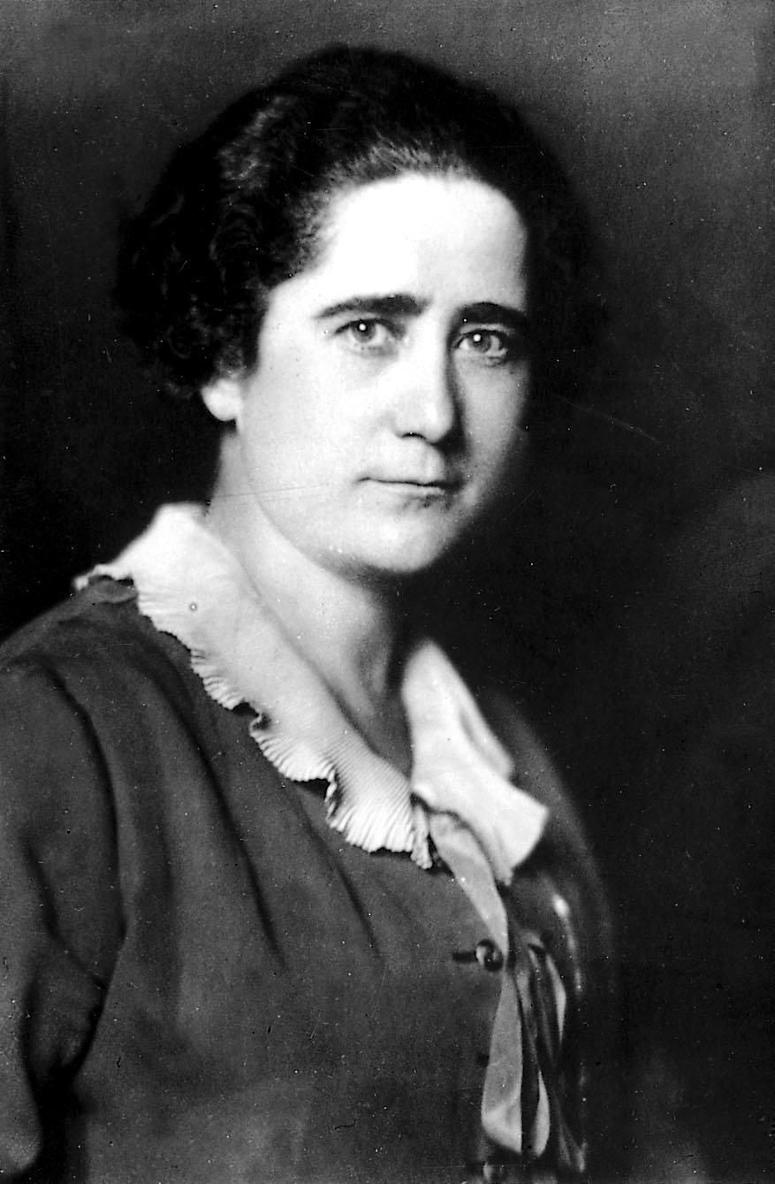
Around the World
The first country to allow women the right to vote was New Zealand in 1893.

In Spain women were first allowed to vote in the 1933 General Election. The first female Spanish member of congress, Clara Campoamor, was elected two years before in 1931 and was a leading figure in the fight for women’s suffrage in Spain.

The United States also allowed women the right to vote after World War I after the 19th Amendment to the Constitution was accepted.
Questions
- What is the definition of Suffragism?

- Why were the Suffragettes formed?

- What was the reaction to the Suffragettes by the Government?

- What role did women take during World War I in Britain?

- When did women get the right to vote in Spain and who was the first female member of Congress?

